1960’s America

Section 1- John F. Kennedy as President
The election of 1960
The 1960 presidential election, which has been described as the “first modern presidential campaign,” pitted Republican Richard Nixon, who had served as Vice President under Dwight D. Eisenhower, against Democratic Senator John F. Kennedy, scion of the elite Kennedy clan of Massachusetts.

Kennedy ran on a strong civil rights platform, hoping to offset the expected hostility from Southern Democrats by adding Texan Lyndon B. Johnson to the ticket as his vice president.
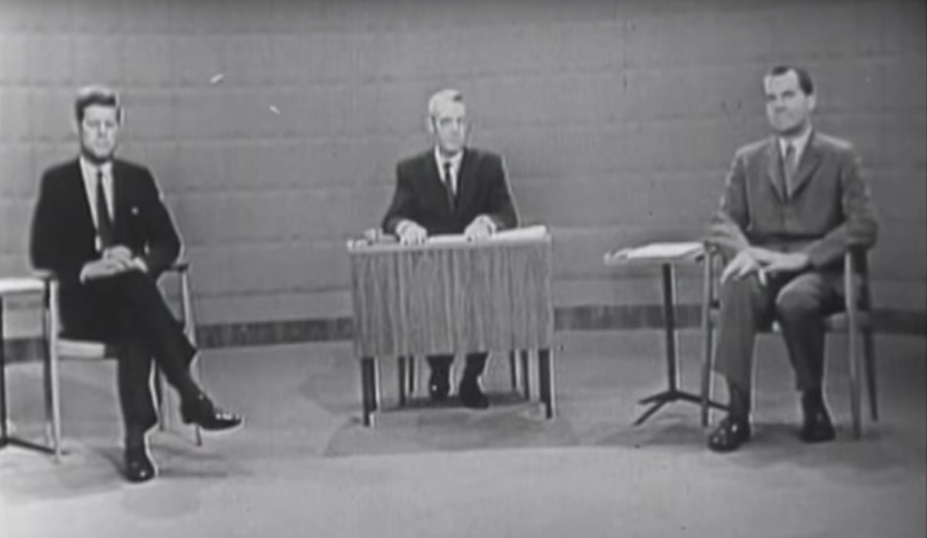
Still from the first presidential debate between Kennedy and Nixon. This was the first nationally-televised presidential debate, and Kennedy's good looks and charming demeanor on screen gave him an edge over Nixon. Debate footage courtesy the John F. Kennedy Presidential Library and Museum.

Though Kennedy and Nixon often have been portrayed as ideological opposites, they both agreed on the necessity of US global leadership in the Cold War. Both men were firmly anti-communist and emphasized the importance of maintaining and strengthening US military supremacy.

There were, however, some substantial differences between the two candidates. While Kennedy pledged to revive the economy by strengthening the public sector, Nixon promised to slash federal spending. Kennedy rhetorically embraced the goals of the Civil Rights Movement, while Nixon largely neglected civil rights issues. Unlike Nixon, Kennedy was Roman Catholic, and his campaign dealt with accusations that his loyalty to the Pope would trump his loyalty to the United States.

There were also significant stylistic differences between the two candidates, which were magnified by their appearances on television. The first nationally-televised presidential debate occurred on September 26, 1960. Kennedy appeared charismatic and handsome, and was very effective at crafting a likable on-screen persona.

Nixon, on the other hand, frequently seemed sweaty, nervous, and brooding. Those who listened to the debate on the radio thought that Nixon had won, while those who watched on television agreed that Kennedy was the winner.

The election was extremely close, but Kennedy ultimately triumphed over Nixon by a slender margin.

John F. Kennedy as president
Once in office, Kennedy embraced an economic model centered on federal tax and spending policies. Originally proffered by the economist John Maynard Keynes, Keynesian economics theorized that federal deficit spending could boost economic growth and lower unemployment.
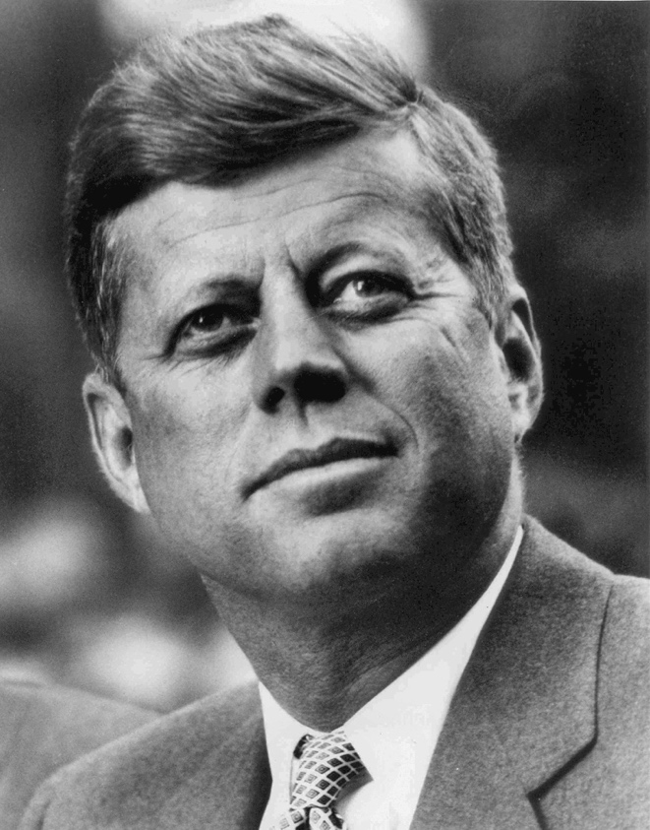
Presidential photo portrait of John F. Kennedy. Image courtesy Wikimedia Commons.

The Kennedy administration approved a series of stimulus measures to combat the recession, including the extension of social security and unemployment benefits, and a twenty percent increase in military spending. The minimum wage was raised and over $4 billion was allocated for housing construction. Kennedy also announced that he would ask Congress for a $10 billion tax cut unaccompanied by decreases in federal spending. He argued that an economic boom would result from such an approach, and thus tax revenues would be higher despite lower tax rates. While such measures did stimulate the economy and reduce unemployment, they also led to an increase in inflation and set the stage for conflict between corporations and labor unions over wages and prices.

Although he had campaigned on a strong civil rights platform, Kennedy adopted a much more cautious approach once in office. This was partly due to the power of Southern Democrats in Congress, who were threatening to block the president’s entire civil rights agenda. Nevertheless, Kennedy appointed several African Americans to high-profile positions in the federal government and judiciary.

In 1963, he introduced comprehensive civil rights legislation, which Congress was still debating at the time of Kennedy’s assassination. The bill he introduced eventually would be passed as the Civil Rights Act of 1964, during the administration of Kennedy’s successor, Lyndon Johnson.

The Kennedy administration’s foreign policy included triumphs, tragedies, and everything in between. The Cuban Missile Crisis brought the world to the brink of nuclear annihilation. Though Kennedy’s vacillation and indecisiveness about the Bay of Pigs invasion had contributed to the missile crisis in the first place, his determined statesmanship helped defuse tensions and negotiate a peaceful resolution to the crisis. Kennedy authorized the Alliance for Progress, a major trade and aid initiative designed to encourage democratic reform and prevent violent revolution in Latin America. Kennedy also set the stage for increased US involvement in Vietnam by supporting a military coup in South Vietnam.

Kennedy's assassination
The presidency of John F. Kennedy was tragically cut short by an assassin’s bullet on November 22, 1963, in Dallas, Texas. Lee Harvey Oswald, an unstable ex-Marine with ties to the Soviet Union and to the Cuban émigré community in Miami, shot Kennedy from the window of a book depository while the president was riding in a convertible limousine as part of a motorcade. Oswald himself was then murdered while in police custody, by Jack Ruby, a Dallas nightclub owner with ties to organized crime. Because of the peculiar circumstances surrounding the Kennedy assassination, numerous conspiracy theories have arisen, though the preponderance of evidence suggests that Oswald acted alone.

Kennedy was succeeded in office by his vice president, Lyndon Baines Johnson.

Section 2- Cuban Missile Crisis
The Cuban Revolution
After waging a successful guerrilla war against the regime of Cuban dictator Fulgencio Batista, Fidel Castro came to power on January 1, 1959. Castro was not yet a communist, and US policymakers initially took a cautious wait-and-see approach to his regime. Over the course of 1959 and 1960, US-Cuban relations worsened due to Castro’s anti-US rhetoric and radical policies, especially his refusal to hold elections. When it became clear that Castro intended to pursue an alliance with the Soviet Union, President Dwight Eisenhower cut off diplomatic ties to Cuba and began preparing contingency plans for overthrowing Castro and replacing him with someone more amenable to the United States.
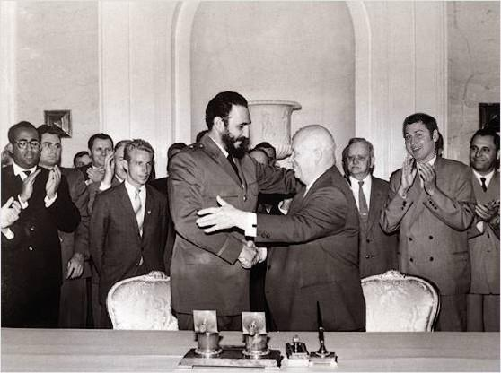
Cuban Prime Minister Fidel Castro, left, shakes hands with Soviet Premier Nikita Khrushchev in 1961. Image courtesy Wikimedia Commons.

As US-Cuban relations deteriorated, Castro turned to the Soviet Union for support. The Soviets signed multiple trade and aid agreements with Cuba, provided Castro with arms and weaponry, and also gave political support to the Cuban Revolution in the United Nations and other international organizations.

Origins of the Cuban Missile Crisis
The origins of the Cuban Missile Crisis lie in the failed Bay of Pigs invasion, during which US-supported Cuban exiles hoping to foment an uprising against Castro were overpowered by the Cuban armed forces. After the invasion, Castro turned to the Soviets for protection against future US aggression. The Soviets provided Cuba with nuclear weapons on the condition that the deal would remain secret until the missiles were fully operational.

Khrushchev claimed that his motivation for providing Cuba with nuclear weaponry was to safeguard the Cuban Revolution against US aggression and to alter the global balance of power in favor of the Soviet Union.
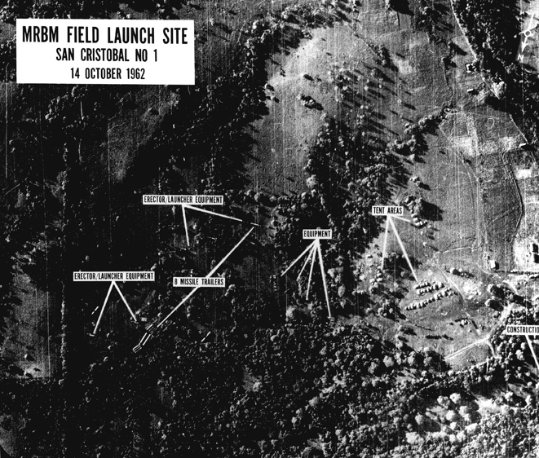
In October 1962, US U-2 spy plane flights over Cuban territory revealed the missile installation sites. This discovery inaugurated what became known as the Cuban Missile Crisis. The strategic implications of these weapons were enormous: the missiles could easily reach targets in the United States, including New York City and Washington, D.C.

Aerial view of the missile site in Cuba, 1962. Image courtesy JFK Library.

The Kennedy administration established a naval blockade to prevent any more missiles from reaching Cuba, and in no uncertain terms demanded the immediate removal of the missiles that had already been delivered. The danger of this approach was that if the Soviets refused to remove the missiles, the United States would be forced to escalate the crisis by authorizing air strikes over Cuba to bomb the missile sites. Contingency plans were drawn up for a full-scale invasion of Cuba and a nuclear attack on the Soviet Union, in the event that the Soviets responded militarily to Kennedy’s demands.

Negotiating a peaceful outcome
Though Khrushchev initially refused to acknowledge the presence of the missiles in Cuba and declared the US naval blockade to be an act of war, he ordered the suspension of all weapons deliveries currently in transit. Over the course of approximately two weeks, Kennedy and Khrushchev negotiated a peaceful outcome to the missile crisis. The Soviets compared their provision of nuclear weapons to Cuba with the stationing of Jupiter missiles in Turkey, which were in range of Soviet territory. Kennedy agreed to remove the missiles from Turkey, and also pledged that the US government would not undertake another invasion of Cuba.
Throughout the negotiations, Khrushchev failed to consult with Castro. For Castro, this was humiliating and seemed to prove that the Soviets prioritized relations with the United States over relations with their own allies. Castro hoped to negotiate the closing of the US naval base at Guantanamo and the cessation of U-2 flights over Cuban territory. Ultimately, Khrushchev agreed to remove all of the nuclear missiles from Cuba, while failing to even broach the subject of Castro’s demands.

Consequences of the Cuban Missile Crisis
Although the Soviets attempted to portray the outcome of the missile crisis as a victory, one of the consequences of the crisis was the ouster of Khrushchev. He was forced into retirement by other Soviet officials who claimed that the missile crisis was proof of Khrushchev’s reckless decision-making and his inability to lead the Soviet Union. Khrushchev’s successor, Leonid Brezhnev, came to power and sought to reduce tensions with the United States.

John F. Kennedy came out of the crisis in a much better position. His calm but firm stance in the negotiations was heralded as great statesmanship, though it is often forgotten that his bungling of the Bay of Pigs invasion had helped lead to the missile crisis in the first place.

The Cuban Missile Crisis also convinced Kennedy of the dangers of nuclear brinksmanship. He and Khrushchev had peered into the abyss of nuclear destruction but had managed to pull back from it. In order to prevent future crises, a Moscow-Washington hotline was set up in the White House to facilitate direct communication between the leaders of the Soviet Union and the United States.

In August 1963, the United States, the Soviet Union, and Great Britain signed a treaty banning atmospheric and underwater nuclear testing. Nevertheless, the test-ban treaty failed to halt the arms race, as Kennedy simultaneously authorized a massive arms buildup that vastly expanded the US nuclear arsenal and amplified US strategic superiority in the Cold War.

Section 3- Lyndon B. Johnson as President

Lyndon Johnson ascends to power
Lyndon Baines Johnson, a New Deal Democrat from rural West Texas, served in both the House of Representatives and the Senate before becoming vice president to John F. Kennedy. He was the Senate Minority Leader for two years, the Senate Majority Whip for two years, and the Senate Majority Leader for six years, and some historians believe he was the most effective majority leader in US history.

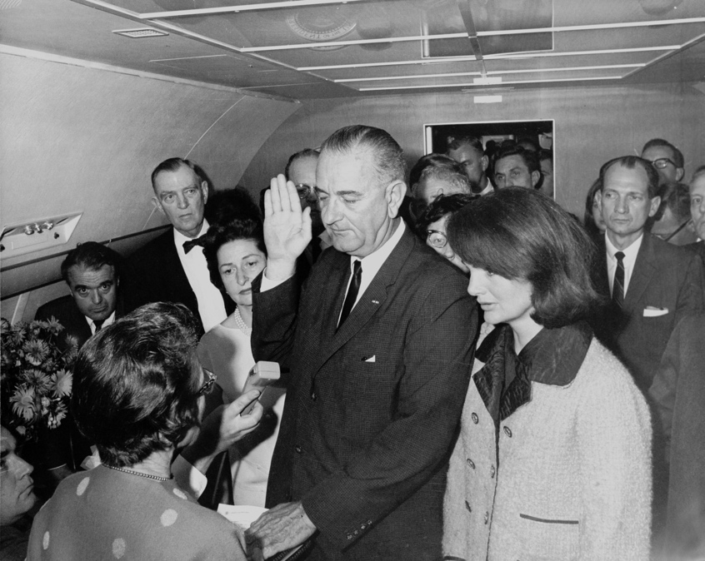
Black and white photograph of Lyndon Johnson holding up one hand as he is sworn in as president amidst a crowd of people in the interior of the presidential plane Air Force One. Next to Johnson stands Jacqueline Kennedy, who is still wearing the bloodstained coat she wore earlier in the day when her husband John F. Kennedy was shot and killed during a parade in Dallas, Texas.
Lyndon Johnson's swearing-in ceremony on Air Force One, just hours after Kennedy's assassination. Former First Lady Jacqueline Kennedy stands next to Johnson. Image courtesy Wikimedia Commons.

On November 22, 1963, President Kennedy was felled by an assassin’s bullet in Dallas, Texas. Two hours after the assassination, Johnson was sworn into office aboard Air Force One. He pledged to carry on Kennedy’s legacy and to fulfill his political agenda, particularly concerning civil rights. In the presidential election of 1964, Johnson won in a landslide against conservative Republican Barry Goldwater.

LBJ and the Civil Rights Movement
Once in office, Johnson moved quickly to secure the passage of civil rights legislation that had languished in Congress during Kennedy’s presidency. The Civil Rights Act of 1964 banned racial segregation in public education and facilities, and prohibited discrimination in jobs and housing. In March 1965, Johnson delivered a speech in which he condemned racial bigotry and informed the nation that he was sending another civil rights bill to Congress. The Voting Rights Act of 1965 outlawed poll taxes, literacy tests, and other devices that had been used to prevent Southern blacks from voting.

Together, these two acts constituted the most comprehensive civil rights legislation ever passed, and were a paramount achievement of Johnson’s presidency.

The Great Society
Johnson’s major focus as president was the Great Society, a package of domestic programs and legislation aimed at eradicating poverty and improving the quality of life of all Americans. The Great Society vastly expanded the welfare state and included initiatives such as the War on Poverty.

Johnson launched the War on Poverty in March 1964, when he sent the Economic Opportunity Act to Congress. The bill created the Job Corps and the Community Action Program, which aimed to eliminate poverty through job creation and block grants to local communities for services such as Head Start for early childhood development. The Office of Economic Opportunity was established to oversee the disbursement of funds to community-based anti-poverty programs, and the Food Stamp Act of 1964 expanded the federal food stamp program.

President Johnson’s Great Society also established Medicare and Medicaid, which provide healthcare to the poor and to the elderly. The Great Society also involved education reform. The Primary and Secondary Education Act of 1965 authorized $1 billion in federal funding for public education and established special programs for schools in low-income areas. The Higher Education Act of 1965 increased federal funding for universities and extended scholarships and low-interest loans to college students.

In sum, the Great Society was an ambitious domestic program that expanded the scope of the federal government far beyond the limits of the New Deal, and it constitutes one of Johnson’s most enduring legacies.

Johnson and the war in Vietnam
In August 1964, reports that North Vietnamese torpedo boats had attacked two US destroyers in the Gulf of Tonkin led Johnson to request and obtain from Congress the Gulf of Tonkin Resolution, which authorized the use of military force in Southeast Asia. Johnson made a series of controversial decisions that dramatically escalated military action and enlarged the US troop presence in Vietnam.

As US casualties mounted, the conflict stalemated, and revelations emerged that the Johnson administration had lied to the American public about the nature and scope of the war. Anti-war sentiment intensified and LBJ’s approval ratings plummeted. Johnson chose not to run for re-election in 1968, largely due to the disastrous war in Vietnam and the internecine conflicts tearing apart the Democratic Party. He was succeeded in office by Richard M. Nixon.

Section 4- The Vietnam War
Origins of the war in Vietnam
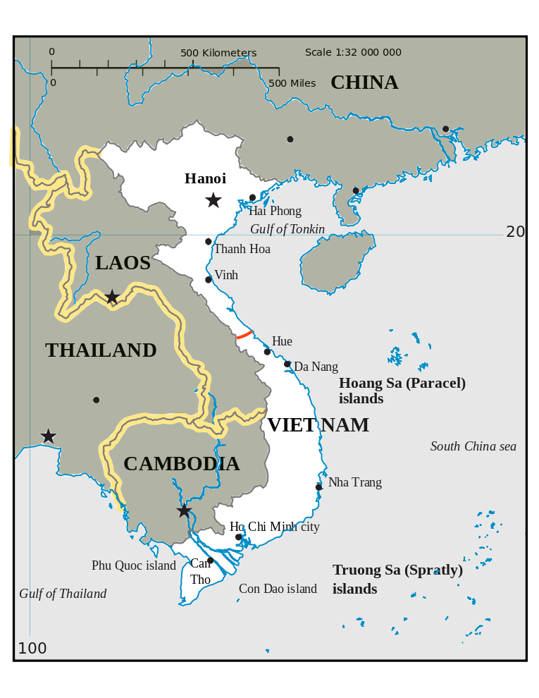
The origins of American involvement in Vietnam date back to the end of the Second World War, when the Vietnamese were struggling against the continued French colonial presence in their country. Ho Chi Minh, the leader of the Viet Minh (Vietnamese Independence League) and the founder of Vietnam’s Communist Party, successfully blended nationalist, anti-French sentiment with Marxist-Leninist revolutionary ideology. In 1954, after a prolonged guerrilla war to liberate Vietnam, the Viet Minh captured Dien Bien Phu, and decisively routed the French.

Map of Vietnam. The red line indicates the separation between North and South Vietnam following the peace negotiations in Geneva in 1954. Before the country was unified under the North Vietnamese government in 1975, Ho Chi Minh City was named Saigon. Map of Vietnam adapted from Wikimedia Commons.

In peace negotiations at Geneva, the decision was reached to divide Vietnam into northern and southern halves. The communists, headed by Ho Chi Minh, would govern the northern half, with its capital at Hanoi, while South Vietnam, with its capital at Saigon, would remain non-communist. The Soviet Union and the People’s Republic of China supported the north, while the United States was determined to maintain an independent, non-communist South Vietnam.

In December 1960, the National Liberation Front, commonly called the Viet Cong, emerged to challenge the South Vietnamese government. A civil war erupted for control of South Vietnam, while Hanoi sought to unite the country under its own communist leadership. The Second Indochina War began in earnest with the US commitment to prevent the communists from overrunning South Vietnam. In spring 1961, the administration of John F. Kennedy expanded US support for the South Vietnamese government, including an increase in US military advisers, the doubling of military assistance, and authorization of the use of napalm, herbicides, and defoliants.
The escalating US involvement in Southeast Asia was driven by the logic of the domino theory, which contended that the falling of one country to communism would result in other surrounding countries succumbing to communism, much as one toppled domino will take down others in a row. The containment strategy, laid out by George Kennan in the Long Telegram, dictated that the United States do everything in its power to prevent the spread of communism. US officials believed that if South Vietnam fell to communism, so would the surrounding countries of Indonesia, Thailand, Burma, Malaysia, Laos, and Cambodia.

Lyndon Johnson and the war in Vietnam
In August 1964, two North Vietnamese torpedo boats attacked US destroyers in the Gulf of Tonkin. President Lyndon Johnson requested authorization from Congress for the use of military force, resulting in the Gulf of Tonkin resolution, which laid the groundwork for the full-scale US military commitment to Vietnam. The resolution declared the support of Congress for “all necessary measures to repel any armed attack against the armed forces of the United States and to prevent further aggression.”

In 1965, Johnson dramatically escalated US involvement in the war. He authorized a series of bombing campaigns, most notably Operation Rolling Thunder, and also committed hundreds of thousands of US ground troops to the fight. Fearful that the war would jeopardize his domestic agenda, Johnson concealed the extent of the military escalation from the American public.

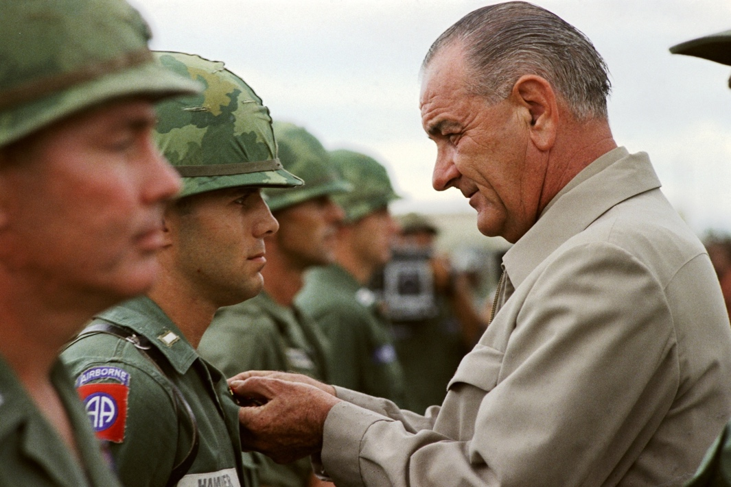
President Lyndon Johnson awards a medal to an American soldier during a visit to Vietnam in 1966. Image courtesy Wikimedia Commons.

The 1968 Tet Offensive, a bold North Vietnamese attack on the south, convinced many US officials that the war could not be won at a reasonable cost. Heightened opposition to the war was one of the major factors in Johnson’s decision not to run for re-election in 1968.

Richard Nixon and Vietnam
Richard Nixon campaigned for the presidency with a “secret plan” to end the war in Vietnam. Once in office, his administration sought to achieve “peace with honor.” Nixon ultimately expanded the war into neighboring Laos and Cambodia, while simultaneously encouraging the “Vietnamization” of the war effort, which entailed the gradual withdrawal of US troops and an increasing reliance on the South Vietnamese armed forces. By the end of 1969, the number of American troops in Vietnam had been cut in half.

The Paris Peace Accords established the terms according to which the last remaining US troops in Vietnam would be withdrawn. In 1975, the North Vietnamese finally achieved the objective of uniting the country under one communist government. The Socialist Republic of Vietnam was formally established on July 2, 1976, and Saigon was renamed Ho Chi Minh City. Though the outcome of the war was a clear defeat for the United States, the countries surrounding Vietnam did not subsequently fall to communism, demonstrating the flawed reasoning of the domino theory.

The war in Vietnam had lasting consequences for US foreign policy. Congress passed the War Powers Act in 1973, in a clear attempt to reassert a measure of control over the making of foreign policy and to impose constraints on presidential power. For well over a decade, American public opinion was hostile to the idea of foreign interventions. This was known as the “Vietnam syndrome,” and it entailed an unwillingness to become bogged down in foreign wars in which American national security interests were unclear.

Section 5- The Antiwar Movement and the Election of 1968
Origins of the student movement
The student movement arose at the University of California at Berkeley in 1964, when students involved in civil rights activism chafed at the university’s sudden attempt to prevent them from organizing politically on campus. The Free Speech Movement arose to challenge the university’s restrictions on political speech and assembly.

Soon, other student groups were springing up across the nation with similar demands. Students for a Democratic Society (SDS) formed at the University of Michigan and issued the Port Huron Statement, which criticized US foreign policy and attacked the Cold War assumptions underlying it.

Some of these student groups became a major part of the New Left, a broad-based political movement that challenged existing forms of authority, while others embraced a counterculture that promoted sexual liberation and unabashed drug use.
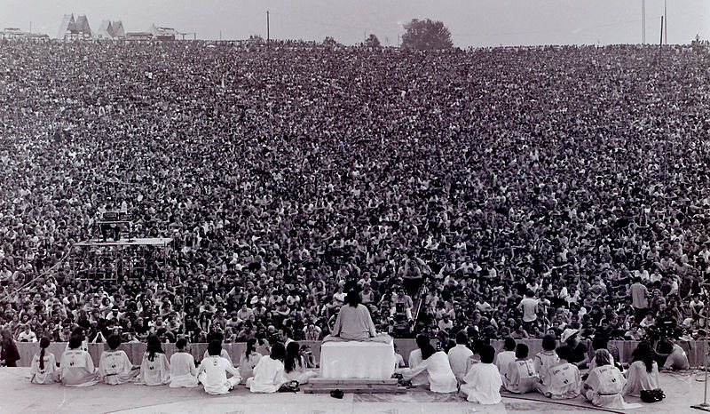
Black and white photograph, taken from the stage, showing Swami Satchidananda addressing a crowd of thousands at Woodstock.
Swami Satchidananda giving the invocation at the opening ceremony of Woodstock, a three-day-long music festival held in August 1969 on a farm in upstate New York. 400,000 people attended the festival, which featured popular performing artists like Joan Baez, Jimi Hendrix, and The Who. Image courtesy Mark Goff.

Vietnam and the rise of the antiwar movement
As the US involvement in the Vietnam War intensified, so did antiwar sentiment. Especially after 1965, when President Lyndon Johnson dramatically escalated the US troop presence and bombing campaigns in Vietnam, the war became the focal point for student political activism.

Student groups held protests and demonstrations, burned draft cards, and chanted slogans like “Hey, hey LBJ, how many kids did you kill today?” Massive US spending on the war effort contributed to skyrocketing deficits and deteriorating economic conditions at home, which turned more segments of the American public, including religious groups, civil rights organizations, and eventually even some Vietnam veterans, against the war.

Although antiwar activism constrained the president’s ability to further escalate the war effort after 1965, it also lent credence to the conservative portrayal of a chaotic society desperately in need of “law and order.”

In 1968, Richard Nixon successfully campaigned for the presidency on the basis of such rhetoric, which implied a harsh approach to dealing with antiwar activists and other challengers of the status quo.

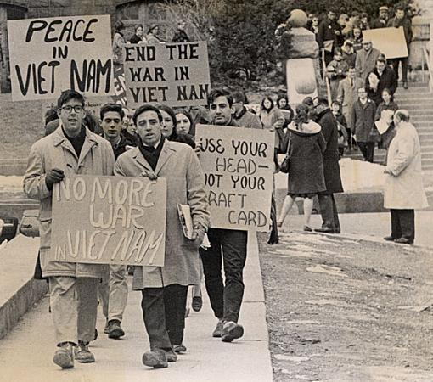
Black and white photograph showing a group of young men and women marching and carrying signs protesting the Vietnam War.
Students protesting the Vietnam War in 1965. Image courtesy Wikimedia Commons.

Once in office, Nixon attempted to quash domestic dissent by reducing the US troop presence in Vietnam and reforming the draft. The elimination of the draft and its replacement with an all-volunteer professional army was a major lasting consequence of the antiwar movement. At the same time, Nixon authorized the FBI and the CIA to expand their surveillance and harassment of antiwar protest groups.

The role of the media in the antiwar movement
The role of the news media in the antiwar movement increased both antiwar sentiment and hostility towards antiwar activists. As investigative journalists began digging into the official version of the US war effort, they began to uncover the truth of conditions in Southeast Asia. Graphic images of death and destruction displayed on the nightly news turned the American public ever more sharply against the war. At the same time, news media coverage was frequently hostile to the activists themselves, and thus contributed to the conservative backlash against the antiwar movement.

In 1971, the New York Times broke the story of the Pentagon Papers, a Department of Defense report that concluded that the Johnson and Nixon administrations had systematically lied to the American people and Congress about the extent of US involvement in the Vietnam war.

Together with the Watergate scandal, which involved Nixon’s authorization of the illegal wiretapping of his political enemies, the Pentagon Papers undermined the trust of the American people in its president and government.

1968: A momentous year
1968 was in many ways a watershed year. The Reverend Martin Luther King, Jr. was assassinated in Memphis, Tennessee by James Earl Ray, an ex-convict and avowed white supremacist. The news of King’s assassination sparked a conflagration of urban riots and protests.

A mere two months later, Robert F. Kennedy, the younger brother of President John F. Kennedy who was campaigning for the Democratic presidential nomination in California, was assassinated by Sirhan Sirhan, a Palestinian incensed by Kennedy’s pro-Israel stance. The assassinations contributed to the perception among many Americans that the social fabric of the nation was ripping apart.

The Democratic Party in disarray
The 1968 Democratic National Convention in Chicago was a stark demonstration of just how divided the Democratic party had become. Students and members of the counterculture, known collectively as the “New Left” made up one faction, while the older generation of New Deal Democrats, which became known as the “Old Left,” constituted another. The convention descended into utter chaos as thousands of antiwar activists converged on the streets of Chicago, where law enforcement officers clubbed them with nightsticks and doused them in tear gas.
Dismayed with the lack of progress in the Vietnam War and disturbed by the factionalism rupturing the Democratic Party, Lyndon Johnson chose not to run for reelection. The Democratic National Convention nominated Johnson’s vice president, Hubert Humphrey. He ran in a three-way race against Republican Richard Nixon and Alabama Governor George Wallace, a Southern segregationist who ran as an independent and sought to capitalize on white backlash against the gains of the Civil Rights Movement.

Richard Nixon’s presidential campaign
Into the chaos of 1968 stepped Richard Nixon with a pledge to restore law and order, end the war in Vietnam, and restore traditional American values. Richard Nixon’s 1968 presidential campaign was notable for a number of reasons. He emphasized the theme of “law and order,” which he understood would appeal to the “silent majority,” those white middle-class Americans anxious and fearful of radical social change. Nixon used “law and order” rhetoric to signal his intention to crack down on student protesters, activists, and virtually anyone who sought to challenge the status quo of American society.

Nixon also embraced the “Southern strategy,” which sought to appeal to Southern racists resentful of civil rights gains and President Johnson’s federal antipoverty programs.
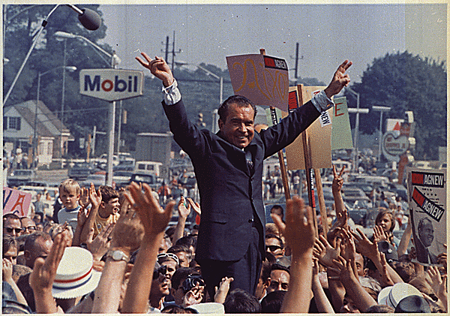
Photograph of Richard Nixon holding up his arms and making "V for Victory" symbols with his hands amidst a large crowd of people.
Campaign rally for Richard Nixon in 1968. Image courtesy Wikimedia Commons.
Nixon won the presidency in a close race, garnering 43.4 percent of the popular vote compared to Humphrey’s 42.7 percent. For an independent candidate, George Wallace made a strong showing, securing 13.5 percent of the popular vote.

The 1968 election inaugurated a conservative shift in American politics. Apart from the one-term presidency of Jimmy Carter, Republicans would dominate the White House until the election of Democrat Bill Clinton in 1992.

Section 6- Feminism

From the Civil Rights Movement to Women's Liberation
In the 1950s and 1960s, the Civil Rights Movement was creating a climate of protest as activists claimed rights and new positions in society for people of color. Women filled significant roles in organizations fighting for civil rights like the Student National Coordinating Committee (SNCC) and Students for a Democratic Society (SDS). However, women often found that those organizations—enlightened as they might have been about racial issues or the war in Vietnam—could still be influenced by patriarchal ideas of male superiority.

Two members of SNCC, Casey Hayden and Mary King, presented some of their concerns about their organization’s treatment of women in a document entitled “On the Position of Women in SNCC,” which argued that SNCC practiced discrimination against women similar to the discrimination practiced against African Americans by whites. Stokely Carmichael, field organizer and future chairman of SNCC, responded that the appropriate position for women in the movement was “prone.”

Nevertheless, the Civil Rights Movement contributed materially to women's rights. The Civil Rights Act of 1964, which prohibited discrimination in employment on the basis of race, color, national origin, and religion, also prohibited discrimination on the basis of sex in Title VII. Ironically, protection for women had been included at the suggestion of a Virginia congressman in an attempt to prevent the act’s passage; his reasoning seemed to be that, while a white man might accept that African Americans needed and deserved protection from discrimination, the idea that women deserved equality with men would be far too radical for any of his male colleagues to contemplate. Nevertheless, the act passed, granting broad workplace protections to women and minorities.

The Feminine Mystique and NOW
Just as the abolitionist movement made nineteenth-century women more aware of their lack of power and encouraged them to form the first women’s rights movement--sometimes called first-wave feminism--the protest movements of the 1960s inspired many white and middle-class women to create their own organized movement for greater rights--known as second-wave feminism. Many were older, married women who found the traditional roles of housewife and mother unfulfilling.

In 1963, writer and feminist Betty Friedan published The Feminine Mystique, a nonfiction book in which she contested the post-World War II belief that it was women’s destiny to marry and bear children. Friedan’s book was a best-seller and began to raise the consciousness of many women who agreed that homemaking in the suburbs sapped them of their individualism and left them unsatisfied.
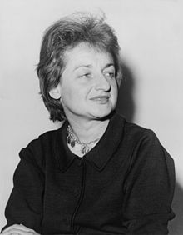
Photograph of Betty Friedan.
Betty Friedan was the author of The Feminine Mystique, a book that critiqued the popular 1950s notion that a woman's highest satisfaction was to be found in life as a homemaker. Friedan went out to become the first president of the National Organization for Women.

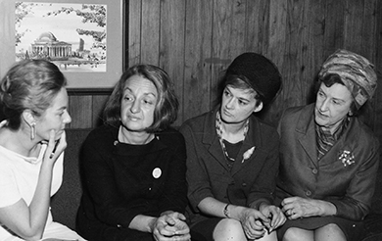
In 1966, the National Organization for Women (NOW), formed and proceeded to set an agenda for the feminist movement. Framed by a statement of purpose written by Friedan, the agenda began by proclaiming NOW’s goal to make possible women’s participation in all aspects of American life and to gain for them all the rights enjoyed by men. Among the specific goals set was the passage of the Equal Rights Amendment (ERA), a proposed Constitutional Amendment guaranteeing equal rights for women. First introduced in Congress in 1923, the ERA was passed in 1972 but failed to receive the 38 state ratifications necessary to become part of the Constitution. It has yet to be adopted today.

A photograph shows Betty Friedan and three other women engaged in conversation.
Early members of NOW discuss the problems faced by American women. Betty Friedan is second from the left. Image credit: Smithsonian Institution Archives

The Pill
Medical science also contributed a tool to assist women in their liberation. In 1960, the US Food and Drug Administration approved the birth control pill, freeing women from the restrictions of pregnancy and childbearing. Women who were able to limit, delay, and prevent reproduction were freer to work, attend college, and delay marriage. Within five years of the pill’s approval, some six million women were using it.

The pill was the first medicine ever intended to be taken by people who were not sick. Even conservatives saw it as a possible means of making marriages stronger by removing the fear of an unwanted pregnancy and improving the health of women. Its opponents, however, argued that it would promote sexual promiscuity, undermine the institutions of marriage and the family, and destroy the moral code of the nation. By the early 1960s, 30 states had made it a criminal offense to sell contraceptive devices.

Radical feminism
More radical feminists, like their colleagues in other movements, were dissatisfied with merely redressing economic issues. They devised their own brand of consciousness-raising events and symbolic attacks on women’s oppression.

The most famous of these was an event staged in September 1968 by New York Radical Women. Protesting stereotypical notions of femininity and rejecting traditional gender expectations, the group demonstrated at the Miss America Pageant in Atlantic City, New Jersey, to bring attention to the contest’s—and society’s—exploitation of women. The protestors crowned a sheep Miss America and then tossed instruments of women’s oppression, including high-heeled shoes, curlers, girdles, and bras, into a “freedom trash can.” News accounts famously, and incorrectly, described the protest as a “bra burning."

