1970’s America
Section 1- Nixon as President
Richard Nixon, the politician's politician
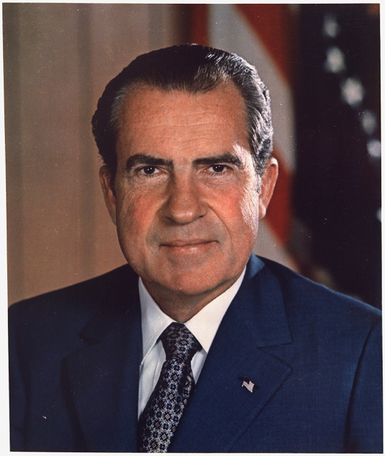
Richard M. Nixon was a career politician, whose all-consuming passion was getting and holding onto power. As one historian put it, "Political maneuvering was the great game of Richard Nixon's life. He played it grimly and with pride in his expertise at it. He had no other hobbies."

A native Californian, Nixon had been vice president to Republican Dwight D. Eisenhower from 1952-1960, but he had lost his first crack at winning the presidency in 1960 to the youthful and charming John F. Kennedy.

Official White House portrait of Richard Nixon.
Richard M. Nixon served as President of the United States from 1968-1974. Image courtesy Wikimedia Commons.

Eight years later, with the Democratic Party in disarray amidst the quagmire of Vietnam, Nixon had a second chance at the highest office in the land. He won the election of 1968 against the uninspiring Democratic challenger Hubert Humphrey, but Democrats still controlled both houses of Congress. Although Nixon was no fan of the Democratic social programs that had taken root during Johnson's presidency, he initially did little to roll them back, choosing to spend what political capital he had on achieving his vision for US foreign policy.

Thus, Nixon focused his attentions mainly outside of the United States, promising that he would bring "peace with honor" after years of bloodshed in Vietnam.

Nixon and Vietnam
During the election of 1968, Nixon had promised he had a "secret plan" to get the United States out of Vietnam. His plan turned out to be twofold: first, the United States would undertake a plan of Vietnamization, slowly replacing the more than 500,000 American soldiers on the ground with South Vietnamese soldiers. Second, the United States would carry the war into the neighboring country of Cambodia, which was officially neutral but had served as a conduit for North Vietnamese and Viet Cong troops.

The American people were hardly enthusiastic about either of these plans; by that time, the war in Vietnam was so unpopular that any course of action other than an immediate end to the conflict was greeted with hostility. Although Vietnamization did reduce the number of American troops in Vietnam to just 50,000 by 1973, it brought morale among the remaining soldiers to the lowest point yet as their reason for fighting became even more uncertain. The incursion into Cambodia set off a wave of protests around the nation and on university campuses in particular. In Ohio, the governor called out the National Guard to put down riots at Kent State University. The guards shot and killed four young people and wounded nine others on May 4, 1970, in an incident that sparked rage across the nation.

Nixon's administration negotiated a ceasefire in Vietnam in 1973, but gained few key concessions. In 1975, the North Vietnamese succeeded in conquering the southern capital, achieving their war aims of uniting Vietnam under a communist government. The cause for which so many Americans had fought and lost their lives was lost.

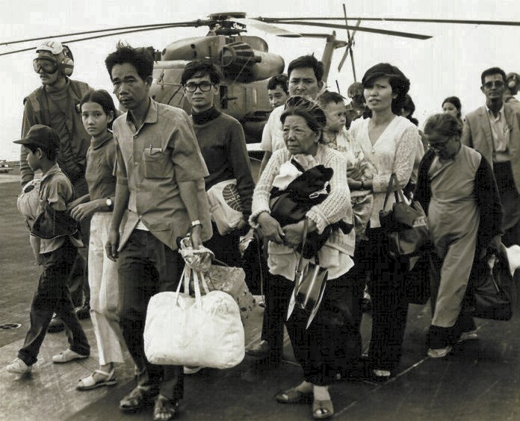
A group of South Vietnamese citizens, including children, adults, and the elderly, carries their meager belongings on the deck of a US carrier. An American man in military uniform and a helicopter are in the background.
South Vietnamese citizens being evacuated by the American military after the fall of Saigon, April 1975. Image courtesy Wikimedia Commons.

Nixon's foreign policy
Despite the debacle in Vietnam, Nixon did achieve a few key foreign policy victories during his time in office. Notably, Nixon reopened the American diplomatic relationship with the People's Republic of China, which the United States had refused to recognize since its communist revolution in 1949. The president and first lady Pat Nixon took a two-week-long public relations trip to China in 1972.

Astutely judging that a closer US relationship with China would make the Soviet Union very anxious, Nixon took a trip to the USSR shortly thereafter. He and Soviet Premier Leonid Brezhnev agreed to a policy of détente (relaxed tensions between the two nations) and signed the Strategic Arms Limitation Treaty (SALT), reducing the number of nuclear missiles in their arsenals.

Domestic policy under Nixon
With Democrats dominating both the House and the Senate, legislation in the early 1970s looked a lot like legislation in the 1960s. Spending for social programs actually increased in the first years of Nixon's presidency, with expansions to Social Security, increases in food stamps and Medicaid benefits, and new funding for the arts and for cancer research. During these years, Congress established the Environmental Protection Agency to combat pollution, as well as protections for female university students in Title IX.

Although Nixon hoped that appointing right-leaning Supreme Court Justices like Warren Burger and William Rehnquist would counteract the liberal rulings of the 1950s and 1960s, the increasing conservative court largely upheld earlier decisions and even ruled that abortion was a private matter between a woman and her doctor in the landmark Roe v. Wade case. The Burger court had a mixed record on racial issues, however, extending affirmative action protections but ruling against busing students to combat de facto segregation.

Economically, Nixon tried and failed to cope with the growing issue of stagflation, an unprecedented combination of wage stagnation and price inflation. In 1971, Nixon announced a ninety day wage and price freeze, and in a bid to increase American exports he took the dollar off the gold standard. Neither of these solutions did much to resuscitate the struggling American economy.

Nixon's fall from grace
A secretive and paranoid man, Nixon believed everyone was plotting against him. In reality, he was his own worst enemy. In 1972, allegations emerged that Nixon loyalists had wiretapped the Democratic National Committee office in Washington's Watergate building in order to spy on Democratic nominee George McGovern. Tapes of Nixon's conversations in the Oval Office revealed that he had forbidden the FBI from investigating the incident, a clear obstruction of justice. Facing impeachment, Nixon resigned in 1974. He was succeeded by Vice President Gerald Ford, who immediately pardoned Nixon on all charges.
Section 2- Watergate
Nixon
Richard Nixon had not clawed his way up to the presidency without scratching a few people along the way. From early in his career, Nixon had made an art of employing "dirty tricks" to win elections, and by the time he made it into the White House he had many enemies. After a military analyst leaked the Pentagon Papers—documents that revealed that the US government had lied to Congress and the American people about the scope of the Vietnam War—Nixon became obsessed with maintaining secrecy in his administration. He employed a group of aides that he called "plumbers" in order to plug any further leaks.

The plumbers helped Nixon's fundraising organization, the Committee to Re-elect the President (CREEP), with a series of illegal activities aimed at maintaining the president's power and harassing individuals on an internally-circulated "enemy list." CREEP and the plumbers undertook a variety of dirty tricks during the election of 1972, including but not limited to forging documents that might incriminate or embarrass Democratic opponents, conducting illegal surveillance, breaking into a psychiatrist's office in order to steal information to discredit a political enemy, placing spies undercover in Democratic campaigns and press corps, and renting facilities and ordering campaign supplies in the name of Democratic challengers and sticking them with the bill.

The Watergate break-in
CREEP eventually made a fatal blunder. On June 17, 1972, a security guard caught a group of five "burglars" in Washington, DC's Watergate office complex, home of the Democratic National Committee (DNC) headquarters. The incident seemed fairly innocuous until the FBI discovered that the burglars had ties with the CIA. Over time, it became clear that the burglary was in fact a botched attempt at wiretapping the phones at the DNC headquarters in order to spy on the presidential campaign of George McGovern.
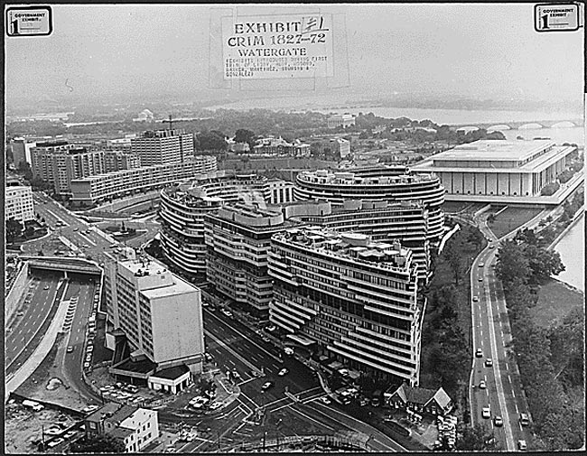
Black and white photograph of the Watergate office complex.
The Watergate office complex in Washington, DC. Image courtesy the Gerald Ford Library and Museum.

During the election of 1972, McGovern accused Nixon and the Republicans of breaking in to his office, but at that time there was little solid information tying the men involved with the break-in to the president. Nixon won the election handily, with 520 electoral votes compared to McGovern's 17.

By early 1973, however, the truth was beginning to trickle out. Bob Woodward and Carl Bernstein, reporters for the Washington Post, had reported on the Watergate story since the break-in. They received tips from a highly-placed anonymous source known only as Deep Throat (revealed in 2005 to have been FBI Deputy Director Mark Felt) and kept the story alive by publishing their research into the break-in and alleged cover-up.

Although several of the Watergate burglars cracked and pointed fingers at Nixon in their testimony before the Senate Judiciary Committee, there was no hard evidence connecting the president to any wrongdoing on the part of his subordinates. Perhaps the investigation would have ground to a halt had the existence of a voice-recording device in the Oval Office not emerged: all of Nixon's conversations had been taped. The Senate Judiciary Committee subpoenaed the tapes.
Denial and "executive privilege"
Nixon refused to hand over the tapes, citing "executive privilege," or the right of the president not to respond to certain subpoenas or reveal confidential White House information. After the revelations from the Pentagon Papers that the president secretly had carried the Vietnam War into the neighboring countries of Cambodia and Laos, it began to seem as though Nixon believed he was above the law. His administration was further compromised when Vice President Spiro Agnew was forced to resign after federal prosecutors charged him with taking bribes. Nixon appointed Gerald Ford as Agnew's successor.

In July 1974, the House Judiciary Committee recommended that the House of Representatives impeach Nixon for obstruction of justice and abuse of power. Nixon finally handed over the tapes after a Supreme Court order in August 1974.

Revelations and resignation
The tapes confirmed that Nixon had been involved in covering up the Watergate affair; in what has been called the "smoking gun" tape, Nixon ordered the FBI not to investigate the break-in any further, a clear obstruction of justice.

A "smoking gun" is a trope in mystery and crime stories that indicates a clear and undeniable piece of evidence proving that an individual has committed a crime, for example holding a smoking gun after a shot has been fired.

On August 8, 1974 Nixon resigned rather than face impeachment. His successor, Gerald Ford, immediately pardoned Nixon for all crimes, discovered and undiscovered. Ford became the first and only person to have served as both vice president and president of the United States without having been elected to either office. Ford's connection with the disgraced Nixon ensured that he would not be elected to a second term.

The Pentagon Papers, the Watergate scandal and Nixon's subsequent fall from grace contributed to a growing sense in the United States that the government was unprincipled and untrustworthy. The power of the executive branch had grown steadily over the course of the 1960s and early 1970s, but Nixon stretched it too far. By impeaching Nixon, Congress demonstrated that the system of checks and balances between the branches of the government still performed its function.

Nevertheless, Watergate was yet another grim chapter in a grim era of US history. Between 1968 and 1975, the United States had witnessed the assassinations of Martin Luther King, Jr. and Robert F. Kennedy, learned that US soldiers had murdered innocent women and children in Vietnam during the My Lai Massacre, endured rising oil prices and a stagnating economy, watched as their president was exposed as a liar and a criminal, and lost the cause they had fought for in Vietnam. Little wonder that the suffix -gate has remained in the American vernacular to indicate scandal and conspiracy.

Section 3- Stagflation and the Oil Crisis
Economic woes of the 1970s
During the twenty-five years after World War II, the economic power of the United States was unparalleled. Indeed, contemporary observers commented that the postwar United States was in the midst of "the greatest prosperity the world has ever known."

The American gross national product (GNP), a measure of all goods and services produced by a country's citizens, increased from $200,000-million in 1940 to more than $500,000-million in 1960 to nearly a trillion dollars by 1970. Thanks to this, the American standard of living had doubled between 1945 and 1970. With just six percent of the world's population, the United States enjoyed 40% of the world's wealth.

But troubling signs began to emerge in the late 1960s. Unemployment rose by 33% between 1968 and 1970, while the consumer price index went up by 11%. At the same time, real wages began to stagnate. Simultaneous inflation and stagnation, nicknamed stagflation, puzzled economic analysts: usually, when wages fell, prices fell, and when wages increased, prices increased. But not in the 1970s. As a result, Americans had less purchasing power, and increasingly expensive American exports were at a disadvantage in the international market. In 1971, the United States experienced its first unfavorable international trade balance since 1893.

What caused this slump? The massive cost of the war in Vietnam and the expansion of social programs at home without commensurate tax increases helped to drive inflation (the price of goods and services). Meanwhile, US manufacturing (especially automotive manufacturing) had become less competitive over time compared to efficient overseas rivals, particularly in Germany and Japan. More and more American jobs were in the service sector, which had lower wages and fewer benefits than manufacturing jobs. Individuals born on the tail end of the baby boom found themselves competing in a very crowded labor market, especially as more women and immigrants entered the workforce.

The oil embargo
In 1971, Richard Nixon attempted to remedy inflation by imposing a 90-day wage and price freeze. At the same time, he attempted to boost American exports by taking the dollar off the gold standard, devaluing the currency. These measures resulted in a short-term improvement (just long enough to get Nixon reelected in 1972) but did nothing to address the tangled roots of the problem.

Then the energy crisis hit. In October 1973, the United States supported Israel after a surprise attack by Egypt and Syria in the Yom Kippur War. The oil-rich nations of the Middle East, already angry with the United States for devaluing the dollar (the currency used to purchase oil) determined to exact their revenge with an oil embargo. Led by Saudi Arabia, the Organization of the Petroleum Exporting Countries (OPEC) announced an oil shipping embargo against the United States as well as Israel's European allies.

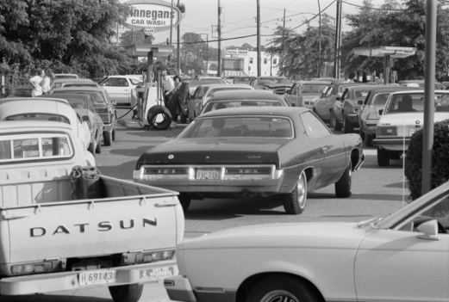
The effects were immediate and dire. The price of oil shot up to $11.65 per barrel, an increase of 387%. Lines miles-long formed at gas stations. The United States consumed one third of the world's oil, and its citizens quickly discovered just how much of daily life depended on cheap oil. Families living in far-flung suburbs depended on automobiles to get everywhere. Even after the embargo ended in March 1974, prices for oil remained about 33% higher than they had been before the crisis.

Black and white photograph showing cars in line for gas.
Line at a gas station in 1979. Image courtesy Library of Congress Prints and Photographs Division.

The end of the postwar economic boom
Stagflation and the oil embargo both seemed to suggest that the American golden age that had followed on the heels of World War II was at an end. First Vietnam and then the Middle East had revealed the limits of US power abroad.

The complex forces which led to the downturn of the 1970s have continued to shape the American economy, particularly globalization (international interdependence of business and culture), which has accelerated as information technology has made communication and coordination easier. For example, many companies have moved manufacturing jobs out of the United States in order to save on labor costs. Today, 80% of all American jobs are in the service industry.

Since the oil embargo, the United States also has worked to reduce its dependence on foreign oil through a variety of means, including reducing energy usage, improving vehicle fuel-efficiency, investing in renewable energy, and increasing domestic oil production.

The quarter century after World War II was a time of incredible growth in the United States which produced the richest nation in human history, as well as a sense of unbridled optimism about the future. By the early 1970s, that chapter of the American adventure had ended. A new, altogether more uncertain era had begun.

Section 4- Liberation Movements of the 70’s
Identity politics in a fractured society
The political divisions that plagued the United States in the 1960s were reflected in the rise of identity politics in the 1970s. As people lost hope of reuniting as a society with common interests and goals, many focused on issues of significance to the subgroups to which they belonged, based on culture, ethnicity, sexual orientation, gender, and religion.

American Indian protest
During this period, many Native Americans were seeking to maintain their culture or retrieve cultural elements that had been lost. In 1968, a group of Native American activists, including Dennis Banks, George Mitchell, and Clyde Bellecourt, convened a gathering of two hundred people in Minneapolis, Minnesota, and formed the American Indian Movement, or AIM.

The organizers were urban dwellers frustrated by decades of poverty and discrimination. In 1970, the average life expectancy for a Native American person was 46 years compared to the national average of 69. The Native American suicide rate was twice that of the general population, and the infant mortality rate was the highest in the country. Half of all Native Americans lived on reservations, where unemployment reached 50 percent. Of Native Americans living in cities, 20 percent lived below the poverty line.
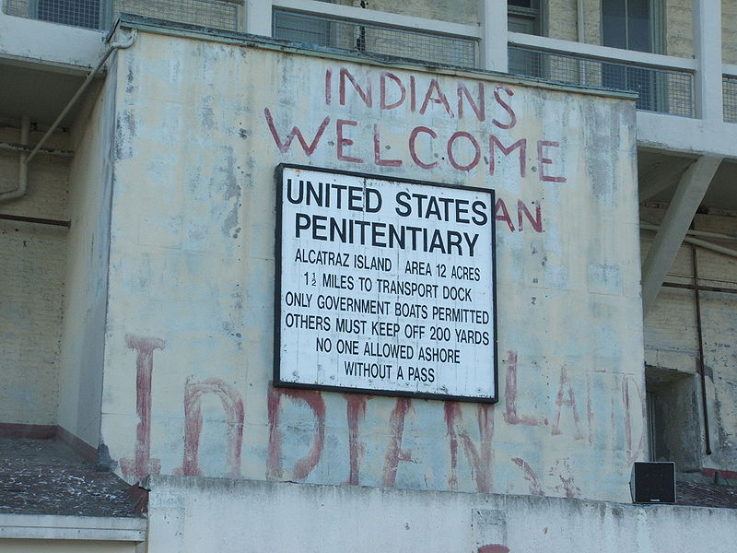
On November 20, 1969, a small group of Native American activists landed on Alcatraz Island—the former site of a notorious federal prison—in San Francisco Bay. They announced plans to build an American Indian cultural center, including a history museum, an ecology center, and a spiritual sanctuary. People on the mainland provided supplies by boat, and celebrities visited Alcatraz to publicize the cause. More people joined the occupiers until, at one point, they numbered about four hundred.

Photograph of a wall at Alcatraz Island featuring a notice that it is a United States penitentiary. Graffiti on the wall says: "Indians Welcome" and "Indian Land."
Photograph of graffiti on Alcatraz Island proclaiming 'Indians Welcome' and 'Indian Land.' Visitors to the island can still see the graffiti today. Image credit: Wikimedia Commons

From the beginning, the federal government negotiated with them to persuade them to leave. They were reluctant to give in, but over time, the occupiers began to drift away of their own accord. Government forces removed the final holdouts on June 11, 1971, 19 months after the occupation began.

The next major demonstration came in 1972 when AIM members and others marched on Washington, DC—a journey they called the Trail of Broken Treaties—and occupied the offices of the Bureau of Indian Affairs (BIA). The group presented a list of demands, which included improved housing, education, and economic opportunities in Native American communities; the drafting of new treaties; the return of Native American lands; and protections for native religions and culture.

The most dramatic event staged by AIM was the occupation of the Native American community of Wounded Knee, South Dakota, in February 1973. Wounded Knee, on the Pine Ridge Indian Reservation, had historical significance: it was the site of an 1890 massacre of members of the Lakota tribe by the US Army. The federal government surrounded the area with US marshals, FBI agents, and other law enforcement forces. A siege ensued that lasted 71 days. There was frequent gunfire from both sides; two Native Americans were killed and a US marshal as well as an FBI agent were wounded.

The government did very little to meet the protesters’ demands. Two AIM leaders, Dennis Banks and Russell Means, were arrested, but charges were later dismissed. The Nixon administration had already halted the federal policy of termination and restored millions of acres to tribes. Increased funding for Native American education, healthcare, legal services, housing, and economic development followed, along with the hiring of more Native American employees in the BIA.

Gay rights
During this era, the struggle for gay and lesbian rights intensified as well. Many gay rights groups were founded in Los Angeles and San Francisco. The first postwar organization for gay civil rights, the Mattachine Society, was launched in Los Angeles in 1950. The first national organization for lesbians, the Daughters of Bilitis, was founded in San Francisco five years later. In 1966, the city became home to the National Transsexual Counseling Unit, the world’s first organization for transgender people (transsexual is an older term that was used by doctors and psychologists to describe transgender people). In 1967, the Sexual Freedom League of San Francisco was born.

Through these organizations and others, gay, lesbian and transgender activists fought against the criminalization of and discrimination against their sexual and gender identities on a number of occasions throughout the 1960s. They employed strategies of both protests and litigation.

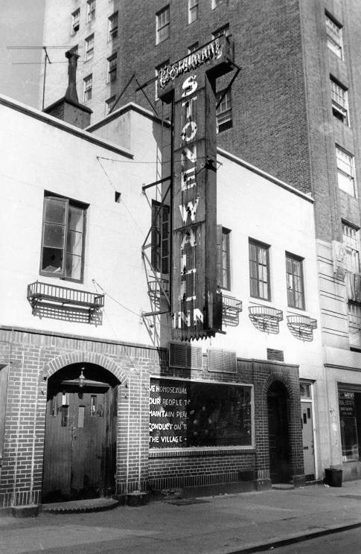
The most famous event in the gay rights movement, however, took place not in San Francisco but in New York City. Early in the morning of June 28, 1969, police raided a Greenwich Village gay bar called the Stonewall Inn. Although such raids were common, the response of the Stonewall patrons was anything but. As the police prepared to arrest many of the customers, especially transgender people and cross-dressers—who were particular targets for police harassment—a crowd began to gather. Angered by the brutal treatment of the prisoners, the crowd attacked. Beer bottles and bricks were thrown. The police barricaded themselves inside the bar and waited for reinforcements. The riot continued for several hours and resumed the following night. Shortly thereafter, the Gay Liberation Front and Gay Activists’ Alliance were formed; these organizations began to protest discrimination, homophobia, and violence against gay people, and promoted gay liberation and gay pride.

Photograph of the Stonewall Inn in 1969.
The Stonewall Inn in 1969. Image credit: Wikimedia Commons
As advocacy organizations called for gay men and lesbians to come out—reveal their sexual orientation—gay and lesbian communities moved from the urban underground into the political sphere. Gay rights activists protested strongly against the official position of the American Psychiatric Association, which categorized homosexuality as a mental illness. This classification often resulted in job loss, loss of custody, and other serious personal consequences for people in the LGBT—lesbian, gay, bisexual, and transgender—community. By 1974, the APA had ceased to classify homosexuality as a form of mental illness but continued to consider it a “sexual orientation disturbance.”

Nevertheless, in 1974, Kathy Kozachenko became the first openly lesbian woman voted into office in Ann Arbor, Michigan. In 1977, Harvey Milk became California’s first openly gay man elected to public office. His service on San Francisco’s board of supervisors, along with that of San Francisco mayor George Moscone, was tragically cut short by the bullet of disgruntled former city supervisor Dan White.

Women's liberation in the 1970s
The feminist push for greater rights continued through the 1970s. Feminists opened battered women’s shelters and successfully fought for protection from employment discrimination for pregnant women, reform of rape laws—such as the abolition of laws requiring a witness to corroborate a woman’s report of rape—criminalization of domestic violence, and funding for schools that sought to counter sexist stereotypes of women. In 1973, the US Supreme Court in Roe v. Wade affirmed a number of state laws under which abortions obtained during the first three months of pregnancy were legal. This made nontherapeutic abortion a legal medical procedure nationwide.
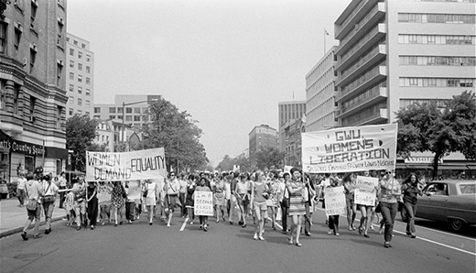
A photograph shows a protest march of women on a city street. Participants hold signs with messages such as “Women Demand Equality;” “I’m a Second Class Citizen;” and “GWU Women’s Liberation. Students Employees Faculty Wives Neighbors.”
In 1970, supporters of equal rights for women marched in Washington, DC. Image credit: OpenStax

Many advances in women’s rights were the result of women’s greater engagement in politics. For example, Patsy Mink, the first Asian American woman elected to Congress, was the coauthor of the Education Amendments Act of 1972, Title IX of which prohibits sex discrimination in education. Mink had been interested in fighting discrimination in education since her youth, when she opposed racial segregation in campus housing while a student at the University of Nebraska. She went to law school after being denied admission to medical school because of her gender. Like Mink, a number of other women sought and won political office, many with the help of the National Women’s Political Caucus, or NWPC. In 1971, the NWPC was formed by Bella Abzug, Gloria Steinem, Shirley Chisholm, and other leading feminists to encourage women’s participation in political parties, elect women to office, and raise money for their campaigns.

The ultimate political goal of the National Organization for Women, or NOW, was the passage of an Equal Rights Amendment, or ERA. The amendment passed Congress in March 1972, and was sent to the states for ratification with a deadline of seven years for passage; if the amendment was not ratified by 38 states by 1979, it would die. Twenty-two states ratified the ERA in 1972, and eight more ratified it in 1973. In the next two years, only four states voted for the amendment. In 1979, still four votes short, the amendment received a brief reprieve when Congress agreed to a three-year extension, but the amendment never passed due to the opposition of socially conservative grassroots organizations.
Section 5- The Presidency of Jimmy Carter
The election of Jimmy Carter
The election of 1976 fell on the bicentennial of the United States, but few people felt much like celebrating. The economy was in bad shape, and the Watergate scandal had eroded Americans' trust in their elected officials. Incumbent president Gerald Ford, who had ascended to the highest office in the land after Nixon's resignation, had little chance of retaining his position given his association with the disgraced ex-president.

Into this bleak political landscape stepped James Earl "Jimmy" Carter Jr., former peanut farmer and governor of Georgia. Carter was such a long shot at the start of the race that when he told his mother he planned to run for president, she asked, "President of what?" But strategic victories in early primaries led Carter to win the 1976 Democratic nomination, along with running mate Walter Mondale.
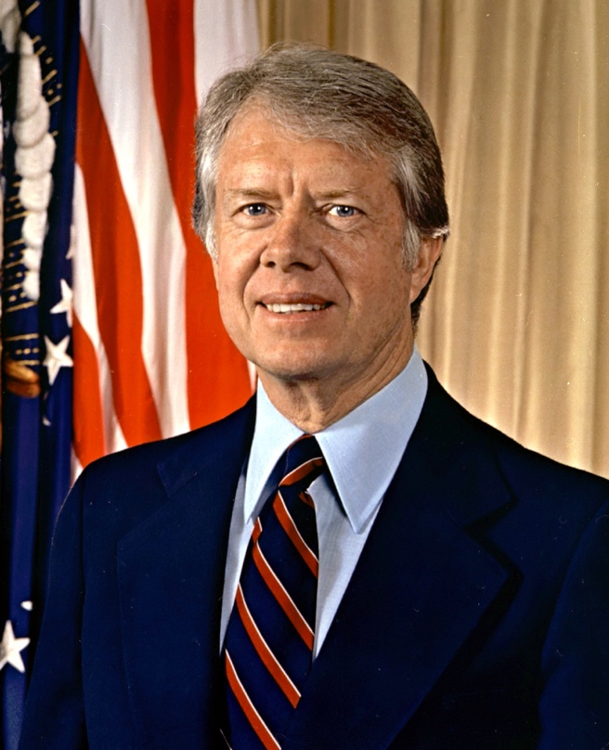
Photograph of President Jimmy Carter.
Official White House portrait of Jimmy Carter. Image courtesy National Archives.

Carter campaigned as a Washington outsider, a pious and forthright man who promised voters that he would never lie to them. His message resonated just enough to put him in office by a narrow margin, 50.1% of the popular vote to Ford's 48%.

The Carter years (1977-1981)
Carter, as a breath of fresh air after the Nixon and Ford years, enjoyed an initial burst of popularity in 1977, but his ratings slipped as it became increasingly clear that Carter was unwilling to work with Washington to achieve results. He surrounded himself with advisers from his native Georgia and refused to delegate any authority whatsoever: in the first six months of his presidency Carter even personally reviewed requests for use of the White House tennis court.

Carter crafted legislation packages concerning crucial fixes to the energy crisis and the economy in secret, and then rained them down upon an increasingly hostile Congress. As a fiscal conservative, he alienated the liberal wing of the Democratic party by refusing to spend much money to invigorate the economy or to fund social programs. He alienated conservatives by pardoning some 10,000 Vietnam War draft evaders, negotiating the return of control of the Panama Canal to Panama, resuming diplomatic relations with the People's Republic of China, and halting the construction of new nuclear weapons.

The economy continued to slump in the late 1970s. Inflation soared to a staggering 13% and gas shortages once again plagued the country after violence erupted in the Middle East. After cloistering himself with advisers for days in summer 1979 in order to determine a solution to these woes, Carter emerged offering nothing more than a highly-critical speech that blamed Americans for causing the present 'malaise' through a loss of moral virtue.

Foreign policy and the Iran Hostage Crisis
As a president deeply committed to human rights around the world, Carter achieved some victories in international relations. Significantly, Carter brought Israel's Menachem Begin and Egypt's Anwar Sadat together at the presidential retreat in Maryland to negotiate the Camp David Accords, which stipulated that Egypt would recognize the state of Israel in return for regaining control of the Sinai peninsula.

But elsewhere, things took a turn for the worse. US-Soviet relations, which seemed on the verge of a breakthrough when Carter and Soviet leader Leonid Brezhnev announced their agreement to a second Strategic Arms Limitation Treaty (SALT II), broke down yet again when the USSR invaded Afghanistan in 1979. Consequently, the US Senate never ratified SALT II, and the United States even boycotted the 1980 Summer Olympics in Moscow.

Meanwhile, the situation in the Middle East rapidly destabilized in January 1979 when followers of Ayatollah Ruhollah Khomeini overthrew Mohammed Reza Pahlevi, the shah of Iran. The shah had been installed as dictator with the help of the CIA in 1953, and Khomeini's Muslim fundamentalist followers sought to purge Iran of secular, Western influences.

In November 1979, Iranian militants seized the US Embassy in Tehran, taking 66 Americans hostage. They demanded that the United States return the shah (who had fled to New York for medical treatment) and his assets to Iran and issue an apology. Though 14 hostages were released within a few months of the siege, negotiations to free the 52 others dragged on for over a year. A complex rescue attempt failed, killing eight American soldiers in a helicopter crash. Finally, the United States agreed to pay the captors nearly $8 billion to end the hostage crisis. To add insult to injury, Ayatollah Khomeini did not release the hostages until January 20, 1981: Ronald Reagan's inauguration day.

Republican challenger Ronald Reagan defeated Carter in the presidential election of 1980, making him the first elected president to be unseated by the American people since Herbert Hoover in 1932.
Although Carter's years in office were rocky, his post-presidential career as a diplomat and human-rights advocate earned him the Nobel Peace Prize in 2002.

