The Civil Rights Movement: Beginnings

Section 1- Introduction to the Civil Rights Movement
The emergence of the Civil Rights Movement
The Civil Rights Movement did not suddenly appear out of nowhere in the twentieth century. Efforts to improve the quality of life for African Americans are as old as the United States. By the time of the American Revolution in the late eighteenth century, abolitionists were already working to eliminate racial injustice and bring an end to the institution of slavery.

During the Civil War, President Abraham Lincoln issued the Emancipation Proclamation, which was codified into law as the Thirteenth Amendment to the US Constitution. The Thirteenth Amendment officially outlawed slavery and went into effect in 1865.

After the Civil War, during the period known as Reconstruction, the passage of the Fourteenth and Fifteenth Amendments established a legal foundation for the political equality of African Americans. Despite the abolition of slavery and legal gains for African Americans, racial segregation known as Jim Crow arose in the South.

Jim Crow segregation meant that Southern blacks would continue to live in conditions of poverty and inequality, with white supremacists denying them their hard-won political rights and freedoms.
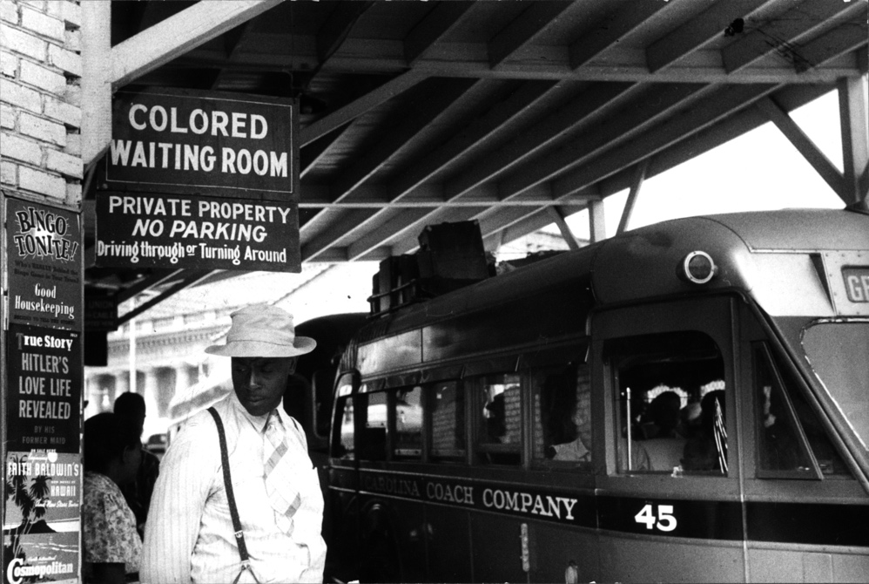
"Colored" waiting room at the Durham, North Carolina bus station, May 1940. Photograph by Jack Delano. Image courtesy Library of Congress.

The twentieth-century Civil Rights Movement emerged as a response to the unfulfilled promises of emancipation, partly as a result of the experiences of black soldiers in the Second World War. African Americans fought in a segregated military while being exposed to US propaganda emphasizing liberty, justice, and equality. After fighting in the name of democracy in other countries around the world, many African American veterans returned to the United States determined to achieve the rights and prerogatives of full citizenship.

The Civil Rights Movement involved many different strategies and approaches, including legal action, nonviolent civil disobedience, and black militancy.

Civil rights and the Supreme Court
One of the earliest approaches was centered in the courts. Spearheaded by the National Association for the Advancement of Colored People (NAACP), this strategy initiated lawsuits to undermine the legal foundation of Jim Crow segregation in the South. The landmark Brown v. Board of Education of Topeka ruling held that separate facilities were inherently unequal and thereby declared segregation in public education to be unconstitutional.

While the Supreme Court decision was a major victory for civil rights, white supremacists in the South pledged "massive resistance" to desegregation. In response to Brown v. Board, a group of Southern congressmen issued the “Southern manifesto,” denouncing the court’s decision and pledging to resist its enforcement. Ultimately, federal intervention was required to implement the ruling.

Nonviolent protest and civil disobedience
With authorities in the South actively resisting court orders to desegregate, some leaders of the Civil Rights Movement turned to direct action and nonviolent civil disobedience. Civil rights activists launched the Montgomery Bus Boycott in 1955, after Rosa Parks refused to vacate her seat on the bus for a white person. Martin Luther King, Jr. emerged as a leader of the boycott, which was the first mass direct action of the contemporary Civil Rights Movement and provided a template for the efforts of activists across the country.
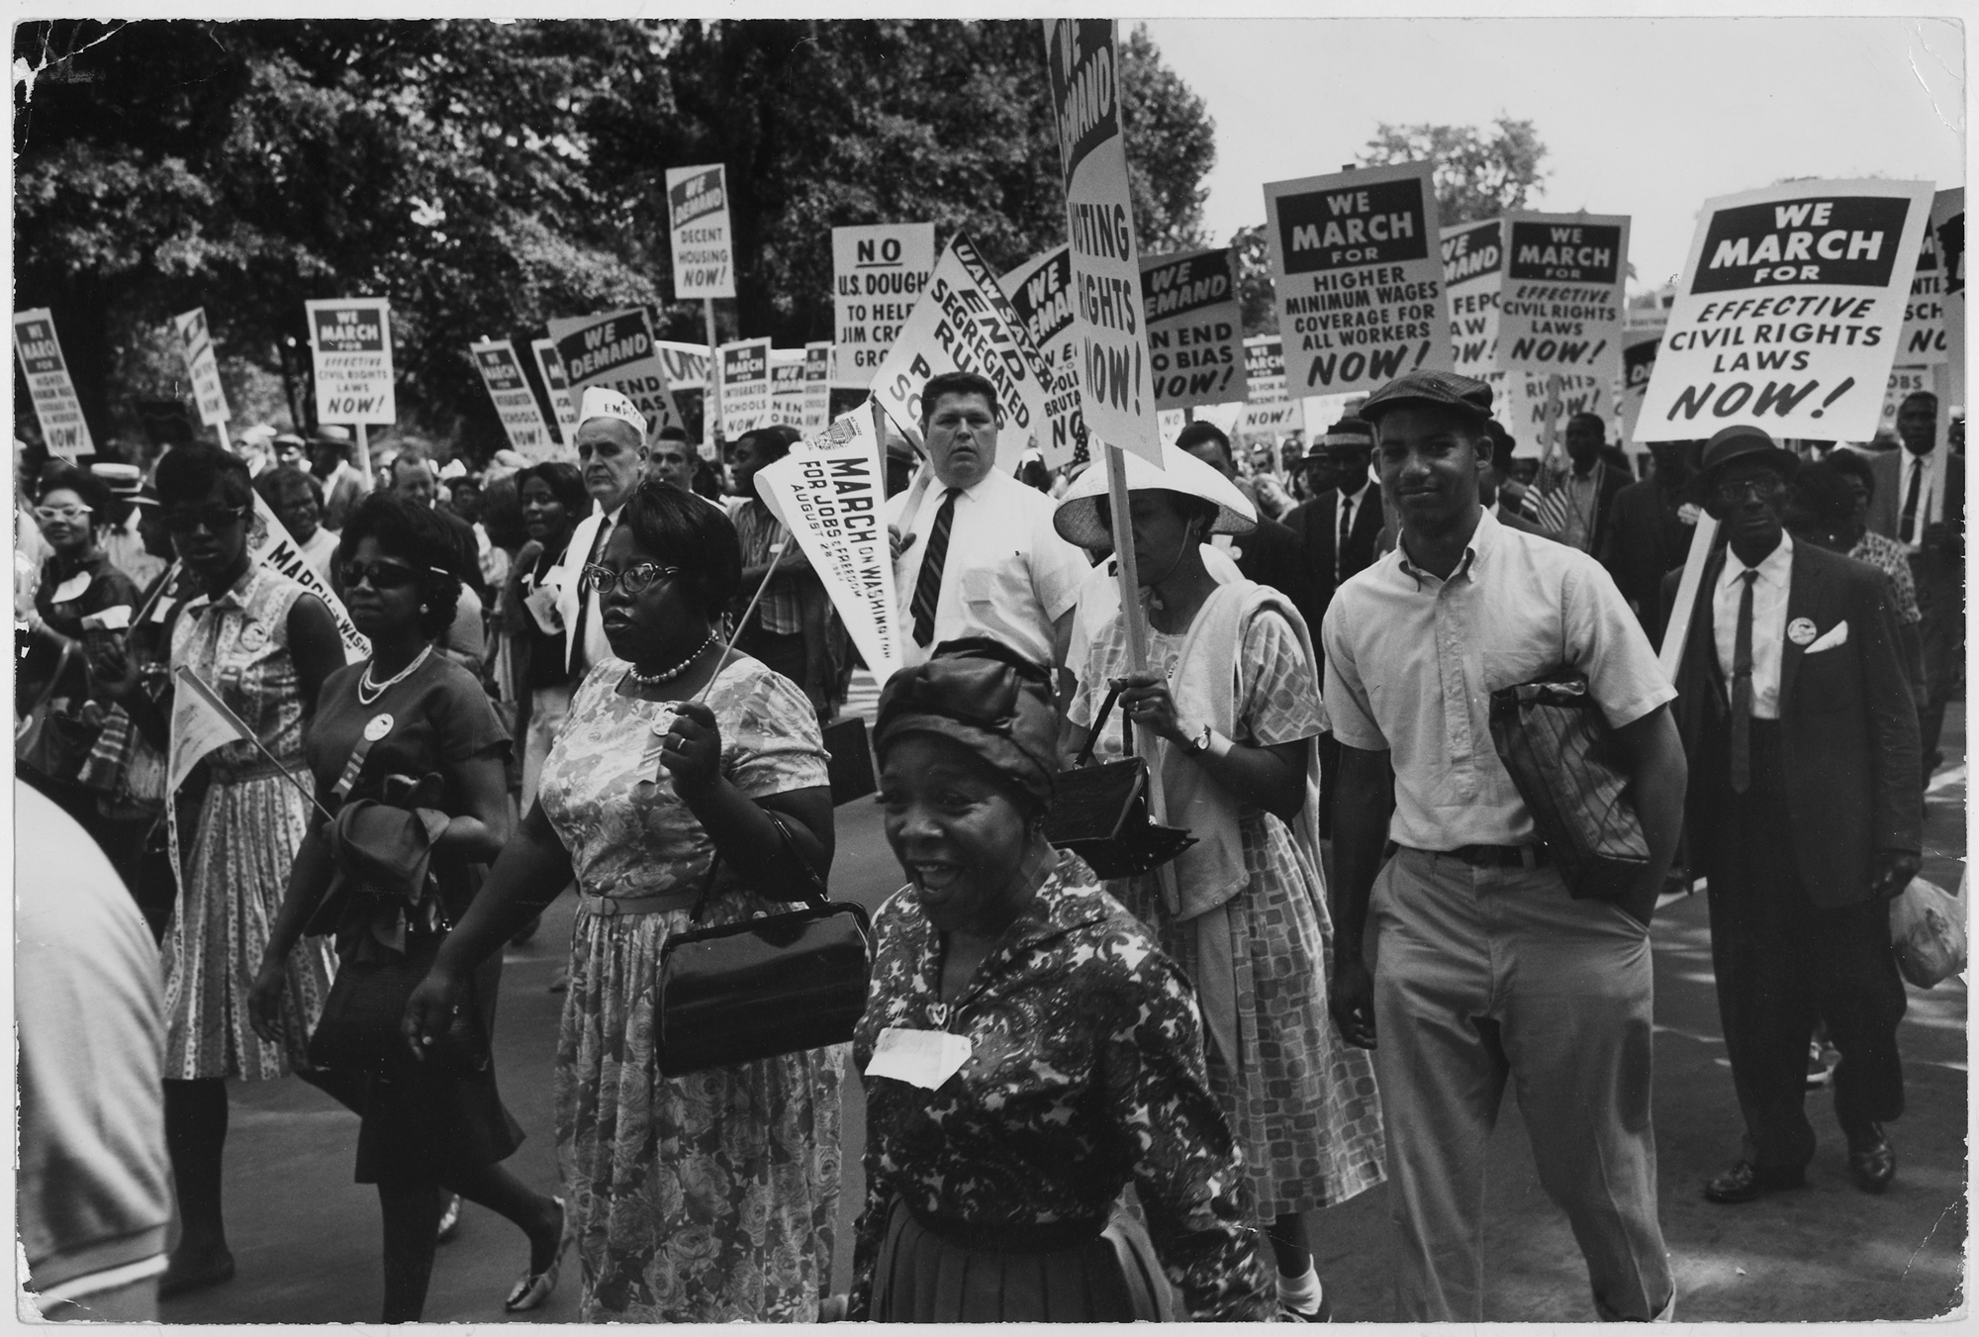
Protestors carrying signs at the March on Washington for Jobs and Freedom, 1963. Image courtesy the National Archives.

Religious groups such as the Southern Christian Leadership Conference (SCLC), student organizations like the Student Nonviolent Coordinating Committee (SNCC), and labor unions such as the American Federation of Labor (AFL-CIO), all took part in massive protests to raise awareness and to accelerate the momentum for passage of federal civil rights legislation. The March on Washington for Jobs and Freedom was the largest civil rights protest in US history, and contributed to the successful implementation of the Civil Rights Act of 1964 and the Voting Rights Act of 1965.

Mass direct action was highly effective, particularly due to widespread news media coverage of nonviolent protestors being harassed and physically beaten by law enforcement officers.

Black Power
Although comprehensive civil rights legislation represented a major victory for the Civil Rights Movement, the obstinacy of the white power structure in the South convinced some black activists that nonviolent civil disobedience was insufficient. Some African Americans were also concerned about the presence of so many northern middle-class whites in the movement. The Freedom Summer of 1964, during which northern white college students joined black activists in a voter registration drive in the South, was seen by some as an attempt to impose white leadership onto the Civil Rights Movement.

As a response to the continued power of whites, both within and outside of the movement, a more militant variety of civil rights activism emerged. One of its most influential proponents was Malcolm X, born Malcolm Little, who advocated black self-reliance, cultural pride, and self-defense in the face of racial violence. The approach that Malcolm X spearheaded came to be known as Black Power, and it gained many adherents after the assassination of Martin Luther King, Jr. in 1968 at the hands of James Earl Ray, an escaped convict and white supremacist. Stokely Carmichael of the Student Nonviolent Coordinating Committee and the Black Panther Party were among the most vocal proponents of Black Power after the assassination of Malcolm X in 1965.

The unfinished business of the Civil Rights Movement
The Civil Rights Movement racked up many notable victories, from the dismantling of Jim Crow segregation in the South, to the passage of federal legislation outlawing racial discrimination, to the widespread awareness of the African American cultural heritage and its unique contributions to the history of the United States. The 2008 election of the nation’s first African American president, Barack Obama, was a striking indication of just how far the struggle for equality has come.

Yet other indicators reveal that there is still much work to do.
The goal of full social, economic, and political equality still has not been reached. African Americans continue to be incarcerated at a rate greatly disproportionate to their percentage of the population.

Black men are the most frequent victims of police brutality, while poverty rates among black children and families are higher than among either whites or Latinos. Stereotypical portrayals of African Americans remain prevalent in popular culture. Many black Americans suffer from poor access to social services and from systemic inequalities in institutions like public education.

As successful as the Civil Rights Movement was, there still remains unfinished business in the struggle for full equality.

Section 2- African American Veterans
African Americans in World War II
More than a million African Americans served in the armed forces of the United States during World War II. As for most American men and women who served, the war was a major turning point in their lives: they traveled across the country and the world, met people from all walks of life, and learned new skills.

Black veterans return home
Black servicemen dedicated themselves to advancing not only the cause of Allied victory in World War II, but also the cause of civil rights at home. This dual enterprise to achieve victory over fascism and victory over racism was deemed the "Double V" campaign by the Pittsburgh Courier, a prominent black newspaper. African Americans, both in and out of uniform, hoped that valorous service to the nation would forge a pathway to equal citizenship.

Unfortunately, white supremacists had other ideas. Black veterans were cautioned against wearing their uniforms in public, lest they project an unseemly sense of pride and dignity. Mississippian Amzie Moore returned to his hometown to find that white citizens even had organized a 'home guard' to protect white women from black veterans. Several returning black servicemen were murdered, as a warning to others who might try to step out of line.

Veterans and the Civil Rights Movement
Their experiences on the battlefield, however, had inured many black veterans to the threat of violence. After being immersed in propaganda touting the virtues of American democracy, African American veterans returned home determined to exercise their right to vote. According to Louisianan William Bailey, "After getting out of the service, knowing the price that I had paid and the problems I had faced . . . why shouldn't I exercise the rights and privileges of any citizen? . . . If I could go over there and make a sacrifice with my life I was willing to do it here."

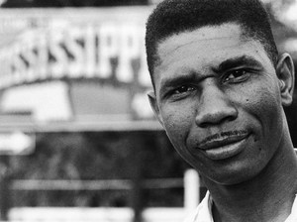
Medgar Evers, field secretary of the NAACP in Mississippi, worked on the Emmett Till trial and championed desegregation. Evers was assassinated in 1963 by a white supremacist. Image courtesy Wikimedia Commons.

Other veterans were similarly determined to make the freedoms they had fought for abroad a reality at home. Mississippian Medgar Evers, for example, convinced a group of young black veterans to go to the courthouse and try to register to vote in 1946 (they were turned away by an mob of armed white men). Evers also tried to integrate the University of Mississippi law school, which refused to admit him on racial grounds. Instead of pursuing a career as a lawyer, Evers became the NAACP's first field secretary in Mississippi. Along with Amzie Moore, he interviewed witnesses and aided reporters during the Emmett Till trial. One civil rights organizer noted that he specifically recruited veterans for his chapter of the NAACP because they "don't scare easy."

Black veterans went on to become key players in the Civil Rights Movement, from Till and Moore to Oliver Brown, the chief plaintiff in the Brown v. Board of Education of Topeka Supreme Court Case.

Section 3- Brown v. Board of Education
A segregated society
An 1896 Supreme Court decision, Plessy v. Ferguson, had declared “separate but equal” Jim Crow segregation legal. The Plessy ruling asserted that so long as purportedly “equal” accommodations were supplied for African Americans, the races could, legally, be separated. In consequence, “colored” and “whites only” signs proliferated across the South at facilities such as water fountains, restrooms, bus waiting areas, movie theaters, swimming pools, and public schools.

Jim Crow was the name for the system of social and legal separation of black Americans from white Americans. Segregation was practiced most fiercely in the Deep South, but some segregationist practices existed elsewhere in the United States as well. Jim Crow segregation was a way of life that combined a system of anti-black laws and race prejudiced cultural practices. Jim Crow oppression and prejudice persisted into the 1960s.

The term "Jim Crow" came from the name of a black character often portrayed in early- and mid- nineteenth century American theater. Crows are black birds, and Jim Crow was a stock black character who was almost always played onstage by a white man wearing blackface makeup.

Despite the claim that black schools were equal to white schools, schools for black children frequently lacked even basic necessities. In South Carolina, black children attended schools without running water, flush toilets, or electricity. In one county, $149 was spent per year on each white student, but only $43 on each black student. In Delaware, black students attended a poorly-equipped one-room schoolhouse, while a well-equipped white school existed nearby. In Virginia, a black high school at the center of the case was overcrowded and was without a cafeteria or gym; the same was not true at the local white school.

In 1950s America segregation was largely, though not exclusively, a southern practice. Every state in the South mandated school segregation, and ten other states outside of the South either permitted or required segregation in public schools.
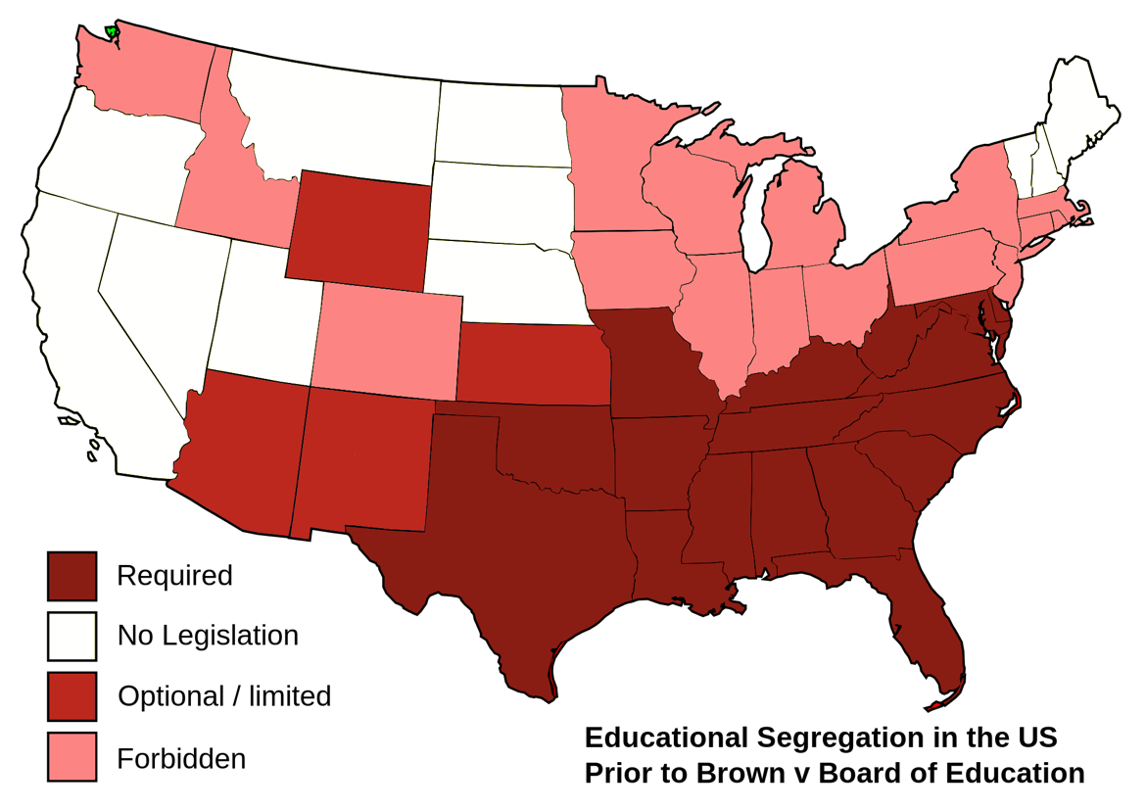
Map of the United States indicating the states where school segregation was required, optional, forbidden, or unaffected by legislation. Segregation was required in all states of the Deep and Upper South, and optional in Arizona, New Mexico, Kansas, and Wyoming.
Map of school segregation laws in each state before the Brown v. Board decision. Map adapted from Wikimedia Commons.

The Brown v. Board of Education case
Linda Brown, a third grader, was required by law to attend a school for black children in her hometown of Topeka, Kansas. To do so, Linda walked six blocks, crossing dangerous railroad tracks, and then boarded a bus that took her to Monroe Elementary. Yet, only seven blocks from her house was Sumner Elementary, a school attended by white children, and which, save for segregation, Linda would otherwise have attended. Her father, Oliver Brown, encouraged by NAACP chief counsel Thurgood Marshall, brought suit against the Topeka school district.

The case was named after a lawsuit filed in 1951 by NAACP lawyers against the Topeka, Kansas school district on behalf of Linda Brown and her family. By the time the Brown’s case made it to the US Supreme Court in 1954 it had been combined with four other similar school segregation cases into a single unified case.

Thurgood Marshall, the NAACP, and the Supreme Court
The NAACP’s chief counsel, Thurgood Marshall, argued the unified case in Brown v. Board before the Supreme Court. Marshall and a team of NAACP lawyers had been challenging segregation laws for several years prior to Brown. In 1950 Marshall had won a case before the Supreme Court, Sweatt v. Painter, in which the Court had ruled that a Texas law school purporting to offer black students an education equal to that which it offered whites was not—as measured by funding, faculty, or facilities—in fact equal. (The law school for black students consisted initially of only three basement classrooms and no library).
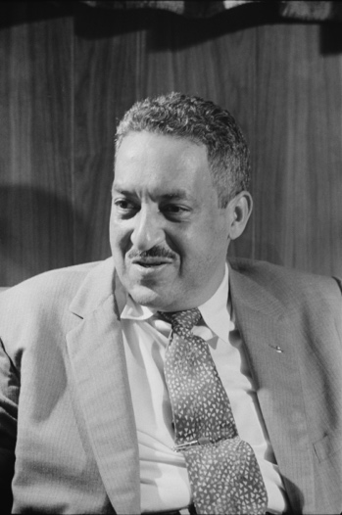
Black and white photograph of Thurgood Marshall taken in 1957.
Thurgood Marshall, the NAACP's chief counsel, argued the Brown v. Board case before the Supreme Court. Marshall would go on to become the first African American Supreme Court justice. Image courtesy Wikimedia Commons.

After their success in Sweatt, Marshall and the other NAACP lawyers wanted to find and develop test cases by which means they could strike at the heart of segregation itself. They wanted the fact that students were being separated into different schools solely because of race itself declared unconstitutional. And, in Brown v. Board, Marshall and his colleagues found five cases through which they could work to achieve their goal.

Linda Brown’s case was particularly useful to Thurgood Marshall’s efforts because Monroe Elementary was not underfunded in comparison to Sumner Elementary. The school Linda attended was separate, but it was not, measured by funding, unequal. The case allowed Marshall and the other NAACP lawyers to focus attention on the question of the constitutionality of segregation itself.

In making the case in Brown, Marshall drew upon the research of two psychologists, Kenneth and Mamie Clark, to argue that the very fact black and white children were sent to separate schools damaged the black children’s self-esteem, stigmatized them, and adversely shaped their self-image for the rest of their lives. Separate schools, Marshall argued, made plain to black children that they were deemed unworthy of being educated in the same classrooms as white children; school segregation reinforced notions of difference and inequality associated with race prejudice and racism.

Separate is "inherently unequal"
In Brown v. Board, the Supreme Court overturned Plessy v. Ferguson and outlawed segregation. The Court agreed with Thurgood Marshall and his fellow NAACP lawyers that segregated schooling violated the 14th Amendment’s guarantee of equal protection of law. Speaking for a unanimous Court, Chief Justice Earl Warren wrote, “We conclude that, in the field of public education, the doctrine of ‘separate but equal’ has no place. Separate educational facilities are inherently unequal.” He added: “Any language in Plessy v. Ferguson contrary to this finding is rejected.” The decision challenged de jure segregation of the races, and electrified the nation.

De jure is a Latin phrase that means "according to the law." It's sometimes used as the opposite of de facto, which means "according to fact" or "according to reality," to denote instances in which what the law dictates is different from what's really going on in society.

Though the Court’s ruling applied only to public schools, its declaration that “separate” is “inherently unequal” served as a reminder that not only in schools, but in all aspects of life, the separation of black and white Americans signaled an “inherently unequal” status between them. As such segregation did not measure up to the nation’s founding ideal that “all men are created equal.”

Brown II: Desegregating with "all deliberate speed”
In the summer of 1955 the Supreme Court issued its implementation ruling in a decision called Brown II. In Brown II the Court ordered that schools undertake desegregation with “all deliberate speed.” But just what the Court meant by “deliberate speed” came quickly into dispute. White citizens in the South organized a "Massive Resistance" campaign against integration.

Although the Supreme Court’s decision in Brown v. Board was a major step forward in civil rights, it is important to note that the decision applied only to public schools. Brown v. Board did not address Jim Crow laws across the South that applied to restaurants, movie halls, public transportation, and more. Not until the 1960s--in laws such as The Civil Rights Act of 1964, The Voting Rights Act of 1965, and The Housing Rights Act of 1968—would these aspects of de jure segregation be put to an end.

Section 4- Emmett Till
The murder of Emmett Till
In the summer of 1955, fourteen-year-old Emmett Till went to visit his great-uncle and cousins in the small town of Money, Mississippi. Till was an African American teenager who had grown up in Chicago, a fun-loving prankster who "loved to make people laugh," according to one friend.

Till was unprepared for the rigidly-maintained racial order in the South, where blacks were expected to display constant deference to whites or else face violent reprisal. Three days after he arrived in Mississippi, Till entered Bryant's Grocery store to buy a pack of bubblegum. Carolyn Bryant, the white woman who was working behind the counter, alleged that Till had wolf-whistled at her, grabbed her around the waist and uttered obscenities. More than fifty years later, Bryant admitted that she fabricated this story and lied under oath about their encounter.

Bryant told her husband, Roy Bryant, that Till had made sexual advances toward her. Four days later he and his half-brother J.W. Milam kidnapped Till from his great-uncle's house in the middle of the night. They beat the fourteen year old boy mercilessly, gouged out one of his eyes, and then shot and killed him. They tied his body to a large industrial fan and dumped him in the nearby Tallahatchie River.
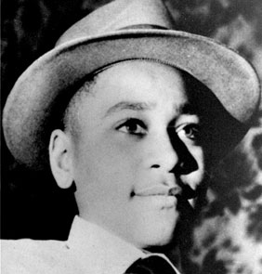
Black and white photograph of Emmett Till, wearing a collared shirt and a hat.
Emmett Till, a fourteen-year-old African American boy, was brutally murdered by two white men in Mississippi in 1955. Image courtesy Wikimedia Commons.
When Till's corpse was salvaged from the river three days later, he was recognizable only by the ring he wore, which had belonged to his father. His remains were sent to his mother with the coffin nailed shut.

Till's funeral
It's likely that Till's murder, like those of so many other African Americans during the Jim Crow era, would have gone virtually unnoticed, if his mother Mamie Bradley had not made the brave decision to hold an open-casket funeral. Jet magazine published pictures of Bradley with her son's mutilated corpse, which excited outrage and horror from the broader public. Bradley said she felt she had to "let the world see what has happened, because there is no way I could describe this. And I needed somebody to help me tell what it was like."

Over 100,000 people attended Till's funeral in Chicago. Had the funeral been an official protest, it would have been the largest civil rights demonstration in American history until that point.

The trial of Till's murderers
Calls for justice throughout the country led to the indictment of Roy Bryant and J.W. Milam, whose trial for Till's kidnapping and murder began on September 22, 1955. Because women and African Americans were barred from serving on juries in Mississippi at that time, the defendants were tried before an all-male, all-white jury. At great personal risk, Till's great-uncle Mose Wright took the stand and identified Bryant and Milam as the men who kidnapped his nephew.

The case was the first major media event of the nascent Civil Rights Movement, bringing hundreds of reporters and all three television networks to the small Mississippi town. The courtroom was segregated, and many outside observers were surprised at the informal conduct of the sheriff, who casually used racial epithets and initially refused to admit black Congressman Charles Diggs to the courtroom.

In his closing statements, defense attorney advised the jury that if they convicted Bryant and Milam for Till's murder, "Your ancestors will turn over in their grave, and I'm sure every last Anglo-Saxon one of you has the courage to free these men." The jury deliberated for just sixty-six minutes before acquitting both men. "We wouldn't have taken so long if we hadn't stopped to drink pop," said one of the jurors.

Till's influence on the Civil Rights Movement
Although Bryant and Milam were never punished for their crime—they admitted to the killing in a 1956 interview—Till's death was a watershed moment for the Civil Rights Movement. To African Americans who had grown up in the Jim Crow South, the fact that Bryant and Milam had been tried for the murder at all was an incredible mark of progress. Amzie Moore, the president of the Bolivar County NAACP, marveled that: "A white man was openly tried for lynching a black boy, you know that hadn’t happened in our memory."

Till's murder awakened Americans to the true extent of racism in the nation. "People really didn't know that things this horrible could take place," according to Till's mother Mamie. "And the fact that it happened to a child, that made all the difference in the world." Many individuals who would go on to play leading roles in the Civil Rights Movement felt that Till's death was the last straw. Rosa Parks, who would initiate the Montgomery Bus Boycott just two months after the trial, said that on that day, "I thought about Emmett Till, and I couldn't go back [to the back of the bus]."

