The Start of the Cold War

Section 1- The Yalta Conference and Containment
What was the Cold War?
The Cold War was a global conflict between the United States and the Soviet Union, lasting from 1947 to 1991, over which of the two superpowers would hold economic and ideological sway over the world. It's called the Cold War because no actual military engagement took place between the United States and the USSR (Union of Soviet Socialist Republics). Instead, fighting took place in proxy wars conducted in "third-world" countries.

In this case, "proxy war" means a war fought with the support of a nation but not by that nation itself. For example, in the proxy war of Vietnam, the USSR supported the communist North Vietnamese with money, weapons and training and the US similarly supported the South Vietnamese. In the context of the Cold War, the United States classified countries in one of three categories:

- The "first world" consisted of the United States and its developed, capitalist allies, such as the United Kingdom and France
- The "second world" referred to communist nations, including China, Russia, and the satellite countries Russia controlled, such as Poland and Ukraine
- The "third world" referred to everywhere else, usually developing countries in Asia and Latin America over which the United States and Soviet Union vied for influence

The United States and USSR clashed over their economic and political philosophies. As a capitalist, democratic nation, the US sought to promote free elections and free markets. As a communist, totalitarian state, the USSR sought to ensure the security of its borders and the political dominance of the Communist party.

The Yalta Conference and the end of World War II
The United States, the United Kingdom, and the Soviet Union worked together to win World War II, but their relationship was tense and fraught from the beginning. The Soviet Union originally had signed a Non-Aggression Pact with Nazi Germany in 1939; the USSR only entered the war on the side of the Allies when Hitler double-crossed Soviet Premier Josef Stalin and invaded Russia in 1941. This proved to be a fatal mistake for Hitler: the Russians eventually stalled his invasion and overtook all of the territory the Nazis had conquered in Eastern Europe.

Before the war's end, the leaders of the Allied powers met at the Russian resort town of Yalta to plan for the future after Hitler's defeat. At this Yalta Conference, they could not agree on much, but they did agree that any remnant of Nazi power had to be stamped out of Germany. To this end, they agreed to divide Germany, as well as the city of Berlin, into four zones, each of which would be occupied by one of the major Allied powers (the "Big Four"): France, the United Kingdom, the United States, and the Soviet Union.
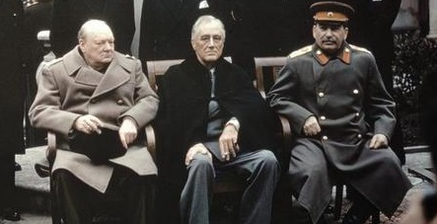
The leaders of the United Kingdom, the United States, and the Soviet Union met at the Yalta Conference to plan for the postwar era. From left to right: Winston Churchill, Franklin D. Roosevelt, and Josef Stalin. Image courtesy Wikimedia Commons.

As the war moved into its final stages in mid-1945, suspicion flared between the United States and the Soviet Union. The terrifying new power of the atomic bomb, which the United States dropped on Japan in August, made the Soviets justifiably nervous. The United States also didn't endear itself to Russia when it abruptly cut off all military and financial aid to the Soviet Union upon the war's conclusion, at a time when Russian citizens dearly needed the help. For its part, the Soviet Union was sending clear signals that it did not intend to give up the territory it had gained from the Nazis, including stalling on its promises to remove troops from oil-rich regions in the Middle East and to allow free elections in conquered Poland.

The "Long Telegram" and containment
Amid this tense atmosphere, the US government received dire intelligence from its ambassador in Moscow, George F. Kennan. In a Long Telegram sent to the US Secretary of State in 1946, Kennan warned that the Soviets believed that "there could be no peaceful coexistence" between communists and capitalists, and that the Soviets desired the relentless expansion not only of their own borders but of communism writ large.

Kennan advised the US government that the only way to handle relations with the Soviet Union was to pursue a vigorous policy of containment: blocking the advance of both Soviet power and communism everywhere in the world.The US government adopted Kennan's ideas for containment, which became the cornerstone of American foreign policy in the twentieth century.

Section 2- The Truman Doctrine and The Marshall Plan
The Truman Doctrine
The world was in flux in the aftermath of World War II, and political upheaval reigned in many countries. Already wary of communism thanks to George Kennan's Long Telegram, the US government was dismayed when a number of countries in Europe and Asia adopted communist governments in the late 1940s.
When the United Kingdom notified the United States that it could no longer afford to fight communist insurgencies in Greece and Turkey, US President Harry S. Truman issued what would become known as the Truman Doctrine: a promise that the United States would do whatever was necessary both economically and militarily to contain the spread of communism around the world.
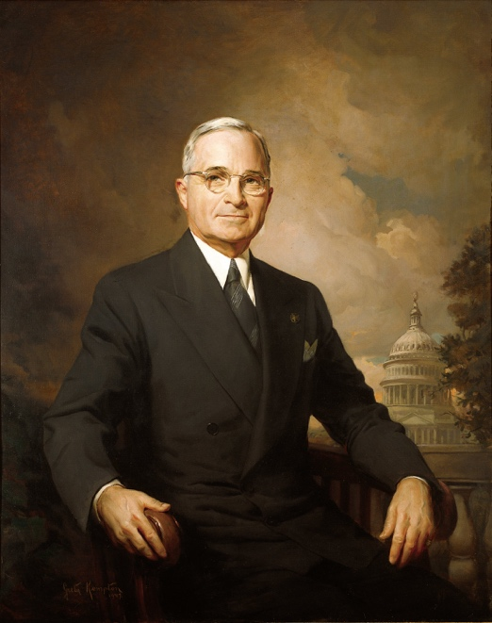
Painting of Harry S. Truman during his time in office. Truman is seated on a chair in front of an outdoor landscape with the US Capitol Building in the background.
Official White House portrait of Harry S. Truman, painted by Greta Kempton, 1945. Image courtesy Wikimedia Commons.

With this step, the United States signaled that its role on the world stage would not conclude after World War II, ending a century and a half of isolationist foreign policy in America.
During Truman's presidency, the Truman Doctrine would result in another conflict in Asia, this time in Korea, as the US government attempted to prevent the unification of Korea under a communist government. Truman's policy would continue to drive American interventions through the 1980s.

The Marshall Plan
One of the most pressing problems in the immediate aftermath of World War II was the reconstruction of Europe. The war left a swath of destruction that crippled infrastructure and led to massive food shortages in the winter of 1946-1947.

The US government feared that a hungry, devastated Europe might turn to communism (as China would do in 1949). To stabilize the European economy, US Secretary of State George C. Marshall proposed a plan to provide Europe with $13 billion in economic aid.

The Marshall Plan proved enormously successful, helping to rehabilitate European nations that accepted the aid. It also provided a boost to the American economy, since Marshall Plan funds were used to purchase American goods.

Section 3- The Berlin Airlift and NATO
The Berlin airlift
The growing tensions between the United States and the Soviet Union finally erupted into crisis in 1948. For three years, the Big Four powers had followed the plan of occupation decided at Yalta, with each power administering a zone of Germany as well as a zone of the capital city of Berlin. But ideological divisions over what should be done with Germany tore the former allies apart.

Believing that a reunified Germany would prevent a repeat of the economic catastrophe that had followed World War I, the US, Britain, and France decided to consolidate their zones of Germany. The USSR, which wanted to make sure that Germany could never attack it again, strongly objected to this plan. In 1948 the USSR flexed its might by cutting off all highway and railroad access to the city of Berlin (which fell within its occupation zone), hoping to absorb all of Berlin under Soviet control. West Berlin would either starve or the Western Allies would surrender to the Soviets' wishes for Germany.
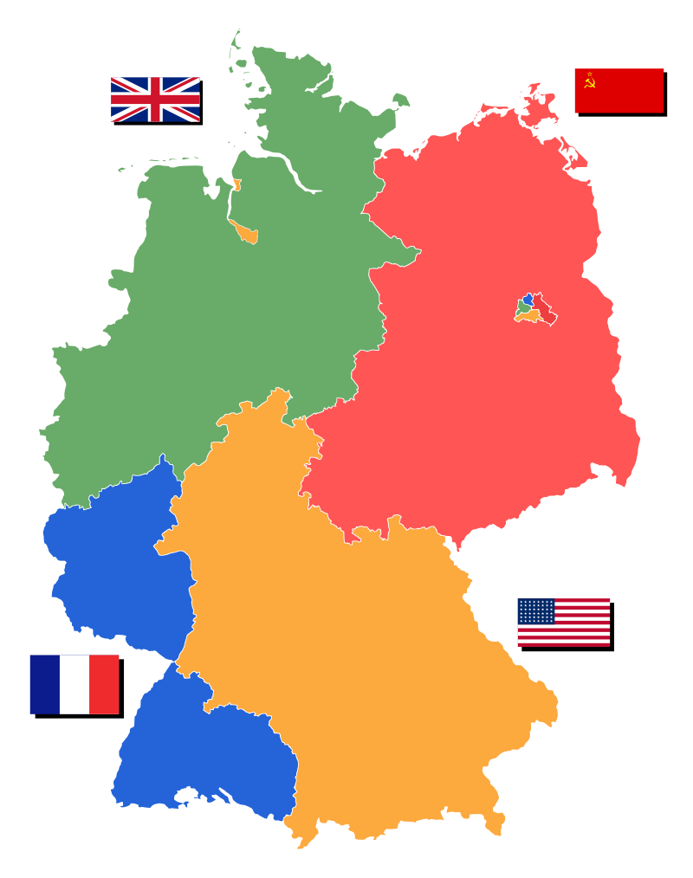
Map of partitioned Germany showing the nations in control of each region: England in the northwest, France in the southwest, the US in the southeast, and the USSR in the northeast. The city of Berlin falls within the Soviet zone.
Map of partitioned Germany showing the nations in control of each region: England in the northwest, France in the southwest, the US in the southeast, and the USSR in the northeast. Note that the city of Berlin, which was itself divided among the four powers, fell within the Soviet region.

The US, Britain, and France refused to allow Russia to hold Berlin hostage. Instead, they arranged for a massive support mission to supply West Berlin. From June 1948 to May 1949, they sent hundreds of airplanes filled with food and fuel every day in what became known as the Berlin airlift. They also instituted a counter-blockade on East Berlin.

After 11 months, the Soviets realized that the blockade was a failure and ended it. But the standoff over Berlin had crystallized the divisions of the Cold War. The Western Allies turned their combined occupation zones into the new country of West Germany, and the Soviets responded by creating East Germany. In Berlin, the Soviets began the process of building a barrier between its eastern and western zones that would stand for the next forty years.

NATO and the National Security Act
As tensions raged in Europe, the United States realized that long-lasting peace was not going to follow on the heels of World War II. When Britain, Belgium, Holland, and Luxembourg asked the United States to join its defensive alliance in 1948, the US broke its longstanding aversion toward entangling alliances abroad and signed on.

The North Atlantic Treaty Organization (NATO), as the pact was named, started with twelve member nations (today, it has twenty-eight). NATO promised that an attack on one of its members would provoke a response from all of its members. NATO became the major international body opposing communism in the twentieth century.

The US also strengthened its commitment to defense at home. In 1947 Congress passed the National Security Act, which united the branches of the armed services under the new Department of Defense. It also created the Central Intelligence Agency and the National Security Council to gather intelligence and advise the president on foreign policy. In addition, Congress reinstituted the Selective Service military draft for young men in 1948. If any hope remained that the world would be tranquil after Hitler's defeat, by the end of the 1940s it had gone.

