1950’s America: Popular Culture, Mass Media, and Conformity

The postwar boom and popular culture
In the aftermath of World War II, the United States emerged as the world's leading industrial power. Generous government support for education and home loans coupled with a booming economy meant that Americans in the postwar era had more discretionary income than ever before.

In the 1950s and 1960s, the bumper crop of children born after World War II, known collectively as the baby boomers, grew into teenagers and young adults. As the largest single generation up until that point in American history, the baby boomers had a tremendous effect on popular culture thanks to their sheer numbers. Starting as early as the 1940s, savvy marketers identified the baby boomers as a target demographic and marketed products and entertainment geared to their needs and interests.

The baby boomers developed a greater generational consciousness than previous generations. They sought to define and redefine their identities in numerous ways. The music of the day, especially rock and roll, reflected their desire to rebel against adult authority. Other forms of 1950s popular culture, such as movies and television, sought to entertain, while reinforcing values such as religious faith, patriotism, and conformity to societal norms.

Rocking around the clock
In the late 1940s, some white country musicians began to experiment with the rhythms of the blues, a decades-old musical genre of rural southern black people. This experimentation led to the creation of a new musical form known as rockabilly; by the 1950s, rockabilly had developed into rock and roll.

Rock and roll music celebrated themes such as young love and freedom from the oppression of middle-class society. It quickly grew in favor among American teens during the 1950s, thanks largely to the efforts of disc jockey Alan Freed. Freed named and popularized rock and roll by playing it on the radio in Cleveland—where he also organized the first rock and roll concert—and later in New York.

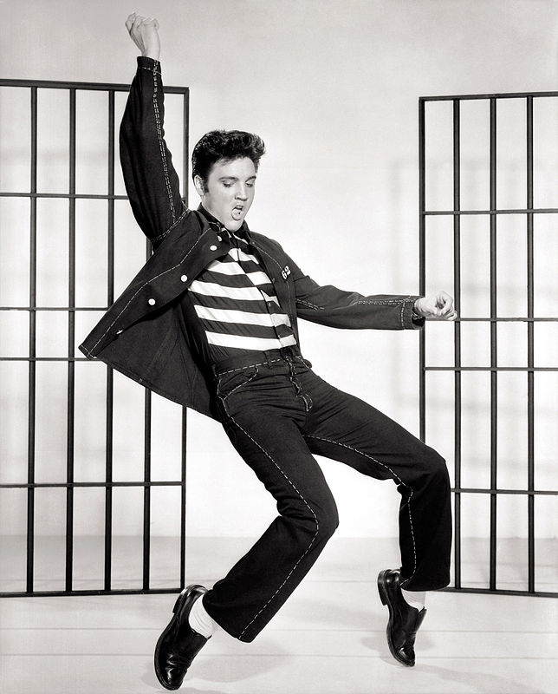
The theme of rebellion against authority, present in many rock and roll songs, appealed to teens. In 1954, rock group Bill Haley and His Comets provided youth with an anthem for their rebellion with the song ”Rock Around the Clock.” The song, used in the 1955 movie Blackboard Jungle about a white teacher at a troubled inner-city high school, seemed to be calling for teens to declare their independence from adult control.
Haley illustrated how white artists could take musical motifs from African American musicians and achieve mainstream success. Teen heartthrob Elvis Presley rose to stardom doing the same. Thus, besides encouraging a feeling of youthful rebellion, rock and roll also began to tear down color barriers in popular culture, as white youths sought out African American musicians such as Chuck Berry and Little Richard.

Photo of Elvis Presley dancing in a promo shoot for the song Jailhouse Rock.
Rock musician Elvis Presley enthralled teens and scandalized adults with his suggestive lyrics and dance moves. Image credit: Wikimedia Commons
While youth had found an outlet for their feelings and concerns, their parents were much less enthused about rock and roll and the rebellion and sexuality it seemed to promote. Many regarded the music as a threat to American values. When Elvis Presley appeared on The Ed Sullivan Show, a popular television variety program, the camera deliberately focused on his torso and did not show his swiveling hips or legs shaking in time to the music.

Despite adults’ dislike of the genre, or perhaps because of it, more than 68 percent of the music played on the radio in 1956 was rock and roll.

Hollywood on the defensive
At first, Hollywood encountered difficulties in adjusting to the post-World War II environment. Although domestic audiences reached a record high in 1946 and the war’s end meant expanding international markets too, the groundwork for the eventual dismantling of the traditional "studio system" was laid in 1948 in a landmark decision by the US Supreme Court. Previously, film studios had owned their own movie theater chains in which they exhibited the films they produced; however, in United States v. Paramount Pictures, Inc., this vertical integration of the industry—the complete control by one firm of the production, distribution, and exhibition of motion pictures—was deemed a violation of antitrust laws.

Hollywood also felt the strain of Cold War fears. The House Un-American Activities Committee hearings targeted suspected Communists in Hollywood. When Senator Joseph McCarthy called eleven “unfriendly witnesses” to testify before Congress about Communism in the film industry in October 1947, only playwright Bertolt Brecht answered questions. The other 10, who refused to testify, were cited for contempt of Congress on November 24. The next day, film executives declared that the so-called “Hollywood Ten” would no longer be employed in the industry until they had sworn they were not Communists.

Eventually, more than three hundred actors, screenwriters, directors, musicians, and other entertainment professionals were placed on the industry blacklist. Some never worked in Hollywood again; others directed films or wrote screenplays under assumed names.
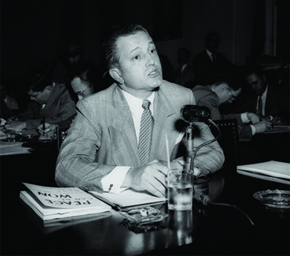
A photograph shows Edward Dmytryk testifying before the House Committee on Un-American Activities.
One of the original Hollywood Ten, director Edward Dmytryk publicly announced he had once been a Communist and, in April 1951, answered questions and “named names” before the House Un-American Activities Committee. Image credit: OpenStax College.

Hollywood reacted aggressively to these various challenges. Filmmakers tried new techniques, like CinemaScope and Cinerama, which allowed movies to be shown on large screens and in 3-D. Audiences were drawn to movies not because of gimmicks, however, but because of the stories they told. Dramas and romantic comedies continued to be popular fare for adults.

To appeal to teens, studios produced large numbers of horror films and movies starring music idols such as Elvis. Many films took espionage, a timely topic, as their subject matter, and science fiction hits such as Invasion of the Body Snatchers—about a small town whose inhabitants fall prey to space aliens—played on audience fears of both Communist invasion and nuclear technology.

The triumph of television
By far the greatest challenge to Hollywood, however, came from the relatively new medium of television. Although the technology had been developed in the late 1920s, through much of the 1940s only a fairly small, wealthy audience had access to it. As a result, programming had been limited.
With the post-World War II economic boom, however, all this changed. Where there had been only 178,000 televisions in homes in 1948, by 1955, over three-quarters of a million US households—about half of all homes—had television.
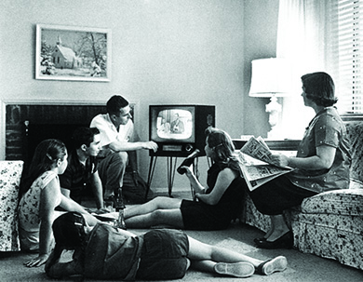
A photograph shows a man, a woman, three teenage girls, and a teenage boy sitting in a living room, watching a television.
An American family relaxes in front of their television set in 1958. Many gathered not only to watch the programming but also to eat dinner. The marketing of small folding tray tables and frozen “TV dinners” encouraged such behavior. Image credit: OpenStax College.

Various types of programs were broadcast on the handful of major networks: situation comedies, variety programs, game shows, soap operas, talk shows, medical dramas, adventure series, cartoons, and police procedurals.

Many comedies presented an idealized image of white suburban family life: happy housewife mothers, wise fathers, and mischievous but not dangerously rebellious children were constants on shows like Leave It to Beaver and Father Knows Best in the late 1950s. These shows also reinforced certain perspectives on the values of individualism and family—values that came to be redefined as “American” in opposition to alleged Communist collectivism.

Westerns, which stressed unity in the face of danger and the ability to survive in hostile environments, were popular too. Programming designed specifically for children began to emerge with shows such as Captain Kangaroo, Romper Room, and The Mickey Mouse Club designed to appeal to members of the baby boom.

Conformity and the 1950s
The 1950s is often viewed as a period of conformity, when both men and women observed strict gender roles and complied with society’s expectations. After the devastation of the Great Depression and World War II, many Americans sought to build a peaceful and prosperous society. However, even though certain gender roles and norms were socially enforced, the 1950s was not as conformist as is sometimes portrayed, and discontent with the status quo bubbled just beneath the surface of the placid peacetime society. Although women were expected to identify primarily as wives and mothers and to eschew work outside of the home, women continued to make up a significant proportion of the postwar labor force. Moreover, the 1950s witnessed significant changes in patterns of sexual behavior, which would ultimately lead to the “sexual revolution” of the 1960s.

Changing social trends following World War II
Demobilization at the end of World War II brought a great many changes. Millions of women who had joined the workforce during the war were displaced by returning soldiers. Messages in popular culture and the mass media encouraged these women to give up their jobs and return quietly to domestic life. Most women, however, wished to keep their jobs, and thus women made up approximately one-third of the peacetime labor force.

During the 1950s, marriage and homeownership rates skyrocketed, so there is no doubt that many Americans were content to pursue the “American dream.” These trends were aided by suburbanization and the mass production of automobiles. Cars allowed Americans who lived in the suburbs to commute easily into urban areas for work. Cars not only changed work and housing patterns, but also facilitated the rise of new sexual norms. They provided young couples with a place to spend time together alone, away from the prying eyes of parents and other members of the community. This, in turn, led to a rise in premarital sex and birth rates. Thus, patterns of sexual behavior were changing even as the traditional ideal continued to insist upon marriage before sex.

Between 1946 and 1964, the largest generation of Americans, known as the baby boomers, was born. This demographic trend in turn reinforced women’s identities as wives and mothers. Despite societal norms that encouraged women to stay in the home and out of the workplace, approximately forty percent of women with young children, and at least half of women with older children, chose to remain in the work force.

Cold War domesticity and popular culture
Gender roles in the 1950s were intimately connected to the Cold War. The term nuclear family emerged to describe and encourage the stability of the family as the essential building block of a strong and healthy society. In this view, a woman played a crucial role in waging the Cold War, by keeping the family unit strong and intact. She could do this best, it was thought, by remaining at home to take care of her husband and children, and refusing to pursue a career. Thus was a link forged between traditional gender roles and national security.
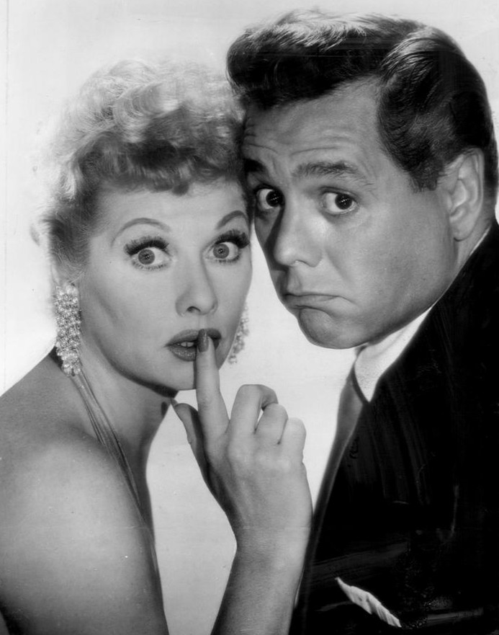
Moreover, because the Cold War was also a competition between two very different economic systems, the virtues of capitalism were touted as proving the superiority of the United States over the Soviet Union. Capitalism revolved around the exchange of goods and services in the marketplace, and so identifying with consumer culture became a way of waging the Cold War. Women, traditionally expected to do most of the shopping for the household, were encouraged to identify as patriotic Americans by being savvy consumers.

Black-and-white photograph depicting actress Lucille Ball with husband and actor Desi Arnaz. Ball is holding a finger to her lips and opening her eyes very wide, and Arnaz is making an exaggerated pout. The photograph emphasizes their silly personalities.
Publicity photograph of Lucille Ball and Desi Arnaz. I Love Lucy both confirmed and undermined 1950s gender norms for white women, as Ball herself was a successful entertainer but her on-screen character repeatedly failed at working outside the home. Image courtesy Wikimedia Commons.
The norms of consumer culture and domesticity were disseminated via new and popular forms of entertainment – not just the television, which became a fixture in middle-class American households during the 1950s, but also women’s magazines, popular psychology, and cinema.

Shows promoting the values of domesticity, like Leave it to Beaver and Father Knows Best, became especially popular. These shows portrayed the primary roles of women as wives and mothers. Lucille Ball, in I Love Lucy, inevitably met with disaster whenever she pursued job opportunities or interests that took her outside of the household. On the other hand, the fact that every episode revolved around Lucy’s attempts to pursue outside interests indicated her discontent with remaining at home.

Moreover, Lucille Ball, while playing the role of a hapless housewife on TV, was in reality a highly successful actress and producer, and thus challenged society’s expectations of women.

African American women in the 1950s
It is important to remember that the ideal of domesticity was primarily aimed at middle-class white women. African American women, as well as women of lower socioeconomic standing, were not portrayed in popular culture as wives and mothers; in fact, these women were hardly portrayed at all. Although African Americans have been hugely influential in popular culture throughout the twentieth century, the 1950s were a very “whitewashed” decade from the standpoint of the mass media.

Additionally, many African American women were forced by economic necessity to work outside of the home, and were thus excluded from the postwar ideal of domesticity.

