The Civil Rights Movement: Action and Resistance

Section 1- The Montgomery Bus Boycott
Rosa Parks’s arrest
Rosa Parks was arrested on December 1, 1955, in Montgomery, Alabama for failing to give up her bus seat—so that it would be available for white passengers—when instructed to do so by the bus’s driver.
Parks was arrested at a time in American history when, under Jim Crow laws, African Americans faced discrimination and segregation across the South. Jim Crow bus laws in Montgomery at the time of Parks’ arrest established a section for whites at the front of the bus, and a section for blacks in the back. The law required that when the white section filled, black passengers in the “colored section” give up their seats and move further back.
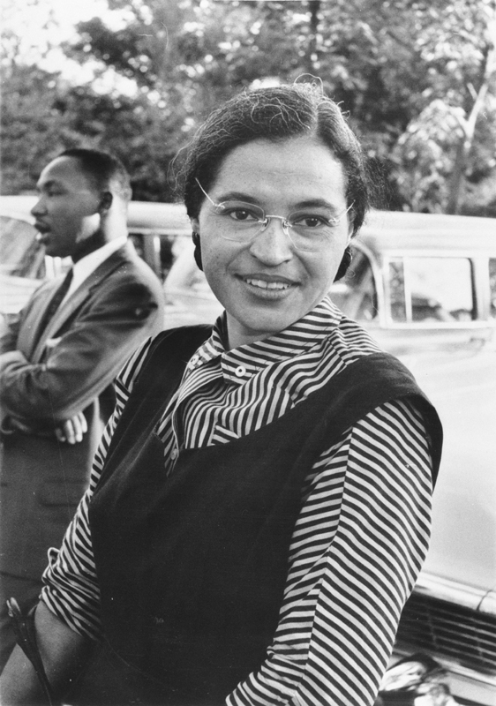
Black and white photograph of Rosa Parks. Martin Luther King Jr. can be seen in the background.
Rosa Parks, the 42 year old secretary of the Montgomery, Alabama NAACP, provided the inspiration for the Montgomery Bus Boycott with her 1955 arrest for refusing to give up her seat on the bus to accommodate white passengers. Image courtesy Wikimedia Commons.
Parks, tired after a day’s work at her job as a seamstress in a downtown department store, was sitting in the first row of seats in the bus’s “colored" section. As the white section filled, the driver announced that black passengers in the “colored" section’s front row were to give up their seats. But Parks refused to do so. She was arrested and fined ten dollars.

Rosa Parks was forty-two years old, married, regularly attended church, and worked as a seamstress in a downtown department store. She had also been active in her local chapter of the NAACP for more than a decade. Four days before her arrest she had attended a large meeting at which the August 1955 murder of Emmett Till had been discussed by a member of the Regional Council of Negro Leadership. She later recounted that Emmett Till was on her mind the evening of her arrest.

Origins of the bus boycott
E.D. Nixon, head of the Alabama NAACP, and Jo Ann Robinson, head of the local Women’s Political Council, had been looking for means by which to challenge the treatment of African Americans in Montgomery for some time. As a model citizen and woman of unimpeachable conduct, Parks was an ideal candidate for a public campaign. After Parks’s arrest, they decided to call for a boycott of the city’s buses.

Nixon held meetings with members from the community in area churches. Robinson and members of her Council worked tirelessly to produce some fifty-thousand leaflets which were distributed that Sunday at the city’s black churches. The leaflets read, “Don’t ride the bus to work, town, to school, or any place Monday, December 5.... Come to a mass meeting, Monday at 7:00 P.M. at the Holt Street Baptist Church for further instruction.”
Martin Luther King, Jr., a little-known, twenty-six-year-old Baptist minister with a doctorate from Boston University, led the boycott. During the boycott he began his rise to national and international prominence in the US Civil Rights Movement. Drawing on his study of nonviolent civil disobedience in the teachings of Henry David Thoreau and Mahatma Gandhi, King delivered a message of nonviolent protest against racial injustice in eloquent, powerful sermons and speeches. On the boycott’s first day, speaking before a crowd of more than 5,000 black citizens, he said:

"There comes a time when people get tired.... tired of being segregated and humiliated.... If you will protest courageously and yet with dignity and Christian love...historians will have to pause and say ‘there lived a great people—a black people—who injected a new meaning and dignity into the veins of civilization.’ This is our challenge and our overwhelming responsibility.”

The boycott succeeds
African American men, women, and children stopped taking the bus, and instead carpooled or walked to their destinations. Most bus riders had been African American, and with the precipitous decline in ridership, bus company revenues collapsed. The boycott became major news as the nation’s television networks, newspapers, and major news magazines covered it.

The leaders of the boycott brought suit, demanding the end of segregation on public buses in Montgomery. The suit took months to make its way through the judicial system, but by mid-November 1956 the US Supreme Court—basing its decision on the 14th Amendment’s guarantee of equal protection under the law—ruled that segregated public buses were unconstitutional. The boycott was a success.

Many of the elements in the Montgomery Bus Boycott—organization, community solidarity, nonviolence, and the intervention of the federal government—proved to be the groundwork on which the Civil Rights Movement of the 1960s would be based.
Section 2- “Massive Resistance” and the Little Rock Nine
Massive Resistance
After the Supreme Court ruled school segregation unconstitutional in the 1954 Brown cases, it ordered that schools be desegregated with “all deliberate speed.” But many white Americans, especially in the South, responded angrily to the Court’s rulings. They did not want public schools to be desegregated. Soon, "Massive Resistance, a campaign to block desegregation at the local, state, and national level, was underway.

To this end, a group of 101 southern congressmen issued a “Southern Manifesto” accusing the Supreme Court of a “clear abuse of judicial power,” and vowing to use “all lawful means to bring about a reversal” of the Court’s decision in Brown. White Citizens' Councils opposed to desegregation organized in towns across the South. Composed of white businessmen, civic leaders, and ordinary citizens, the Citizens’ Councils led local and statewide efforts against public school desegregation.

In late summer 1956, crowds of angry whites prevented the desegregation of public schools in Texas, Tennessee, and elsewhere. And, since the Supreme Court’s ruling applied to public but not to private schools, some counties simply closed public schools altogether.

Massive Resistance spread beyond opposition to school desegregation to encompass a broad agenda in defense of the race prejudiced traditions in the South. Some southern states outlawed the NAACP. In 1956, Georgia incorporated the Confederate battle flag into its state flag, and within a few years South Carolina and Alabama began flying the Confederate battle flag over their state capitol buildings. Even President Eisenhower did not personally support the Court’s ruling in Brown, saying privately, “I don’t believe you can change the hearts of men with laws.”
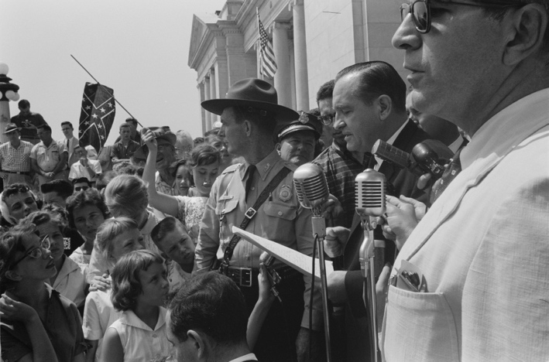
Black and white photograph of Arkansas Governor Orval Faubus speaking to a large crowd of white adults and children. One young white girl is waving a Confederate flag.
Arkansas Governor Orval Faubus speaking before a school integration protest in Little Rock. Note the young white woman waving a Confederate battle flag. Image courtesy Wikimedia Commons.

The "Little Rock Nine"
On 3 September, the first day of school, a small group of African American high school students, accompanied by an escort of ministers, were turned away from Central High School in Little Rock, Arkansas by a large crowd of white citizens and armed troops from the Arkansas National Guard.

Among the African American students soon to be known as the Little Rock Nine was Elizabeth Eckford. She recounted her efforts that morning: “I walked up to the guard who had let the white students in.... When I tried to squeeze past him, he raised his bayonet and then the other guards closed in and they raised their bayonets. They glared at me with a mean look and I was very frightened and didn’t know what to do. I turned around and the crowd came toward me . . . . I tried to see a friendly face somewhere in the crowd—someone who maybe would help. I looked into the face of an old woman and it seemed a kind face, but when I looked at her again, she spat on me.”

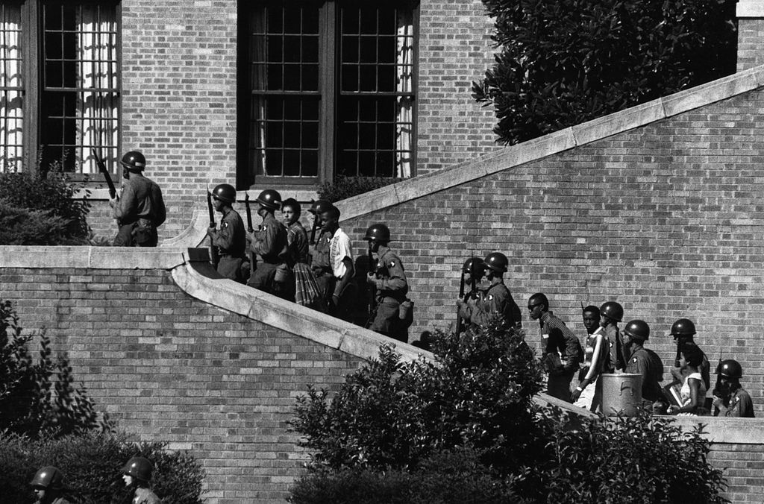
Television and newspaper reports showing of the event drew national and international attention to the issue of school desegregation.

Soldiers from the 101st Airborne Division escort the Little Rock Nine students into Central High School in Little Rock, Arkansas. Image courtesy Wikimedia Commons.

Eisenhower enforces desegregation
Arkansas Governor Orval Faubus removed the National Guard from the school only after a federal district court ordered him to do so on September 20. On September 24, President Eisenhower federalized the Arkansas National Guard and ordered more than a thousand federal troops from the 101st Airborne to Little Rock. It was the first time that federal troops had been deployed in a southern state since the end of Reconstruction in 1877.

President Eisenhower addressed the nation on television from the White House on the evening of September 24. In his address he called attention to the necessity of law and order, and to his obligation as president to “support and insure the carrying out of the decisions of the federal courts.” He also reminded Americans that segregation was a blight on the international image of the United States in the midst of the Cold War. Due to segregation, Eisenhower said, “We are portrayed as a violator of those standards of conduct which the peoples of the world united to proclaim in the Charter of the United Nations. There they affirmed ‘faith in fundamental human rights and in the dignity and worth of the human person’ and they did so ‘without distinction as to race, sex, language or religion.’”
Protected by the armed federal troops who accompanied them to school, September 25 was the first full day of school for the African American students at Central High. That day, as the New York Times reported, some classrooms were half-empty, and “from time to time groups of [white] students threw down their books and walked out of school. Some of them chanted . . . ‘two, four, six, eight, we don’t want to integrate.’”

Troops remained in Little Rock for the 1957-1958 school year. After the troops were withdrawn, however, Governor Faubus closed Little Rock’s public schools for the 1958-1959 school year. “Massive Resistance” persisted: by 1964 fewer than two percent of black students in the South attended school with white students.
Section 3- The March of Washington
The Civil Rights Movement and the March on Washington
The March on Washington brought together many different civil rights groups, labor unions, and religious organizations, including the National Association for the Advancement of Colored People (NAACP), the Student Non-Violent Coordinating Committee (SNCC), the American Federation of Labor (AFL-CIO), and the Southern Christian Leadership Conference (SCLC).
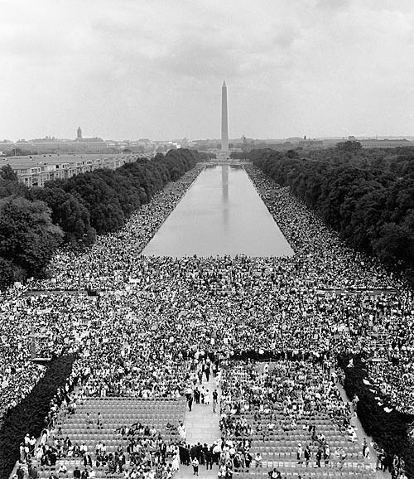
View from the Lincoln Memorial in Washington, DC, on August 28, 1963, where more than a quarter of a million protestors gathered to hear Dr. Martin Luther King deliver his 'I Have a Dream' speech. Image courtesy Wikimedia Commons.

Nevertheless, not all civil rights activists were in favor of the march. Bayard Rustin, though one of the main organizers of the march, was concerned that it would turn violent and damage the international reputation of the Civil Rights Movement. Others, like Malcolm X, who helped popularize the militant Black Power Movement, derided the March on Washington because of its nonviolent, integrationist approach. Calling it the “Farce on Washington,” Malcolm X condemned black civil rights activists for collaborating with whites and accepting donations from whites.

On August 28, 1963, 250,000 protestors converged on the National Mall in Washington, DC to demonstrate in favor of full civil, political, and economic rights for African Americans. The March on Washington was one of the largest demonstrations for human rights in US history, and a spectacular example of the power of non-violent direct action. 1963 was the 100th anniversary of Abraham Lincoln’s Emancipation Proclamation, and one of the major themes of the rally was that the promises of emancipation remained unfulfilled. The march began at the Washington monument and ended at the Lincoln Memorial, where representatives of the sponsoring organizations delivered speeches.

The last speaker of the day was Dr. Martin Luther King, Jr., who delivered what became the most famous speech of the entire civil rights era, the “I Have a Dream” speech, which envisioned a world in which people were judged not by the color of their skin, but by the content of their character.
[Read an excerpt from King's 'I Have a Dream' speech]
Lincoln Memorial, Washington D.C. August 28, 1963
"I am happy to join with you today in what will go down in history as the greatest demonstration for freedom in the history of our nation.
Five score years ago, a great American, in whose symbolic shadow we stand today, signed the Emancipation Proclamation. This momentous decree came as a great beacon light of hope to millions of Negro slaves who had been seared in the flames of withering injustice. It came as a joyous daybreak to end the long night of their captivity.
But one hundred years later, the Negro still is not free; one hundred years later, the life of the Negro is still sadly crippled by the manacles of segregation and the chains of discrimination; one hundred years later, the Negro lives on a lonely island of poverty in the midst of a vast ocean of material prosperity; one hundred years later, the Negro is still languished in the corners of American society and finds himself in exile in his own land.
So we've come here today to dramatize a shameful condition. In a sense we've come to our nation's capital to cash a check. When the architects of our republic wrote the magnificent words of the Constitution and the Declaration of Independence, they were signing a promissory note to which every American was to fall heir. This note was the promise that all men, yes, black men as well as white men, would be guaranteed the unalienable rights of life, liberty, and the pursuit of happiness.
It is obvious today that America has defaulted on this promissory note in so far as her citizens of color are concerned . . . .
I say to you today, my friends, so even though we face the difficulties of today and tomorrow, I still have a dream. It is a dream deeply rooted in the American dream. I have a dream that one day this nation will rise up and live out the true meaning of its creed, "We hold these truths to be self-evident, that all men are created equal." I have a dream that one day on the red hills of Georgia, sons of former slaves and the sons of former slave owners will be able to sit down together at the table of brotherhood. I have a dream that one day even the state of Mississippi, a state sweltering with the heat of injustice, sweltering with the heat of oppression, will be transformed into an oasis of freedom and justice. I have a dream that my four little children will one day live in a nation where they will not be judged by the color of their skin, but by the content of their character . . ."
Because of this, a popular misconception has arisen that it was Dr. King who initiated the rally. In fact, the idea for a march on Washington belonged to A. Philip Randolph, a black labor leader who headed the Negro American Labor Council at the time of the march, and had previously organized the Brotherhood of Sleeping Car Porters, the first African American labor union in US history.
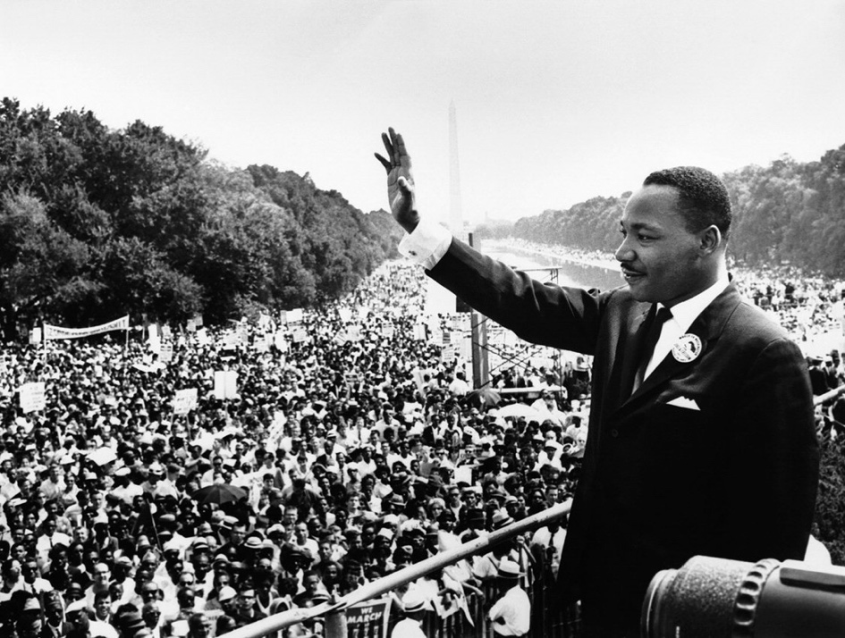
Black and white photograph of Martin Luther King waving to the crowd from the Lincoln Memorial during the March on Washington.
Dr. Martin Luther King Jr. at the March on Washington. Image courtesy Wikimedia Commons.

African American demands for economic justice
The sole purpose of the March on Washington was not to eliminate Jim Crow laws, though the protestors certainly desired to bring a swift end to the segregation that had been institutionalized in the South after the Civil War.

Though the organizers of the rally demanded the desegregation of all schools, the majority of the demands revolved around issues of economic justice – like equal access to public facilities and accommodations, housing, education, and jobs.
Many in the Civil Rights Movement had come to believe that the economic deprivation and exploitation of African Americans was just as significant a problem as racism. At the time of the March on Washington, Congress was debating civil rights legislation, and widespread news coverage of the rally helped to draw the nation’s attention to these issues and to attain broad public support for the protestors’ demands.

One of the most important demands was for a federal Fair Employment Practices Act, which would ban discriminatory hiring practices. This demand would be realized the following year, with the Civil Rights Act of 1964, which created the Equal Employment Opportunity Commission. The demand for the enforcement of the Fourteenth Amendment, moreover, would finally be realized with the passage of the Voting Rights Act of 1965, which eliminated the barriers to black enfranchisement that had been erected as part of Jim Crow.
Section 4- The Civil Rights Act of 1964 and the Voting Rights Act of 1965
The Civil Rights Act of 1964
After years of activist lobbying in favor of comprehensive civil rights legislation, the Civil Rights Act of 1964 was enacted in June 1964. Though President John F. Kennedy had sent the civil rights bill to Congress in 1963, before the March on Washington, the bill had stalled in the Judiciary Committee due to the dilatory tactics of Southern segregationist senators such as James Eastland, a Democrat from Mississippi.

After the assassination of President Kennedy in November 1963, his successor, Lyndon Baines Johnson, gave top priority to the passage of the bill.

The Civil Rights Act of 1964 contained provisions barring discrimination and segregation in education, public facilities, jobs, and housing. It created the Equal Employment Opportunity Commission to ensure fair hiring practices, and established a federal Community Relations Service to assist local communities with civil rights issues. The bill also authorized the US Office of Education to distribute financial aid to communities struggling to desegregate public schools.

After a coalition of religious groups, labor unions, and civil rights organizations mounted an intense grassroots effort to lobby support for the bill, the Senate finally passed it on June 11, by a vote of 73 to 27.

Popular resistance to civil rights legislation
The period following the enactment of the Civil Rights Act of 1964 witnessed resistance to the implementation of its measures. George Wallace, the segregationist governor of Alabama, made a strong showing in the 1964 presidential primaries in Indiana, Maryland, and Wisconsin. His campaign relied heavily on anti-integration rhetoric and bemoaned the loss of “traditional” American values, prefiguring the rise of the new social conservatism.

There was also some confusion about whether the provisions of the act applied to the private sector. Some public venues attempted to transform themselves into private clubs rather than desegregate and open their doors to African Americans. The Supreme Court declared such actions illegal, thereby upholding the constitutionality of the equal access provisions of the Civil Rights Act.

Though the Civil Rights Act of 1964 included provisions to strengthen the voting rights of African Americans in the South, these measures were relatively weak and did not prevent states and election officials from practices that effectively continued to deny southern blacks the vote. Moreover, in their attempts to expand black voter registration, civil rights activists met with the fierce opposition and hostility of Southern white segregationists, many of whom were entrenched in positions of authority.
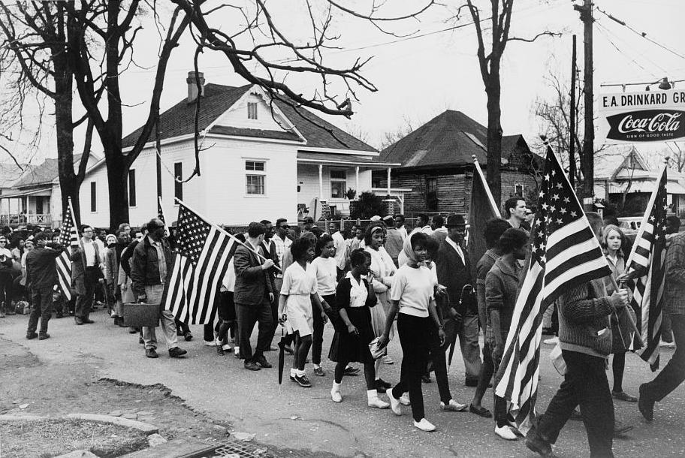
Black and white photograph of civil rights activists marching from Selma to Montgomery, Alabama. Many marchers are carrying American flags.
Civil rights activists marching from Selma to Montgomery, Alabama, in March 1965.

The vicious beatings and murders of civil rights workers after the passage of the Civil Rights Act radicalized some black activists, who became skeptical of nonviolent, integrationist tactics and began to adopt a more radical approach. On March 7, 1965, six hundred activists set out on a march from Selma, Alabama to Montgomery to peacefully protest the continued violations of African Americans’ civil rights. When they reached the Edmund Pettus Bridge over the Alabama River, hundreds of deputies and state troopers attacked them with tear gas, nightsticks, and electric cattle prods. The event, which the press dubbed “Bloody Sunday,” was broadcast over television and splashed across the front pages of newspapers and magazines, stunning and horrifying the American public. Bloody Sunday galvanized civil rights activists, who converged on Selma to demand federal intervention and express solidarity with the marchers. President Johnson quickly became convinced that additional civil rights legislation was necessary.

The Voting Rights Act of 1965
A week after Bloody Sunday, on March 15, 1965, President Johnson delivered a nationwide address in which he declared that “all Americans must have the privileges of citizenship regardless of race.”
[Read an excerpt from Johnson's speech]
Speech Before Congress on Voting Rights (March 15, 1965)
"Mr. Speaker, Mr. President, Members of the Congress:
I speak tonight for the dignity of man and the destiny of democracy. . ..
In our time we have come to live with moments of great crisis. Our lives have been marked with debate about great issues; issues of war and peace, issues of prosperity and depression. But rarely in any time does an issue lay bare the secret heart of America itself. Rarely are we met with a challenge, not to our growth or abundance, our welfare or our security, but rather to the values and the purposes and the meaning of our beloved Nation.
The issue of equal rights for American Negroes is such an issue. And should we defeat every enemy, should we double our wealth and conquer the stars, and still be unequal to this issue, then we will have failed as a people and as a nation. . ..
There is no Negro problem. There is no Southern problem. There is no Northern problem. There is only an American problem. And we are met here tonight as Americans—not as Democrats or Republicans--we are met here as Americans to solve that problem. . .. Yet the harsh fact is that in many places in this country men and women are kept from voting simply because they are Negroes.
Every device of which human ingenuity is capable has been used to deny this right. The Negro citizen may go to register only to be told that the day is wrong, or the hour is late, or the official in charge is absent. And if he persists, and if he manages to present himself to the registrar, he may be disqualified because he did not spell out his middle name or because he abbreviated a word on the application.
And if he manages to fill out an application he is given a test. The registrar is the sole judge of whether he passes this test. He may be asked to recite the entire Constitution, or explain the most complex provisions of State law. And even a college degree cannot be used to prove that he can read and write.
For the fact is that the only way to pass these barriers is to show a white skin.

Experience has clearly shown that the existing process of law cannot overcome systematic and ingenious discrimination. No law that we now have on the books—and I have helped to put three of them there—can ensure the right to vote when local officials are determined to deny it.
In such a case our duty must be clear to all of us. The Constitution says that no person shall be kept from voting because of his race or his color. We have all sworn an oath before God to support and to defend that Constitution. We must now act in obedience to that oath. . ..
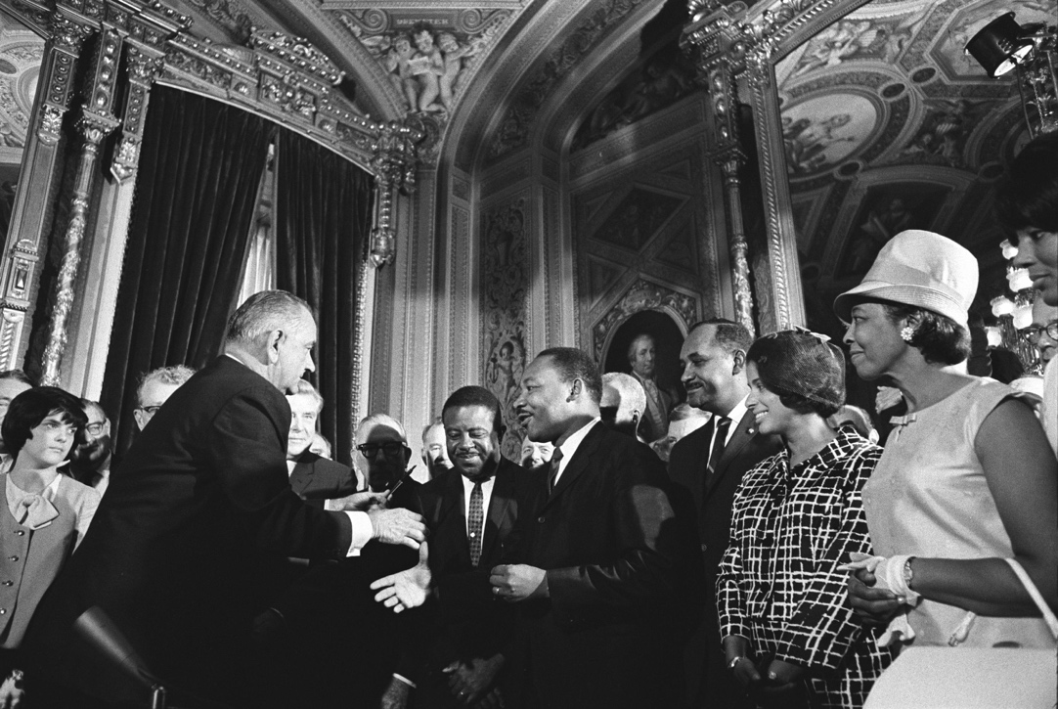
Johnson informed the nation that he was sending a new voting rights bill to Congress, and he urged Congress to vote the bill into law. Congress complied, and President Johnson signed the Voting Rights Act of 1965 on August 6, 1965.

Black and white photograph of Lyndon Johnson extending a hand to Martin Luther King Jr. They are surrounded by a crowd of onlookers, both black and white.
President Lyndon Johnson shakes hands with civil rights activists, including Dr. Martin Luther King Jr., after signing the Voting Rights Act of 1965. Image courtesy the LBJ Presidential Library.

The bill outlawed poll taxes, literacy tests, and other practices that had effectively prevented southern blacks from voting. It authorized the US attorney general to send federal officials to the South to register black voters in the event that local registrars did not comply with the law, and it also authorized the federal government to supervise elections in districts that had disfranchised African Americans. The Voting Rights Act of 1965 transformed patterns of political power in the South. By the middle of 1966, over half a million Southern blacks had registered to vote, and by 1968, almost four hundred black people had been elected to office.

As African Americans joined the Democratic Party, many white southerners began to defect to the Republicans. (Richard Nixon’s “Southern strategy,” designed to shift white Southerners to the Republican Party, accelerated this trend.) With African Americans voting en masse, some Southern Democrats, like George Wallace, began to shed their segregationist rhetoric and attempt to appeal to black voters. At the federal level, President Johnson appointed the first black cabinet member, Robert C. Weaver, as head of the Department of Housing and Urban Development, and in 1967 appointed Thurgood Marshall as the first African American justice of the Supreme Court.
Section 5- SNCC and CORE
CORE
CORE was founded by a group of white and black students on the campus of the University of Chicago in 1942. Its founders had been active in the interfaith, pacifist Fellowship of Reconciliation, and drew inspiration from Mahatma Gandhi’s practice of nonviolent civil disobedience. CORE sent some of its members to help in the Montgomery Bus Boycott, and supported student sit-ins at lunch counters across the South.

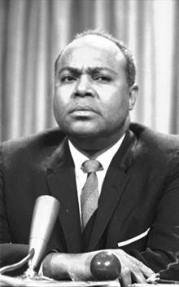
James Farmer, co-founder of the Congress of Racial Equality and president during the Freedom Rides of 1961. Image courtesy Wikimedia Commons.

In 1961, CORE's national director James Farmer organized an effort to integrate interstate bus stations and buses in the Deep South with a series of Freedom Rides. Freedom Riders were groups of white and black civil rights activists who rode buses to challenge segregation in interstate transportation in southern states.

In 1946 the US Supreme Court had ruled segregated interstate bus travel unconstitutional, and in 1960 the Court ruled that interstate bus terminals must be desegregated. But southern states were reluctant to implement the Court’s ruling. The Freedom Riders sought to ensure that the Supreme Court’s ruling was enforced in practice.

The first Freedom Riders left Washington, D.C. on two buses that traveled into southern states. Freedom Riders were met with brutal violence by whites opposed to racial integration. An unidentified white person threw a fire bomb through an open bus window outside Anniston, Alabama, and Freedom Riders were beaten by a white mob after exiting the burning bus. One rider suffered permanent brain damage from a beating. In Birmingham, Alabama another rider required more than fifty stitches after being struck by a metal pipe.

The first two Freedom Ride buses were terminated after ten days. But during the summer of 1961, the Freedom Rides were carried on by more than a thousand Americans. John Lewis, who would soon become a celebrated civil rights leader, wrote at the time that he would “give up all if necessary for the Freedom Ride, that Justice and Freedom might come to the Deep South.” The Freedom Rides were widely covered in the press, and remain one of the most memorable events in Civil Rights Movement history.

CORE activists also contributed to the voter registration drives in the Deep South that became the focus of the civil rights movement in late 1961, and contributed to the voter education and registration drives during 1963 and 1964 in Mississippi and elsewhere. CORE cosponsored the 1963 March on Washington for Jobs and Freedom, the gathering of some 250,000 Americans at which Martin Luther King, Jr. delivered his “I Have a Dream” speech.

By 1966 CORE increasingly embraced black separatism and black power, and lent its support to the anti-Vietnam War movement.

SNCC
SNCC—pronounced “snick”—grew out of student sit-ins at lunch counters that had begun in February 1960 in Greensboro, North Carolina.

On February 1, 1960 four black students, in a purposeful effort to challenge segregation, sat down at a Woolworth store’s lunch counter and ordered a cup of coffee. They were refused service, but remained seated. Their action sparked similar sit-ins in other southern cities. Sit-in protesters were pelted with food and ketchup, taunted and jeered, shoved, and otherwise harassed by whites. The protests were partially successful, though segregation in public accommodation was not outlawed until the passage of the Civil Rights Act of 1964.
In April, Ella Baker, the executive secretary of the Southern Christian Leadership Conference (SCLC) and students from the sit-ins met on the campus of Shaw University in Raleigh, North Carolina and founded SNCC.

SNCC, as its name suggests, endeavored to coordinate efforts among students—both black and white—in direct action, nonviolent efforts in the movement for civil rights. SNCC conducted lunch-counter sit-ins, contributed participants to the 1961 Freedom Rides, cosponsored the 1963 March on Washington, and contributed to voter education and registration drives across the South. During the 1964 Mississippi Freedom Summer three young SNCC activists were murdered in their efforts to register black voters.
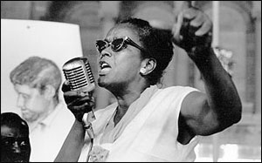
Ella Baker, civil rights activist and grassroots organizer who helped to found the Student Nonviolent Coordinating Committee. Image courtesy Wikimedia Commons.

In 1966 Stokely Carmichael was elected to head SNCC. Carmichael embraced the Black Power Movement, which included black separatism and the use of violence in self-defense. In June 1966, Carmichael declared at a rally that “1966 is the year of the concept of Black Power. The year when black men realized their full worth in society—their dignity and their beauty—and their power—the greatest power on the earth—the power of the right.”

With its commitment to nonviolence dropped, Carmichael renamed the organization the Student National Coordinating Committee. In 1967, H. Rap Brown took over as SNCC chairman and moved the organization further toward black separatism. By the late 1960s, the broader Civil Rights Movement fragmented in the wake of the April 1968 assassination of Martin Luther King, Jr. and rioting in major American cities. By the early 1970s, SNCC had dissolved.
Section 6- Black Power
The origins of Black Power
Though the actual phrase “Black Power” did not come into widespread usage until 1966, the ideas underlying Black Power were not new. As early as the 1940s, A. Philip Randolph, an African American labor activist, called for a march on Washington to pressure President Franklin D. Roosevelt to outlaw racial discrimination in federal employment. Randolph envisioned the march as “an all-Negro movement” that would inculcate “a sense of self-reliance” and “break down the slave psychology and inferiority-complex in Negroes which comes and is nourished with Negroes relying on white people for direction and support.”

Though Randolph himself eschewed black nationalism, the goals of self-reliance and racial pride would become key components of the Black Power ideology.
The author Richard Wright had also published a book called Black Power in 1954, a non-fiction chronicle of his travels to Africa’s Gold Coast, the country that would become Ghana.

Wright’s journeys underscore the significance of ties between Africans and African Americans and the centrality of decolonization in black power ideology. In the 1950s and 1960s, African countries were becoming independent after decades of European colonial rule. African American thinkers like Richard Wright and later, Malcolm X, drew a connection between the struggles of Africans to overthrow the remaining vestiges of colonial oppression and the struggles of African Americans to overcome the white power structure in the United States.

Malcolm X and the Nation of Islam
Led by Elijah Muhammad, born Elijah Poole, the Nation of Islam, also known as the Black Muslims, had existed since the 1930s. Malcolm X, born Malcolm Little, became acquainted with Elijah Muhammad and the teachings of the Nation of Islam while serving time for burglary at the Norfolk Prison Colony in Massachusetts. After the expiration of his parole, he became involved with the Nation of Islam, serving as its emissary on a visit to the Middle East and Africa in 1959, and becoming the minister of Mosque No. 7 in Harlem. Malcolm X’s fiery rhetoric and charismatic presence gained the Nation of Islam many new adherents in the late 1950s and early 1960s. The Nation of Islam advocated black self-empowerment and self-reliance, as well as cultural and racial pride. The most famous Black Muslim was undoubtedly the heavyweight boxer Cassius Clay, who changed his name to Muhammad Ali after converting.
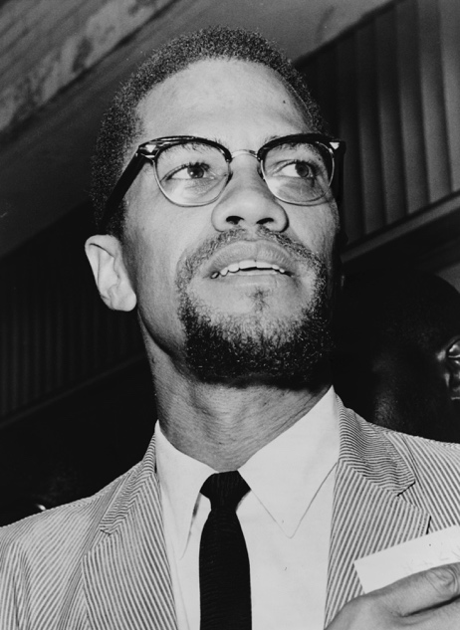
Malcolm X, Black Power advocate and founder of the Organization of Afro-American Unity. Image courtesy Wikimedia Commons.

In 1964, Malcolm X again traveled to the Middle East and Africa, and made his Hajj (Islamic pilgrimage) to Mecca in Saudi Arabia. Upon his return to the United States, he publicly repudiated the Nation of Islam and the teachings of Elijah Muhammad, choosing instead to adhere to a more conventional version of Sunni Islam. He founded the Organization of Afro-American Unity, which embraced the internationalization of the black freedom struggle and continued to emphasize black self-determination and self-defense. On February 21, 1965, after months of receiving death threats, Malcolm X was assassinated at the Audubon Ballroom in Manhattan by members of the Nation of Islam.

His autobiography was published shortly after his death and quickly became a bestseller.

The Black Panther Party
In June 1966, Stokely Carmichael of the Student Nonviolent Coordinating Committee shouted the words “black power” in an address to a freedom rally in Greenwood, Mississippi.

The incident reflected the increased militancy of groups like SNCC and CORE, which had previously adhered to nonviolent civil disobedience. The Black Panther Party of Self-Defense was founded in 1966 in Oakland, California, by Huey P. Newton and Bobby Seale, who issued a ten-point program demanding, among other things, freedom, employment, and an immediate end to police brutality.

The Black Panther Party for Self-Defense Ten-Point Platform and Program
What We Want Now!
- We want freedom. We want power to determine the destiny of our Black Community.
- We want full employment for our people.
- We want an end to the robbery by the white men of our Black Community.
- We want decent housing, fit for shelter of human beings.
- We want education for our people that exposes the true nature of this decadent American society. We want education that teaches us our true history and our role in the present day society.
- We want all Black men to be exempt from military service.
- We want an immediate end to POLICE BRUTALITY and MURDER of Black people.
- We want freedom for all Black men held in federal, state, county and city prisons and jails.
- We want all Black people when brought to trial to be tried in court by a jury of their peer group or people from their Black Communities, as defined by the Constitution of the United States.
- We want land, bread, housing, education, clothing, justice and peace.
The Black Panthers gained notoriety when in the spring of 1967, its gun-toting members staged a protest at the state capitol against a gun control bill then being debated by the California state legislature. The Black Panthers espoused a militant form of black self-defense and functioned as a local militia, taking advantage of open-carry gun laws to patrol black neighborhoods in Oakland in order to prevent police harassment and brutality. The Panthers also provided community services, such as free breakfasts for children, drug and alcohol rehabilitation programs, self-defense classes, and free medical clinics and childcare centers.

Largely due to the Panthers’ militant rhetoric and armed self-defense, the state of California imposed strictures on open-carry gun laws, and the FBI employed its counter-intelligence program (COINTELPRO) to combat what it perceived as the Black Panther Party’s subversive threat to American democracy.

