Korea, Eisenhower, and Anticommunism

Section 1- The Korean War
The Korean War begins
When Korea was liberated from Japanese control at the end of the Second World War, the United States and the Soviet Union agreed temporarily to divide Korea at the 38th parallel of latitude north of the equator. This division resulted in the formation of two countries: communist North Korea (supported by the Soviets) and South Korea (supported by the United States).
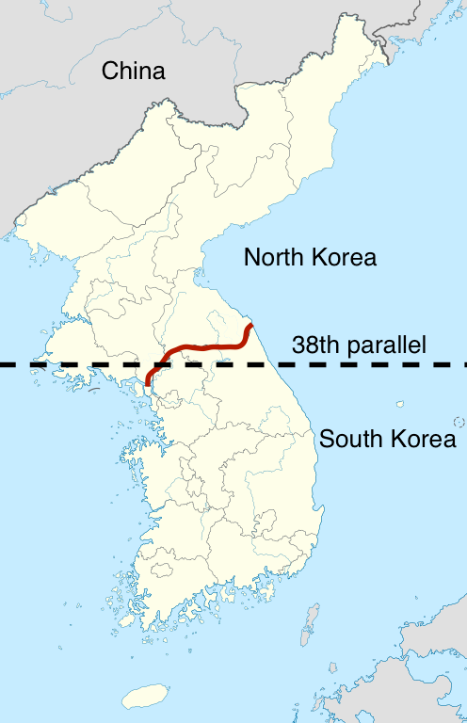
Map of North Korea and South Korea. The red line indicates the present-day border between the two nations. Map adapted from Wikimedia Commons.
Five years after the country’s partition, the communist leader of North Korea, Kim Il Sung, decided to attempt to reunify Korea under his control. On June 25, 1950, Kim launched a surprise invasion of South Korea.

Believing that the Soviet Union had backed the invasion, United States President Harry Truman and his advisers followed through on their policy of containment, refusing to allow communism to spread anywhere in the world. Within two days of the invasion, the United States had rallied the United Nations Security Council to declare support for South Korea. An American-led UN coalition deployed to South Korea.

By August, North Korean forces had swept across almost all of South Korea; American forces held only a small defensive perimeter in the country’s southeast, near Busan. In September, however, under the command of General Douglas MacArthur, the United States launched a bold counter-offensive that included a daring amphibious landing in territory held by North Korean forces at Inchon, on South Korea’s western coast. Soon, US forces drove the North Koreans back to the border at the 38th parallel.
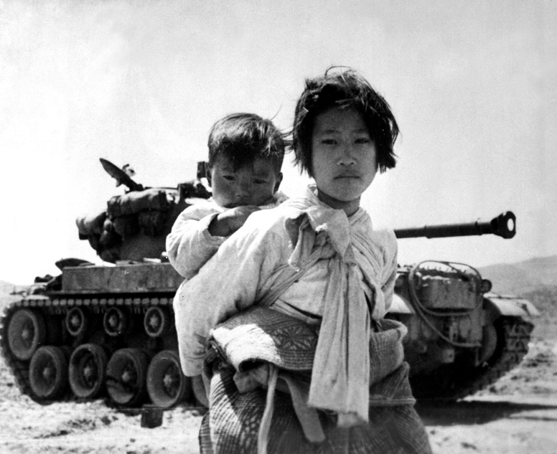
Beyond the 38th parallel
The Truman administration then made the decision to proceed across the 38th parallel into North Korea. But in late November 1950, as American forces neared the Chinese border, leaders in communist China (fearful that the United States might invade) sent tens of thousands of Chinese soldiers streaming into North Korea and drove the American and UN forces southward, back across the 38th parallel.

Child refugees during the Korean War. Image courtesy Wikimedia Commons.

By spring 1951 the Americans had pushed to the 38th parallel once again. That same spring President Truman fired General MacArthur when MacArthur publicly challenged the administration’s strategy. The next two years saw periods of fierce fighting, but the border held. In 1953, an armistice established a status quo antebellum border near the border that had originally divided North and South Korea. In the case of the Korean War, after the conflict the border between North and South Korea was maintained at the 38th parallel.

The heavily armed two-and-a-half mile wide DMZ (Demilitarized Zone) separating North and South Korea exists to this day. About 36,500 American soldiers died in the war, as well as hundreds of thousands of soldiers and civilians from North Korea, South Korea, and coalition forces.

Korea in the context of the Cold War
In Korea, the United States demonstrated its continuing commitment to key elements of its Cold War strategy. It demonstrated its global leadership by committing its resources and soldiers in the fight against the spread of communism. The United States also confirmed its commitment to a foreign policy based on collective security by mobilizing other countries to support its position both politically and militarily.

In Korea, the United States demonstrated the ideals expressed in the Truman Doctrine, which promised support for the "free peoples of the world" who wished to keep communist aggression at bay. Although the war ended where it began, the United States and its allies did succeed in preventing communism from overtaking South Korea.
Section 2- The Eisenhower Era
Dwight D. Eisenhower and Modern Republicanism
Dwight Eisenhower was a celebrated hero of the Second World War, well known to the public as the five-star general who had commanded Allied forces in Europe on D-Day. Eisenhower won landslide victories in both the 1952 and 1956 presidential elections over his Democratic rival Adlai Stevenson, the former governor of Illinois.
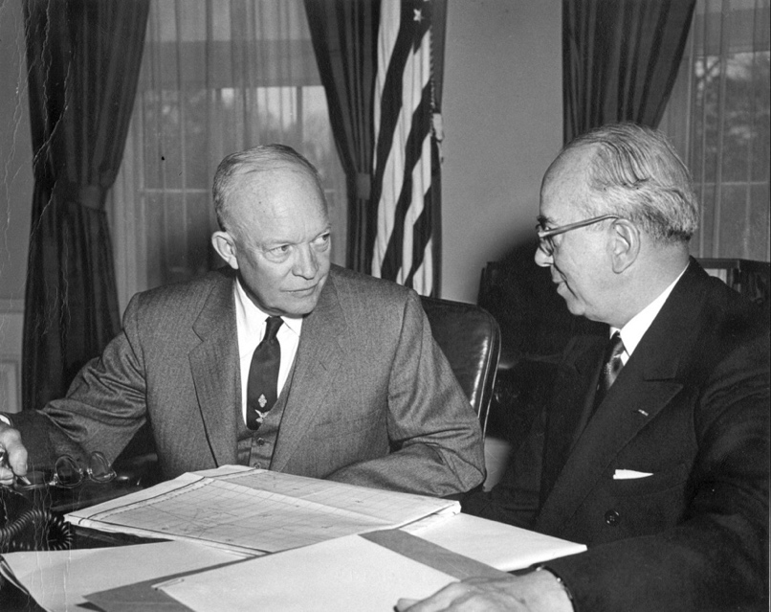
Photograph of President Dwight Eisenhower sitting at a table talking with Lewis Strauss, Chairman of the Atomic Energy Commission, in 1954.
President Dwight Eisenhower in 1954, talking with Lewis L. Strauss, chairman of the Atomic Energy Commission. Image courtesy Wikimedia Commons.

Eisenhower was a moderate Republican. Eisenhower did not try to dismantle the social welfare programs of the New Deal; on the contrary, the federal government continued to grow during his presidency. He signed an expansion to Social Security—to cover the self-employed, and disabled—and established the Department of Health, Education, and Welfare. He also signed legislation increasing the minimum wage by a third.

Eisenhower also emphasized the importance of a balanced federal budget, and his administration worked for modestly lower taxes on corporations and the highest income earners. He called his brand of politics Modern Republicanism, and said he wanted to lead the country “down the middle of the road.” With the Federal-Aid Highway Act, he funded the largest public works project in American history—authorizing the expenditure of $25 billion to build more than 40,000 miles of four-lane interstate highways.

1950s prosperity
The Eisenhower era of the 1950s was a time of unprecedented economic growth and prosperity. GDP (gross domestic product) grew by an astonishing 150% in the period from 1945 to 1960. In the 1950s, with only five percent of the world’s population the U.S. economy produced almost half of the world’s manufactured products.

Americans drove three-quarters of the world’s cars and consumed half of the world’s energy. Union membership reached its historic peak in American history in 1954 when almost 35% of the nation’s workforce was unionized. The GI Bill and Marshall Plan expenditures, along with Cold War defense spending, contributed to economic growth. So, too, did the nation’s growing population—some 50 million babies were born during the continuing baby boom in the Eisenhower era.

Eisenhower and civil rights
Eisenhower was a limited supporter of civil rights legislation. He signed the Civil Rights Act of 1957, the first civil rights bill passed by Congress since the nineteenth century, and appointed a Commission on Civil Rights to ensure that citizens were not being “deprived of their right to vote.” In 1960, he signed the Civil Rights Act, which introduced penalties for anyone who destroyed voter registration records or attempted to block a person from registering to vote.

The integration of the United States armed services, which began under President Truman, was completed during Eisenhower's administration. Finally, in 1957 Eisenhower deployed federal troops to aid with the integration of Central High School in Little Rock, Arkansas.

Eisenhower's foreign policy
Eisenhower’s eight years in office were relatively peaceful ones for the nation. He ended the Korean War with a July 1953 armistice, and did not take the country into war in Vietnam when communists took over part of that country in 1954 (though he did supply South Vietnam with military advisers and equipment). In concert with Nikita Khrushchev, his Soviet counterpart, Eisenhower voluntarily suspended nuclear atmospheric testing in 1958, although an official test-ban treaty would not be signed until after he left office.
The Cold War framed Eisenhower’s foreign policy. Cold War thinking frequently took on an "us-versus-them" mindset, and this view of the world as one polarized between Soviet totalitarian communism (them) and American democracy and freedoms (us) saw Eisenhower’s administration both provide aid to dictators friendly to US interests (the Shah of Iran, Fulgencio Batista in Cuba, for example) and authorize covert CIA missions to overthrow governments sympathetic to the Soviets. For example, in 1954 Eisenhower authorized the CIA to depose the democratically elected president of Guatemala, Jacobo Arbenz.

The Eisenhower administration’s national security strategy was called the New Look. It relied on strategic nuclear weapons and air power while scaling back conventional army and navy forces. A nuclear arsenal was cheaper to maintain than paying a standing army: "more bang for the buck," the popular slogan went. New Look policy gave rise to talk of the need to employ a diplomacy of brinksmanship: a willingness on the part of American leaders to take the world to the brink of a nuclear war with the hope that the Soviets would back down in the face of a potential US nuclear strike. But the stakes were high. If brinksmanship failed, nuclear war might result. Consequently, fear of nuclear war weighed heavily on the minds of Americans during the Eisenhower era.

Section 3- Anticommunism in the 1950’s
Red fears
In 1949, the Soviet Union detonated its first atomic device, ending the United States' short reign as the sole atomic power on Earth. The entry of the Soviets into the atomic club made Americans nervous, not to mention a little suspicious: how did the USSR get the bomb so fast?

When it came to light that Soviet spies in the US atomic program had passed secrets to Russia, Americans began to worry that spies might be lurking in every corner of society. In the late 1940s and early 1950s, there were several highly-publicized espionage trials that convicted leading scientists and government figures of espionage, culminating in the 1953 execution of scientist Julius Rosenberg and his wife Ethel for passing information about the atomic bomb to Russia. These convictions served to justify fears that spies could be active throughout the country.

In this atmosphere of mistrust, a broad range of institutions rushed to root out suspected communists from their ranks. The US government stepped up loyalty programs and purged itself of anyone deemed a security threat. Individuals believed to be particularly susceptible to bribery or blackmail, such as debtors or homosexuals, were summarily dismissed. Schools and universities fired teachers who refused to swear an oath that they were not communists. Even civil rights organizations like the NAACP and the Urban League moved quickly to rid themselves of communists, lest they be accused of subversion.

Although it is true that Soviet spies were at work in the United States (recently declassified documents reveal that Julius Rosenberg was indeed sending atomic secrets to the Russians, though Ethel was innocent), only a tiny fraction of those who lost their positions were actually connected with the USSR in any way.

HUAC
First formed in 1938, the House Committee on Un-American Activities, or HUAC, was a special committee in the US House of Representatives tasked with investigating subversive individuals and organizations. In the 1950s, HUAC turned its attention to hunting reds (a slang term for communists, associated with the red flag of the Soviet Union).

Influenced by a pamphlet called Red Channels, which alleged that communists had infiltrated the entertainment industry and intended to use the suggestive power of media to spread propaganda to American audiences, in 1950 HUAC began investigating Hollywood figures. Red Channels charged 151 actors, writers, and directors with having ties to the Communist Party. All of them were immediately blacklisted, whether or not the charges were substantiated. Studios refused to hire anyone on the blacklist, fearing backlash from sponsors and audiences, destroying the careers of many talented entertainers.

Joseph McCarthy
Some politicians also profited from this Red Scare, notably Republican Senator Joseph R. McCarthy. Fearful that his weak record in the Senate would prevent his reelection, McCarthy cast about for an issue that would shore up his image to voters. He seized on communism. At a meeting of Republican women in 1950, McCarthy brandished a sheath of papers and declared that he had in his hand "a list of names that were made known to the Secretary of State as being members of the Communist Party who nevertheless are still working and shaping policy in the State Department."

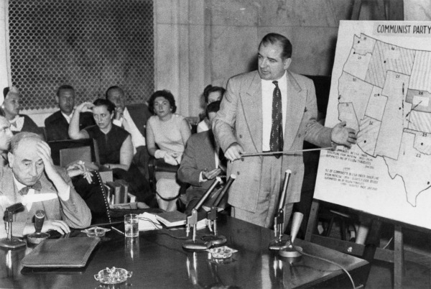
In the US Senate chamber, Senator Joseph McCarthy points at a map of the United States labeled "Communist Party" while Chief Army Counsel Joseph Welch sits at a table with his hand on his head. A group of onlookers sits watching the proceedings.
Senator Joseph McCarthy (right) interviewing Chief Army Counsel Joseph Welch (left) during the Army-McCarthy hearings, 1954. Image courtesy US Senate.

McCarthy's allegations shocked the nation. Finding himself in the spotlight, McCarthy held hearings in the Senate, relying on innuendo and hearsay to condemn members of the State Department of communist ties. For more than four years, McCarthy railed against supposed communists, eastern "establishment" Democrats, and homosexuals. He never produced a shred of real evidence against anyone, but even those powerful enough to stop him were afraid McCarthy would turn his accusations against them if they spoke out. "I will not get in the gutter with that guy," President Eisenhower reportedly said of McCarthy, thus leaving McCarthy to operate without challenge.

McCarthy finally went too far in 1954 when he initiated hearings against the US Army. The televised Army-McCarthy hearings showcased McCarthy's increasingly erratic behavior and reliance on guilt-by-association rather than evidence. In December 1954 the US Senate voted to censure McCarthy.

McCarthy died of complications of alcoholism less than three years later, but use of the term McCarthyism to describe the practice of making unsubstantiated accusations has lived on.

