The 1980’s and 1990’s
Section 1: Ronald Reagan
The political career of Ronald Reagan
A two-term President (1981-1989), Ronald Reagan headed one of the most successful coalitions of political conservatives in American history. Born in 1911 in northern Illinois, a graduate of Eureka College, Reagan was a Hollywood actor—and six-term head of the Screen Actors Guild—before taking up a job as spokesperson for General Electric Corporation in the 1950s.
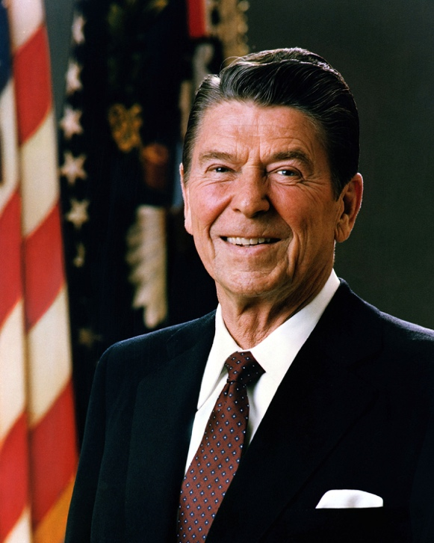
Photograph of Ronald Reagan.
Official portrait of President Reagan. Image courtesy Wikimedia Commons.
Though he had been a liberal Democrat into his forties, Reagan became a free-market political conservative in the 1950s, and formally switched party affiliations to become a Republican in 1962. During his two terms as governor of California (1967-1975), Reagan was a vocal critic of the expansion of government.

In his 1980 campaign for the US presidency, Reagan promised to cut taxes, increase defense spending, promote deregulation, and balance the federal budget. Reagan also promised to end the double-digit inflation that characterized Jimmy Carter's presidency, and restore both Americans' faith in their country and America’s status in the world. “Let’s make America great again,” the candidate and his campaign posters declared.

Reagan also addressed key concerns of the Religious Right. He called for a “return to spiritual values” as a means of strengthening traditional families and communities, advocated a Constitutional amendment to ban abortion, and another Constitutional amendment to permit organized prayer in public schools.

President Reagan earned the nickname “The Great Communicator” for his plain-spoken, self-effacing, and humorous manner of public speaking. In both his first and second terms he exuded an upbeat optimism about the nation’s domestic and international future, an attitude captured in both of his inaugural addresses as well as in his 1984 reelection campaign television commercial, “Morning in America.”

Reaganomics
President Reagan’s supply-side economic policies, often called Reaganomics, set out to grow the economy by cutting taxes and deregulating some industries. Supply-side economics depended on the idea that corporations and wealthy individuals would reinvest the money they saved by paying lower taxes to build businesses, create jobs, boost profits, and spur economic growth. In Reagan’s first year in office he engineered a three-stage 25 percent income tax reduction. In the Tax Reform Act of 1986, the top marginal rate (the tax paid by the highest income earners) was lowered to 28 percent.

Deregulation, or the removal of government regulations on some industries, would, it was hoped, lower costs and boost profits for employers while lowering prices for consumers. During Reagan's first term, the trucking and telephone industries were deregulated, and clean air standards for cars were lowered.

Reagan often said that "Government is not the solution to our problem, government is the problem," and memorably quipped: "The nine most terrifying words in the English language are: I'm from the Government, and I'm here to help." In practice, however, Reagan was more moderate than his language let on. He cut taxes when possible, but aggregate tax receipts during his presidency remained similar to those of his more liberal predecessors.

Although Democrats blocked many of his efforts to limit government expenditures through cuts to social welfare programs, Reagan succeeded in making cuts to spending on food stamps, low-income housing, and school lunch programs. He also reduced the percentage of federal expenditures on education and promoted the transfer of some federal control and expenditures to state governments.

Foreign policy and foreign affairs under Reagan
A staunch anticommunist, President Reagan worked to assert American power and rollback Soviet communist influence around the world. He celebrated American founding ideals and institutions—including the nation’s freedoms, democracy, and competitive market capitalism—and, in a 1983 speech, denounced the Soviet Union as an “evil empire.”

In his first term, President Reagan authorized the largest military build-up in US history, including new bombers and missiles, as well as the development of a space-based Strategic Defense Initiative (nicknamed "Star Wars") to shoot down Soviet missiles before they reached the United States. He also deployed medium-range nuclear missiles in five NATO countries in late 1983 to counter a Soviet missile build-up.

Seeking to contain and rollback Soviet communist influence around the world, President Reagan’s administration funded anti-communist “freedom fighters” around the world, sending covert aid to anti-communist UNITA rebels in Angola; covert military support to the Contras seeking to overthrow the Marxist government of Nicaragua; and authorized aid to the mujahideen in Afghanistan in their battle against the Soviet Union.

In 1983, US forces invaded the small Caribbean island nation of Grenada after a coup by hardline members of the island’s own leftist government, and replaced the Marxist government with one friendly to the United States. The Reagan administration also supported authoritarian anticommunist dictatorships in Chile and South Africa, and gave aid to authoritarian regimes in El Salvador and Guatemala to finance the resistance against leftist insurgents in those countries.

The Cold War thaws
The rise of Mikhail Gorbachev to Soviet leadership in March 1985, along with the policies of glasnost (openness) and perestroika (Soviet economic and political restructuring) he introduced, led to warmer relations between the two superpowers.

Reagan and Gorbachev held four summit meetings during Reagan’s second term, and agreed to the first-ever nuclear arms reduction treaty. They also began negotiations that led to the Strategic Arms Reduction Talks (START) in the 1990s, which reduced the two nations’ nuclear arsenals by 50 percent.

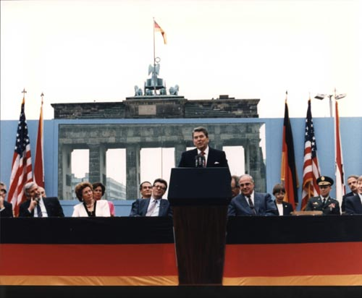
Ronald Reagan in Berlin, 1987. Image courtesy Wikimedia Commons.
On June 12, 1987, President Reagan delivered a moving speech at the Brandenburg Gate of the Berlin Wall which culminated with an entreaty to the Soviet leader: “Mr. Gorbachev, tear down this wall.” Two years later, on November 9, 1989, the wall came down.

Middle East and North Africa
From the outset of his presidency, President Reagan faced not only the challenges of the Cold War, he also faced the growing threat of terrorism in the Middle East and North Africa. On the day of his inauguration in January 1981, Iran released the last of the American embassy workers it had held hostage for 444 days. (President Carter’s inability to secure the hostages' release had been a major issue in the 1980 presidential campaign.)

Two years later, in April 1983, a suicide bomber detonated a van packed with explosives outside the US embassy in Beirut, Lebanon, killing seventeen Americans and forty-six others. Six months later, a suicide bomber drove an explosives-laden truck into US Marine barracks in Beirut, killing 242 United States Marines stationed there as peacekeepers in support of the Lebanese government. President Reagan withdrew US forces from Lebanon soon thereafter.

Relations between the United States and the North African country of Libya were contentious throughout President Reagan’s time in office. In 1981, US forces shot down two Libyan fighter planes in the Gulf of Sidra incident. In April 1986, after Libya’s alleged involvement in a bombing at a Berlin club that killed or injured more than sixty American soldiers, President Reagan authorized the bombing of ground targets in Libya. In a televised address to the nation, Reagan said, "When our citizens are attacked or abused anywhere in the world on the direct orders of hostile regimes, we will respond so long as I'm in this office."

President Reagan’s second term was sullied by the Iran-Contra affair, in which US officials secretly sold weapons to Iran and funneled the profits from those sales to Nicaraguan rebels.

The Iran-Contra affair
Issues of Central American communism and Middle Eastern terrorism combined in the Iran-Contra affair to cast a shadow over President Reagan’s second term in office. The first stage of the events involved a weapons-for-hostages exchange in which officials in the Reagan administration sold antitank missiles to Iran. In exchange, Iran worked to have American hostages released from Lebanon. Reagan administration officials, including Colonel Oliver North, then used the money from the missile sales to fund US military support for the Contras, anticommunist guerrillas who were fighting against the Marxist government in Nicaragua.

The problem with all this was that President Reagan had vowed that his administration would never negotiate with hostage-takers, on top of the fact that Congress had placed an embargo on the sale of weapons to Iran. Congress also had passed the Boland Amendment, limiting US assistance to the Contras in Nicaragua, citing evidence that they had tortured and murdered civilians. Therefore, both the sale of arms to Iran and the use of money from that sale to aid the Contras was illegal.

The scandal began to unravel after an C-123 supply plane over northern Nicaragua was shot down in October 1986. An American who survived the crash described how he had been hired by the CIA to load and drop weapons cargoes to the Contras, and, soon, investigative reporters and Congress were uncovering the various elements of the scandal.

By late 1986, the US Attorney General announced that between $10 and $30 million of the money received from Iran in the missiles-for-hostages deal had been diverted to fund military aid to the Contras, though later it was found that US funding for the Contras—with Iranian and other monies—amounted to more than $70 million.

Reagan and Iran-Contra
Although it is certain that Reagan condoned the sale of missiles for hostages in Iran, there is no evidence that the president knew that Oliver North was diverting money from the missile sales to the Nicaraguan Contras.

Some people blamed Reagan’s hands-off administrative style as a contributing factor in Iran-Contra. For, while Reagan concerned himself with big-picture strategy in domestic and foreign policy, he assigned others responsibility for carrying out the details. But this administrative approach seemed to lead to serious—some said impeachable—consequences in the Iran-Contra affair. Reagan earned another nickname, the “Teflon president,” since scandals never seemed to stick to him and his popularity with the public remained unchanged.
Section 2: Emergence of the AIDS Crisis
Emergence of the AIDS crisis
In the summer of 1981 the CDC published its first reports describing a rare cancer, Kaposi sarcoma, found in homosexual men living in Los Angeles, San Francisco, and New York City. By the end of the year, 121 of the individuals with the disease (of 270 reported cases) had died.

Research determined that acquired immunodeficiency syndrome had been the cause of their deaths, and, in 1982, the CDC began to refer to the disease as AIDS.
In September 1983 the CDC ruled out transmission of AIDS by casual contact, underscoring the impossibility of contracting AIDS from food, water, air, or surfaces. By 1984 human immunodeficiency virus (HIV) was identified as the agent that caused AIDS.

In the early and mid-1980s rumors of a “gay disease” or “gay plague” spread, misrepresenting AIDS as a threat only to homosexual men. Although AIDS is most prevalent among men who have sex with men, HIV may be contracted through blood, semen, pre-ejaculate, vaginal fluids and breast milk. (It cannot be transmitted through saliva, tears, sweat, or urine.)

The first clinics, support groups, and community-based service providers opened in San Francisco and New York City in 1982. Gay rights activists undertook initiatives promoting education about safer sex and countering discrimination against AIDS. In these early years, there was no treatment for AIDS, and friends and family members could only comfort the dying.

Fear and discrimination
In the 1980s, fear of HIV/AIDS spread, and discrimination against people living with AIDS was common. The nation was torn between sympathy for the afflicted and fear that the disease might spread in the general population. Gay activists, HIV-positive individuals, and their allies battled job, school, and housing discrimination.

In 1985 Ryan White, a thirteen-year-old hemophiliac who had contracted AIDS from a blood transfusion, was banned from his middle school in Indiana out of fear that he would pass HIV to his classmates. After a year-long court battle Ryan was allowed to return to school. He passed away in 1990.

The death of Hollywood actor Rock Hudson from complications related to AIDS in 1985 drew public attention to the disease, as did the 1993 death of tennis star Arthur Ashe. In 1991, basketball great Earvin “Magic” Johnson announced that he was living with AIDS.
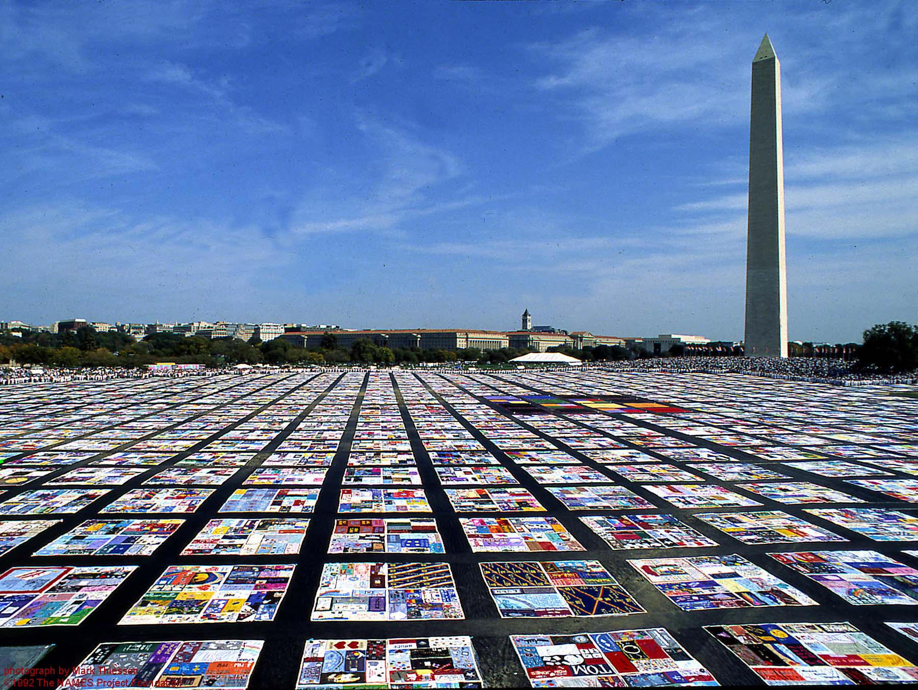
Religious and political conservatives often spoke harshly about individuals with AIDS. Patrick Buchanan, a senior adviser to Richard Nixon and Ronald Reagan and a conservative commentator, wrote in 1984 that homosexuals “have declared war upon nature, and now nature is exacting an awful retribution.”

In October 1987, during a march on Washington DC for gay rights, a giant AIDS quilt—with panels celebrating the lives of people that the disease had claimed—was displayed on The National Mall as a memorial to those who had died.

Photograph of the AIDS quilt on the National Mall in Washington, DC.
In 1987, activists covered the National Mall in Washington, DC with a giant quilt memorializing the many people who had died from AIDS. Image courtesy Wikimedia Commons.

Reagan and the AIDS crisis
The first congressional hearings were convened on AIDS in 1982, and the next year Congress allocated $12 million for AIDS research and treatment. Within several years, in response to the efforts of gay activists and healthcare professionals, the federal government was committing hundreds of millions of dollars for research, education, care services and treatment.

Activists condemned President Ronald Reagan for his public silence on AIDS during his first term. Thanks to their advocacy, President Reagan issued an executive order in his second term establishing the President’s Commission on the HIV Epidemic, and signed legislation that increased federal funding for research and education on HIV/AIDS to 500 million dollars.

In 1987, the Food and Drug Administration approved the drug AZT, which inhibits HIV and delays the onset of AIDS. By 1989 Louis Sullivan, the Secretary of Health and Human Services, could say: “Today we are witnessing a turning point in the battle to change AIDS from a fatal disease to a treatable one.” More effective antiretroviral drug treatments were discovered in the mid-1990s.

AIDS after the 1980s
AIDS is by no means history. In the United States alone, there have been 1,651,454 cases and 698,219 deaths from HIV/AIDS between 1980 and 2014. The CDC reports that there are about 50,000 new incidents of HIV infection each year in the United States today. In 2012 about 1.2 million people in the United States were living with HIV.

Worldwide it is estimated that 34 million people have died from HIV/AIDS, and the World Health Organization estimates that in 2014 36.9 million people worldwide were living with HIV/AIDS.
Section 3: Bill Clinton
Bill Clinton’s rise to power
Bill Clinton was born William Jefferson Blythe III in Hope, Arkansas in 1946 but formally adopted his stepfather’s surname, Clinton, when he was fifteen years old. He attended Georgetown University and was a Rhodes scholar at Oxford before going on to earn his law degree at Yale. He served one term as Attorney General of the state of Arkansas and was elected governor in 1978.
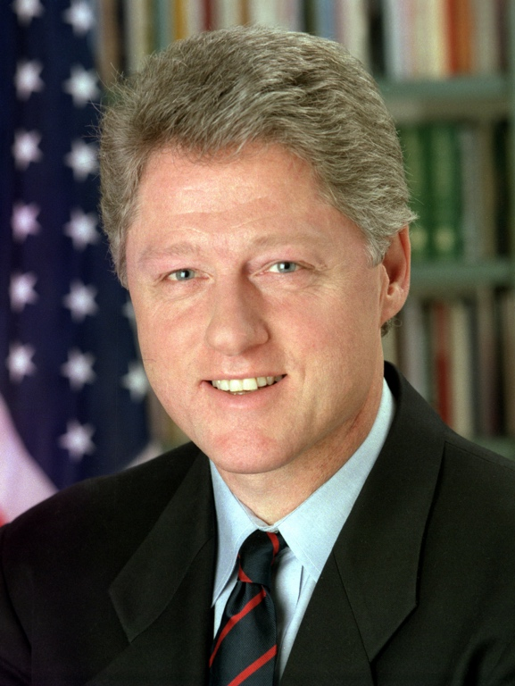
Photograph of Bill Clinton.
Official White House portrait of Bill Clinton. Photograph by Robert McNeely. Image courtesy Wikimedia Commons.

Frequently referred to as the “Boy Governor” because of his young age (he was 32 years old), Clinton enacted reforms in the areas of education, welfare, and healthcare. He was reelected in 1982 and became a leader of the New Democrats, a centrist wing of the Democratic Party that sought to decrease the size and scope of the federal government—a goal to which progressives and liberals were vehemently opposed.

In 1992, he secured the Democratic Party’s presidential nomination, and won in a three-way race against incumbent President George H.W. Bush, a Republican, and independent third-party candidate Ross Perot. Clinton was the first US president from the Baby Boomer generation. He was reelected in 1996, becoming the first Democrat since Franklin D. Roosevelt to serve two terms as president. He is married to Hillary Rodham Clinton, who represented the state of New York in the US Senate before becoming Secretary of State during the Obama administration.

Clinton’s first term (1993-1997)
Bill Clinton came to the White House with an ambitious domestic agenda centered on economic growth. He immediately set to work reducing the federal budget deficit. The Omnibus Budget Reconciliation Act of 1993, known unofficially as the Deficit Reduction Act of 1993, raised taxes for the wealthiest 1.2 percent, while cutting taxes for small businesses and lower-income wage earners. The legislation included a requirement to balance the federal budget, and set the stage for an economic resurgence that culminated in a federal budget surplus.

The Clinton administration proved less successful in the realm of healthcare reform. Although implementing a national health care plan with universal coverage was a top priority for Clinton, opposition from Republicans, the American Medical Association, and the health insurance industry proved an insurmountable obstacle to healthcare reform.
On January 1, 1994, President Clinton signed into law the North American Free Trade Agreement (NAFTA), which eliminated barriers to trade and investment between the United States, Canada, and Mexico. Though some have criticized NAFTA for moving jobs out of the United States, the overall economic impact of the agreement has been mostly beneficial, not only for the United States, but for Canada and Mexico as well. The Gross Domestic Product (GDP) of all three countries grew as a direct result of NAFTA, while trade and investment flourished and some industries that were expected to decline instead thrived as never before.

Clinton’s second term (1997-2001)
Although Bill Clinton easily won reelection in 1996, his second term in office was marred by corruption and scandal. Clinton became the second president in US history to be impeached, after he was discovered to have lied to Congress and the American people about his involvement in an extramarital affair with White House intern Monica Lewinsky. Though the House of Representatives charged Clinton with perjury and obstruction of justice, the Senate vote, which was largely along party lines, did not attain the two-thirds majority required by the US Constitution to remove him from office.

In the United States, impeachment is a way for the legislative branch, Congress, to hold members of the executive branch accountable for crimes committed while in office.
The act of impeachment is the formal bringing of such charges, which is the prerogative of the House of Representatives. Impeachment is followed by a trial, which is carried out in the Senate. After the trial, the Senate votes on whether to convict the impeached official. If a two-thirds majority of the Senate votes to convict, the official is automatically removed from office.
To date, only two US presidents—Andrew Johnson and Bill Clinton—have been impeached by the House of Representatives. Both were acquitted by the Senate. No US president has been convicted by the Senate and removed from office.

Despite the scandal, Clinton left the White House with the highest approval rating of any US president in the post-World War II era. He was succeeded in office by George W. Bush.
Section 4: Globalization
What is globalization?
Globalization refers to the technological, political, economic, financial, and cultural exchanges between peoples and nations that have made and continue to make the world a more interconnected and interdependent place. In the business world, this includes increased trade and investment flows, currency exchange, and the rise of multinational corporations. Communication and transportation technologies are capable of linking people who are physically distant from one another, thereby facilitating the exchange of culture, knowledge, and ideas.

Although the concept and vocabulary of globalization is fairly recent, emerging most forcefully in the 1990s, the processes of globalization are as old as history itself. This is because humans have always engaged in cultural exchange, the dissemination of knowledge, and the trade of goods and services. However, important developments in the latter part of the twentieth century, particularly the 1990s, accelerated these processes.

Globalization in the 1990s
With the collapse of the Soviet Union in 1989 and the end of the Cold War in 1991, the world became more interconnected. This is because the communist bloc countries, which had previously been intentionally isolated from the capitalist West, began to integrate into the global market economy. Trade and investment increased, while barriers to migration and to cultural exchange were lowered.

Photograph of a McDonald's in St. Petersburg featuring a sign in Cyrillic characters.
A McDonald's restaurant in St. Petersburg. After the fall of the Soviet Union, the former communist bloc nations began to integrate into the global economy. Photograph by Dirke Ingo Franke. Image courtesy Wikimedia Commons.

Technological advances, including mobile phones and especially the internet, have contributed to globalization by connecting people all over the globe. The World Wide Web links billions of people and devices, providing innumerable opportunities for the exchange of goods, services, cultural products, knowledge, and ideas.

Free trade agreements, such as the North American Free Trade Agreement (NAFTA), which the governments of the United States, Canada, and Mexico signed in 1992, removed barriers to the free flow of people, goods, and services, thereby facilitating greater trade, investment, and migration across national borders.
Though free trade and open markets have led to job losses in some sectors in certain countries, and have displaced workers in certain industries, they can also increase economic growth and prosperity.

For instance, NAFTA has been criticized for moving almost three-quarters of a million manufacturing jobs out of the United States and into Mexico, but US trade with Mexico increased substantially as a direct result of the agreement.

The dark side of globalization
Although globalization has had many positive effects and has contributed to greater prosperity in many countries, it has a dark side as well. Global terrorist networks have used the conditions created by globalization to enhance their own influence and to promote a culture of intolerance and hate. For example, the al-Qaeda members who perpetrated the attack on September 11th used mobile phone technology and the internet to coordinate their plans. They were also easily able to move from one country to another because of lowered barriers to international travel and mobility.

Moreover, the increasing interconnectedness of the world economy and international finance has heightened the risk of global economic catastrophe. This is because banking or financial failures in one country will lead to crises in other countries, and thus will become internationalized rather than remaining isolated. This was the case with the Great Recession of 2008-2009, during which the financial crisis in the US subprime mortgage market led to a global economic meltdown.

