The Great Depression

Section 1- The Presidency of Herbert Hoover
The early life of Herbert Hoover
Herbert Clark Hoover was born in 1874 in Iowa, and was the first US president to have been born west of the Mississippi River. He worked as a mining engineer and an independent mining consultant, traveling the world and building a sizable personal fortune.

When World War I broke out, Hoover became active in humanitarian work, and chaired the Commission for Relief in Belgium, which provided relief to that country as it faced a food crisis brought on by the German invasion in 1914.He also served as the director of the American Relief Administration, which was formed in 1919 and supplied relief to war-torn Europe and Russia.
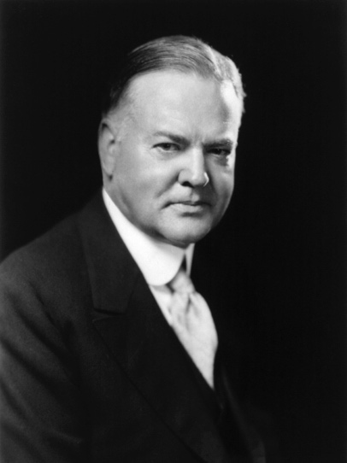
Photograph of Herbert Hoover.
Herbert Hoover. Image courtesy Wikimedia Commons.

During the First World War, President Woodrow Wilson appointed Hoover head of the US Food Administration, which sought to reduce consumption and avoid wartime food rationing. Hoover went on to serve as Secretary of Commerce in the administration of Warren G. Harding.

The presidency of Herbert Hoover
Hoover won the Republican nomination in the 1928 presidential election after Republican President Calvin Coolidge announced that he would not be running for reelection. Hoover campaigned on Coolidge’s legacy of economic prosperity, pledging to support business, improve the quality of life of the nation’s farmers, and conduct a relatively isolationist foreign policy. Hoover was ambivalent about Prohibition, referring to it as a “great social and economic experiment,” but failing to back it wholeheartedly.

Hoover won the election in a landslide against his Democratic opponent. Once in office, Hoover sought to reform the nation’s regulatory system. He was not an advocate of a laissez-faire economy, but instead encouraged the voluntary cooperation of the federal government and big business. At Hoover’s direction, the Internal Revenue Service and the Justice Department prosecuted gangsters, including Al Capone, for tax evasion. Hoover considered himself a progressive, and this was reflected in some of his administration’s policies, including the reorganization of the Bureau of Indian Affairs, the organization of the Federal Bureau of Prisons, the closing of tax loopholes for the wealthiest Americans, the expansion of national park lands, and the strengthening of protections for labor.

Hoover’s most notable foreign policy achievements were in Latin America. His administration laid the groundwork for what became the Good Neighbor Policy under Hoover's successor Franklin D. Roosevelt. The Good Neighbor policy explicitly disavowed military interventionism in hemispheric relations. Hoover himself embarked upon a goodwill tour in Latin America, traveling to ten countries and delivering pledges to reduce US political and military interference in the domestic affairs of Latin American countries. Hoover also successfully mediated a dispute between Chile and Peru over land.

Hoover and the Great Depression
In 1929, the stock market crash catalyzed the onset of the Great Depression.

Though Hoover has gained a reputation for dithering in the face of economic peril, his administration actually pursued measures that helped lay the basis for Roosevelt’s New Deal. Hoover launched a massive public works program, part of which included funding for construction of the Hoover Dam on the Colorado River. His administration implemented stronger protections for labor and substantially increased federal subsidies for agriculture.

Hoover also played a key role in passing the Glass-Steagall Act of 1932, which limited the activities of commercial banks in an attempt to stabilize the banking sector.

However, many of these policies were not immediately effective, and some of the administration’s actions actually worsened the effects of the depression. The Smoot-Hawley Tariff Act, for instance, which Hoover signed reluctantly, raised tariffs on thousands of imported goods and initiated a trade war between the United States and Europe, thereby exacerbating the global economic downturn.

Although Hoover ran for reelection in 1932, his inability to mitigate the negative economic consequences of the Great Depression had made him widely unpopular. He lost the election to Democrat Franklin D. Roosevelt.

Section 2- The Great Depression
The stock market crash of 1929
The value of the US stock market nearly doubled in a frenzy of speculative buying in the eighteen months before the crash began on “Black Thursday,” October 24, 1929. On that day, and on “Black Tuesday,” October 29, panic set in as millions of shares of stock traded at ever-falling prices.

The October 1929 downturn was only the beginning of the market collapse. By mid-November the stock market had lost a third of its September value, and by 1932—when the market hit bottom—stocks had lost ninety percent of their value. A share of US Steel which had sold for $262 before the crash sold in 1932 for $22.

The stock market crash signaled the beginning of the Great Depression, but it was only one factor among many root causes of the Depression. A weak banking system, further collapse in already-low farm prices, and industrial overproduction each contributed to the economic downturn. The disastrous 1930 Hawley-Smoot Tariff (which raised average tariff rates to nearly 60 percent) caused America’s international trading partners to retaliate by raising rates on US-made goods. The result was shrinking international trade and a further decline in global economies.

The Great Depression
As the effects of the Depression cascaded across the US economy, millions of people lost their jobs. By 1930 there were 4.3 million unemployed; by 1931, 8 million; and in 1932 the number had risen to 12 million. By early 1933, almost 13 million were out of work and the unemployment rate stood at an astonishing 25 percent. Those who managed to retain their jobs often took pay cuts of a third or more.

Out of work Americans filled long breadlines, begged for food, or sold apples on street corners. A Chicago social worker wrote that “We saw Want and Despair walking the streets, and our friends, sensible, thrifty families, reduced to poverty.”
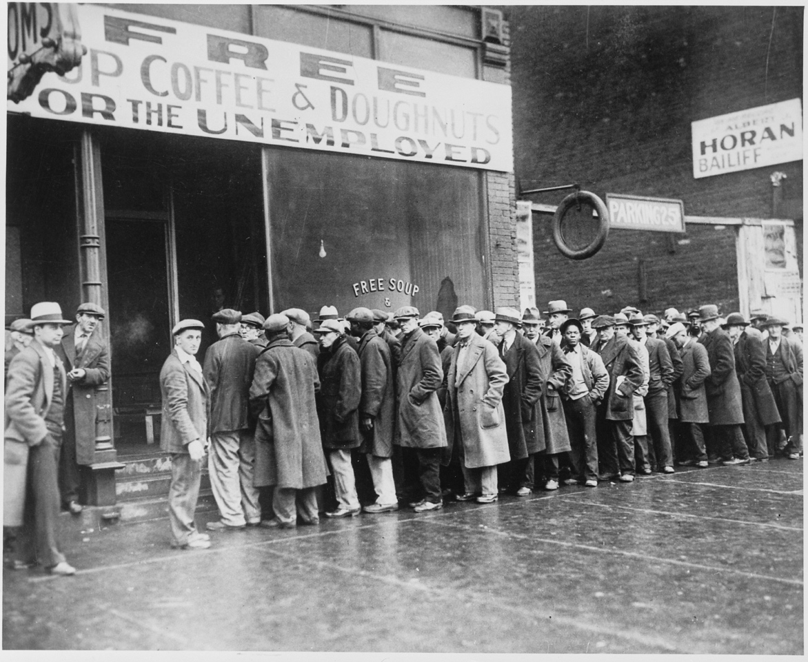
Photograph of a long line of men waiting in front of a storefront which advertises free soup, coffee, and doughnuts for the unemployed.
Men waiting in line for free soup, coffee, and doughnuts in Chicago, 1931. Image courtesy National Archives.

More than a third of the nation’s banks failed in the three years following 1929.

Long lines of desperate and despairing people outside banks hoping to retrieve their savings were common. Many ordinary citizens lost their life savings when banks failed.
Farmers were hit particularly hard by the crisis. On top of falling prices for crops, a devastating drought in Oklahoma, Texas, and Kansas brought on a series of dust storms known as the Dust Bowl. In the South, sharecroppers—both white and black—endured crushing poverty and almost unimaginable degradation. African Americans suffered significantly higher levels of unemployment than whites due to pervasive racism.

The financial crisis was not limited to the United States. Countries in Europe and around the world experienced the depression. Hitler’s rise to power in Germany was fueled in part by the economic slowdown, and throughout the 1930s international tensions increased as the global economy declined.

Hoover's response to the crisis
President Hoover initially met the economic downturn from the perspective of his long-held voluntarist principles—that is, his belief in minimal government interference in the economy, as well as a conviction that direct public relief to individuals would weaken individual character, turn people away from the work-ethic, and lead them to develop a dependency on government handouts. By 1931 Hoover reversed his earlier approach and embraced government intervention in the economy. The 1932 Reconstruction Finance Corporation (RFC) authorized the lending of $2 billion to banks, railroads, and other privately held companies, and in July 1932 the federal government appropriated $300 million for the nation’s first relief and public works projects.

For many, however, these actions were too little, too late. Shantytowns of makeshift hovels—disparagingly labeled “Hoovervilles” in disgust with the president’s inaction in the face of crisis—grew up across the country in public parks and in vacant lots, as the out-of-work, unable to pay mortgages or rent, were evicted from their homes. Trouser pockets pulled out to signal the lack of money within them were “Hoover flags.” Newspapers used for warmth by the homeless were “Hoover blankets.”

In November 1932, Franklin D. Roosevelt was elected president in a landslide, winning 57.4% of the vote to Hoover’s 39.7%.
Section 3- FDR and the Great Depression
Roosevelt's life and long career
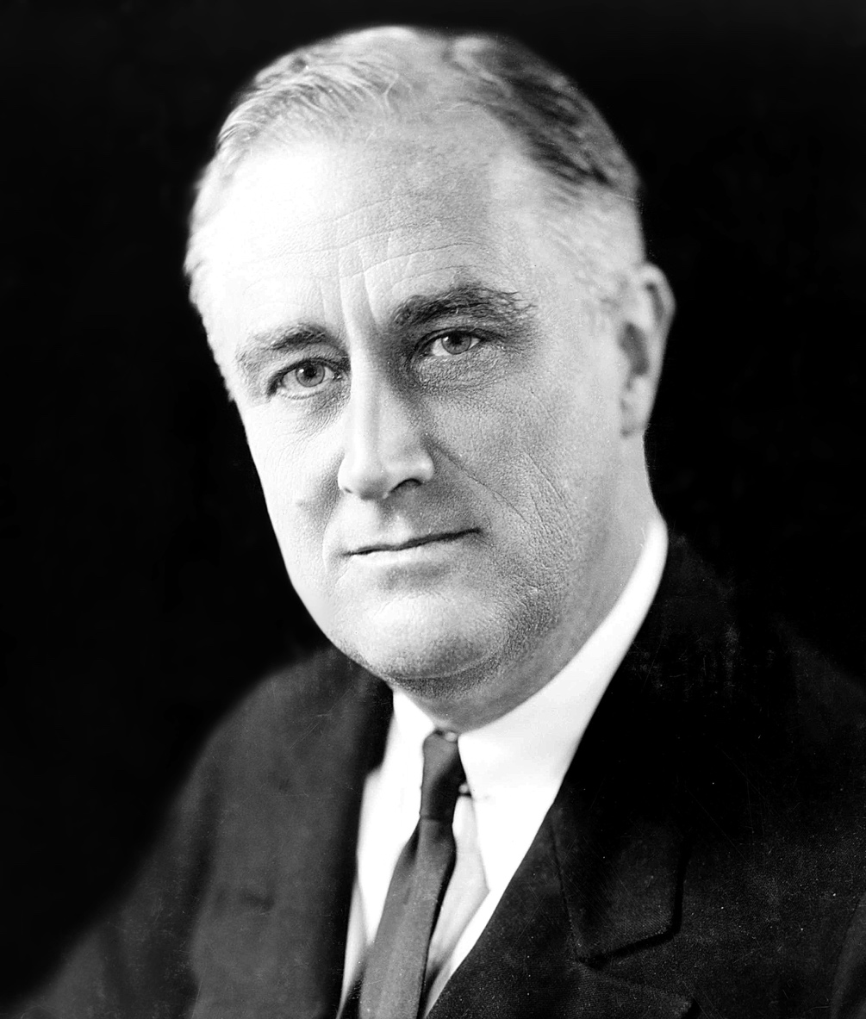
Franklin Delano Roosevelt, fifth cousin of former President Teddy Roosevelt, was raised amid privilege in Hyde Park, New York. He attended Harvard University, was elected to the New York State Senate in 1910, and served as assistant secretary of the Navy during the First World War. From 1929 to 1932 he served as governor of New York.

Franklin Delano Roosevelt in 1933. Image courtesy Library of Congress.

Known as FDR, Roosevelt was elected President of the United States in 1932, 1936, 1940 and 1944. He served as the nation’s 32nd president from March 4, 1933 to his death in 1945.
At age thirty-nine, Roosevelt contracted polio. He lost the use of his legs for the rest of his life, though the public was largely unaware of his disability. (In private, he moved around by wheelchair. In public, supported by steel leg braces and assistants, he could walk short distances.) His life experiences forged a man whose easygoing manner belied an interior toughness.

Roosevelt and the New Deal
In his 1932 run for the presidency, Roosevelt asserted that he would help “the forgotten man at the bottom of the economic pyramid,” and pledged himself to “a new deal for the American people.” In his First Inaugural Address, saying “the only thing we have to fear is fear itself,” he sought to reassure the public amid the anxieties of the Great Depression.

As president he championed the series of federal legislative initiatives known as the New Deal. The New Deal was not a blueprint for action, but was instead animated by a spirit, as Roosevelt said, of “bold, persistent experimentation,” in which he would “take a method and try it: if it fails, admit it frankly and try another.”

On March 12, 1933, Roosevelt delivered the first of his live-radio “fireside chats.” In the first chat he spoke about the banking crisis and explained the actions he and Congress had taken to address it. During his presidency he delivered thirty “fireside chats,” explaining to the public in reassuring tones and plain-spoken language his New Deal policies and the Second World War through the medium of radio.

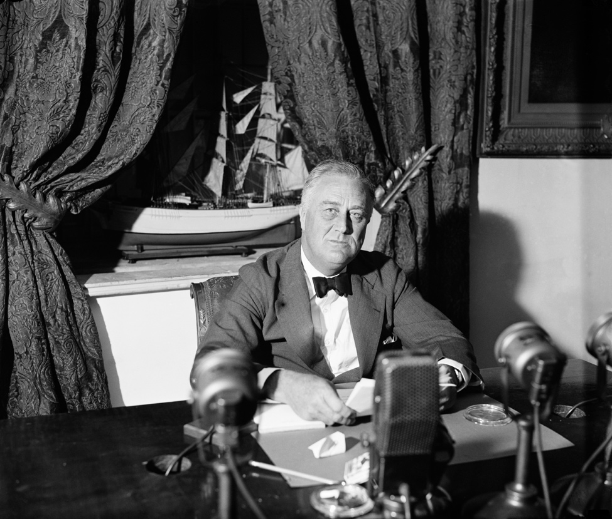
Roosevelt delivering one of his fireside chats, September 1936. Image courtesy Wikimedia Commons.

In an ill-fated move in 1937, President Roosevelt sought to pack the US Supreme Court, which had ruled against many of his programs, with justices who would be more favorable to the New Deal. His “court packing” plan called for adding an additional justice to the Court for every justice over the age of 70. The measure was widely denounced by the public and failed in Congress.

Although the New Deal did not ultimately succeed in lifting the United States out of the Great Depression, the United States' mobilization for World War II revived the economy during the late 1930s and 1940s.

Section 4- The New Deal
Origins of the New Deal
The term New Deal derives from Franklin Roosevelt’s 1932 speech accepting the Democratic Party’s nomination for president. At the convention Roosevelt declared, “I pledge you, I pledge myself, to a new deal for the American people.” Though Roosevelt did not have concrete policy proposals in mind at the time, the phrase "New Deal" came to encompass his many programs designed to lift the United States out of the Great Depression.

The New Deal created a broad range of federal government programs that sought to offer economic relief to the suffering, regulate private industry, and grow the economy. The New Deal is often summed up by the “Three Rs”:
- relief (for the unemployed)
- recovery (of the economy through federal spending and job creation), and
- reform (of capitalism, by means of regulatory legislation and the creation of new social welfare programs).

Roosevelt’s New Deal expanded the size and scope of the federal government considerably, and in doing so fundamentally reshaped American political culture around the principle that the government is responsible for the welfare of its citizens. As one historian has put it: “Before the 1930s, national political debate often revolved around the question of whether the federal government should intervene in the economy. After the New Deal, debate rested on how it should intervene.”

The First New Deal (1933-1934)
At the time of Roosevelt’s inauguration on March 4, 1933 the nation had been spiraling downward into the worst economic crisis in its history. Industrial output was only half of what it had been three years earlier, the stock market had recovered only slightly from its catastrophic losses, and unemployment stood at a staggering 25 percent.

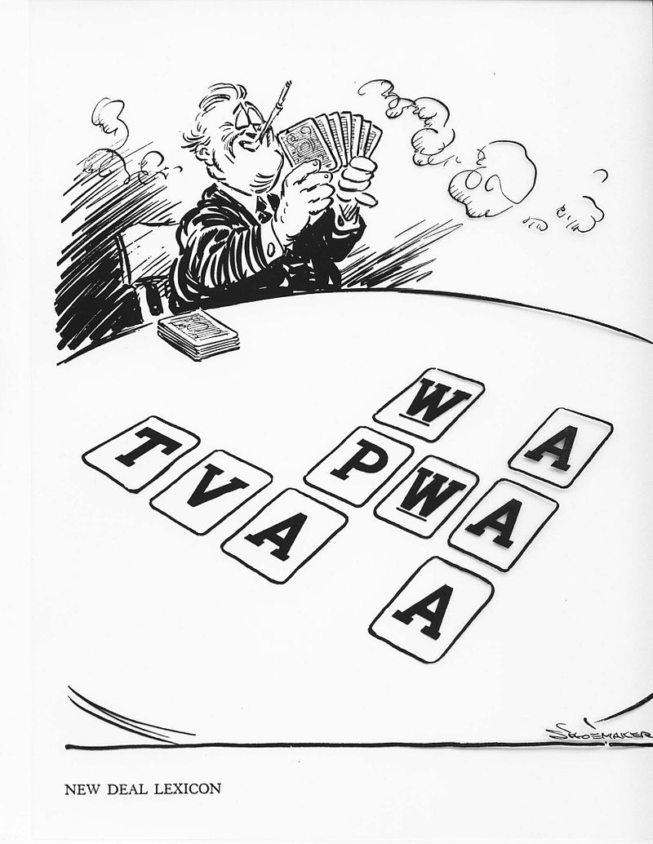
Political cartoon satirizing the "alphabet agencies" of the New Deal. Even contemporaries had trouble remembering all the acronyms. Vaughn Shoemaker, Chicago Daily News, 1935. Image courtesy Wikimedia Commons.

The First New Deal began in a whirlwind of legislative action called “The First Hundred Days.” From March through June 1933, at Roosevelt’s behest, Congress passed legislation aimed at addressing the banking crisis, unemployment, and weak industrial performance, among other problems, through an “alphabet soup” of new laws and agencies. Among these, some of the most important were:
The Agricultural Adjustment Act (AAA), which boosted agricultural prices by offering government subsidies to farmers to reduce output.
The Civilian Conservation Corps (CCC), which employed young, single men at federally funded jobs on government lands.
The Federal Emergency Relief Act (FERA), which gave federal grants to states that funded salaries for government workers as well as local soup kitchens and other direct-aid to the poor programs.
The National Recovery Act (NRA), which sought to boost businesses’ profits and workers’ wages by establishing industry-by-industry codes that set prices and wages, as well as guaranteeing workers the right to organize into unions.
The Federal Deposit Insurance Corporation (FDIC), which guaranteed individuals that money they deposited in a bank would be repaid to them by the federal government in the event that their bank went out of business.

In 1934, Roosevelt supported the passage of the Securities and Exchange Commission (SEC), which brought important federal government oversight and regulation to the stock market.

The Second New Deal (1935-1938)
The second phase of the New Deal focused on increasing worker protections and building long-lasting financial security for Americans. Four of the most notable pieces of legislation included:
The Works Progress Administration (WPA), which employed millions of Americans in public works projects, from constructing bridges and roads to painting murals and writing plays.
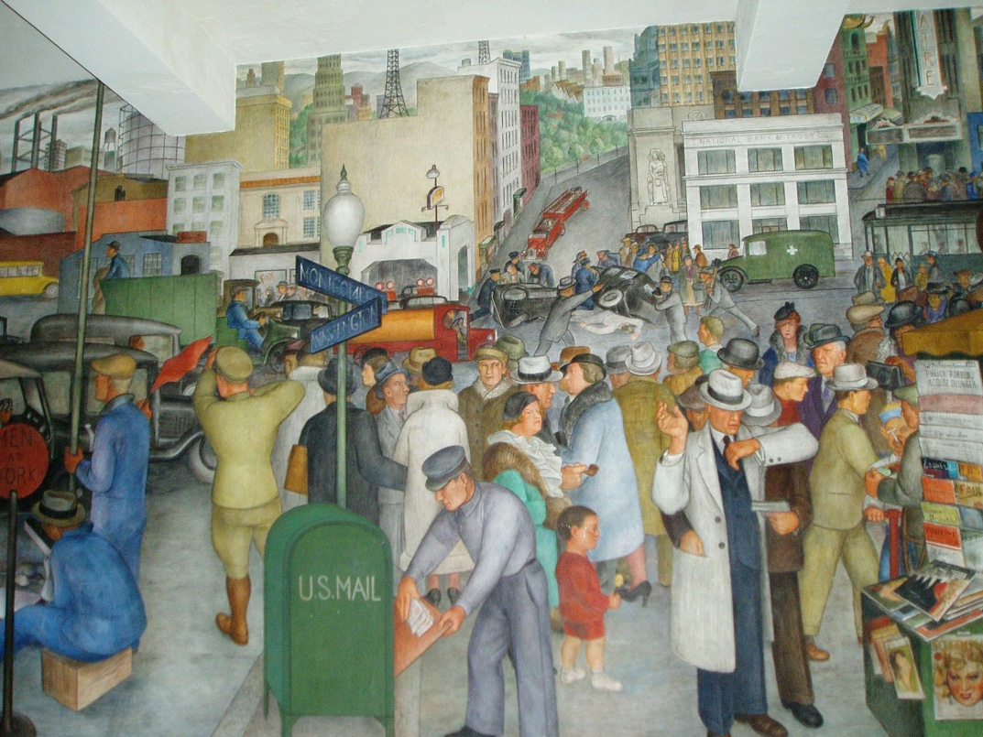
This mural in San Francisco's Coit Tower was supported by the Works Progress Adminsitration. Many post offices and other public buildings became canvases for WPA murals. Image courtesy Wikimedia Commons.

The Wagner Labor Relations Act, which guaranteed workers the right to form unions and bargain collectively.
The Social Security Act, which required workers and employers to contribute—through a payroll tax—to the Social Security trust fund. That fund, in turn, makes monthly payments to retirees over the age of 65, as well as to the long-term disabled.

The Fair Labor Standards Act, which mandated a 40-hour work week (with time-and-a-half for overtime), set an hourly minimum wage, and restricted child labor.

The legacy of the New Deal
Roosevelt’s New Deal sought to reinvigorate the economy by stimulating consumer demand. The New Deal embraced federal deficit spending to promote economic growth, a fiscal approach that came to be associated with the British economist John Maynard Keynes. Keynes argued that government spending that put money in consumers' hands would allow them to buy products made in the private sector. Then, as employers sold more and more products, they would have the money to hire more and more workers, who could afford to buy more and more products, and so on.

In this way, Roosevelt and his supporters theorized, the Great Depression’s downward economic spiral could be reversed.

The New Deal was only partially successful, however. The Supreme Court ruled against several New Deal initiatives in 1935, leading a frustrated Roosevelt to suggest expanding the Supreme Court to as many as fifteen Justices (a political misstep that would haunt him for the rest of his career).

Despite the New Deal's lofty dreams, the United States only fully recovered from the Great Depression due to massive military spending brought on by the Second World War. Nevertheless, key elements in the New Deal remain with us today, including federal regulation of wages, hours, child labor, and collective bargaining rights, as well as the social security system.

